# Creating two pipeline in Jenkins

Step 1:open Jenkins and click on new item.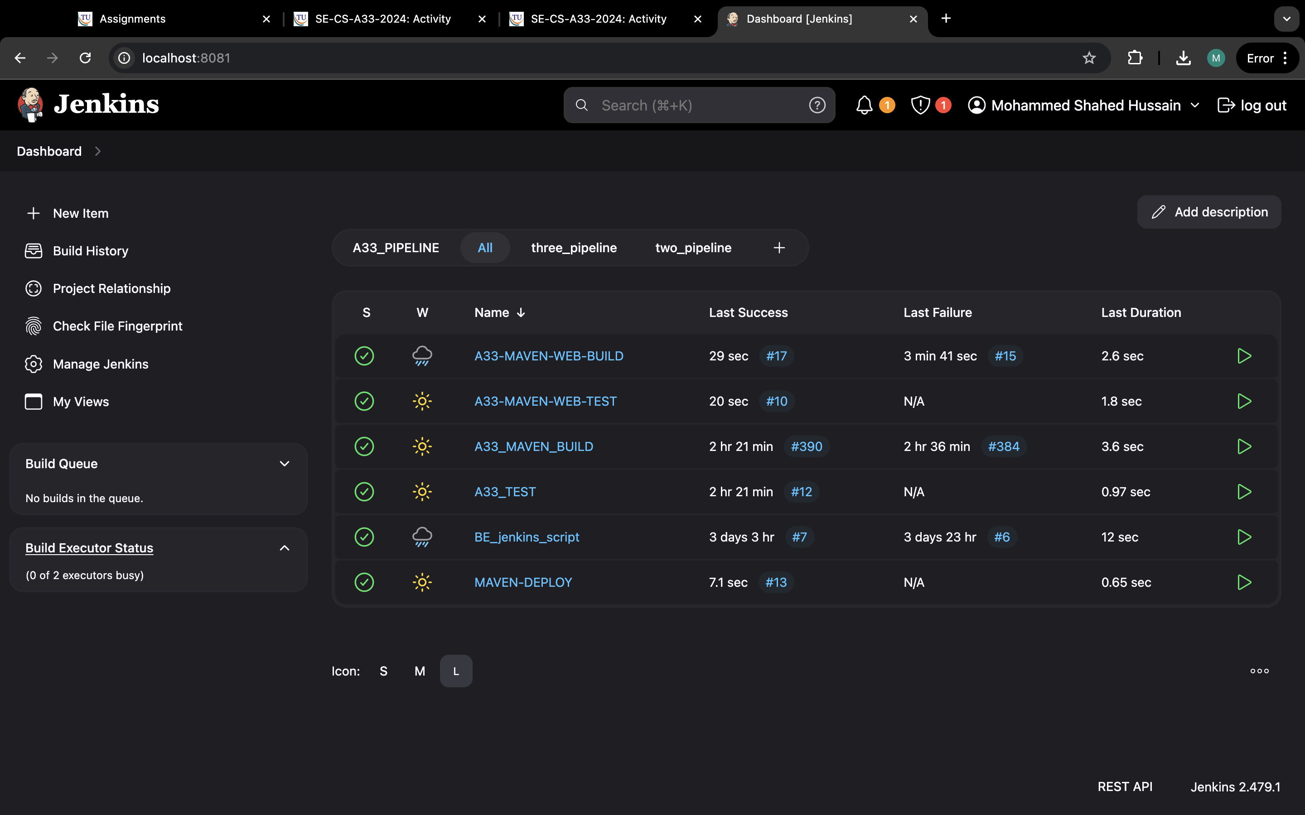

Step 2: enter the item as “name-build” and select freestyle and ok.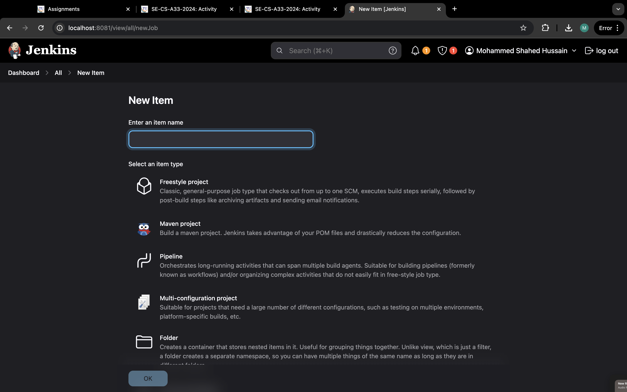

Step 3: Now go to GitHub and copy the https link form code.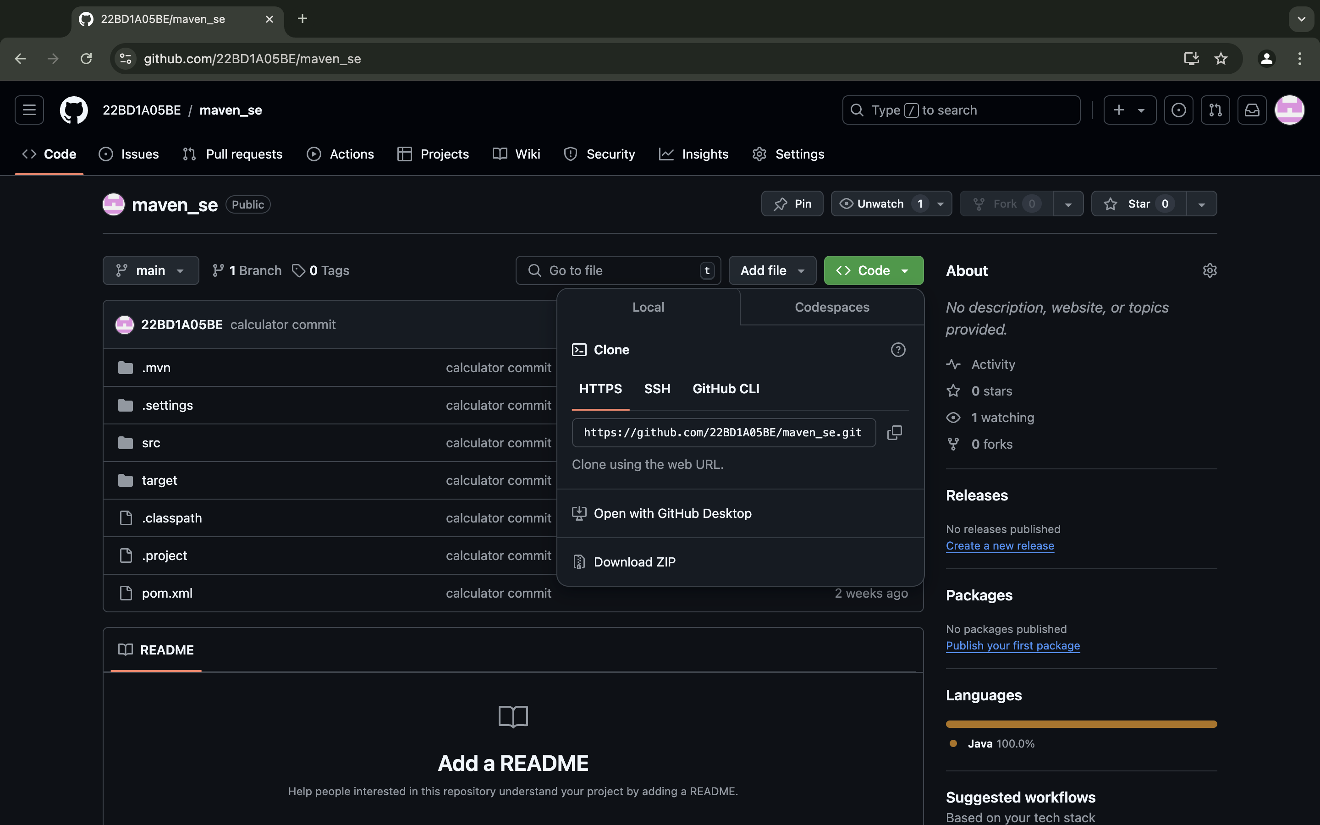

Step 4: write something in description.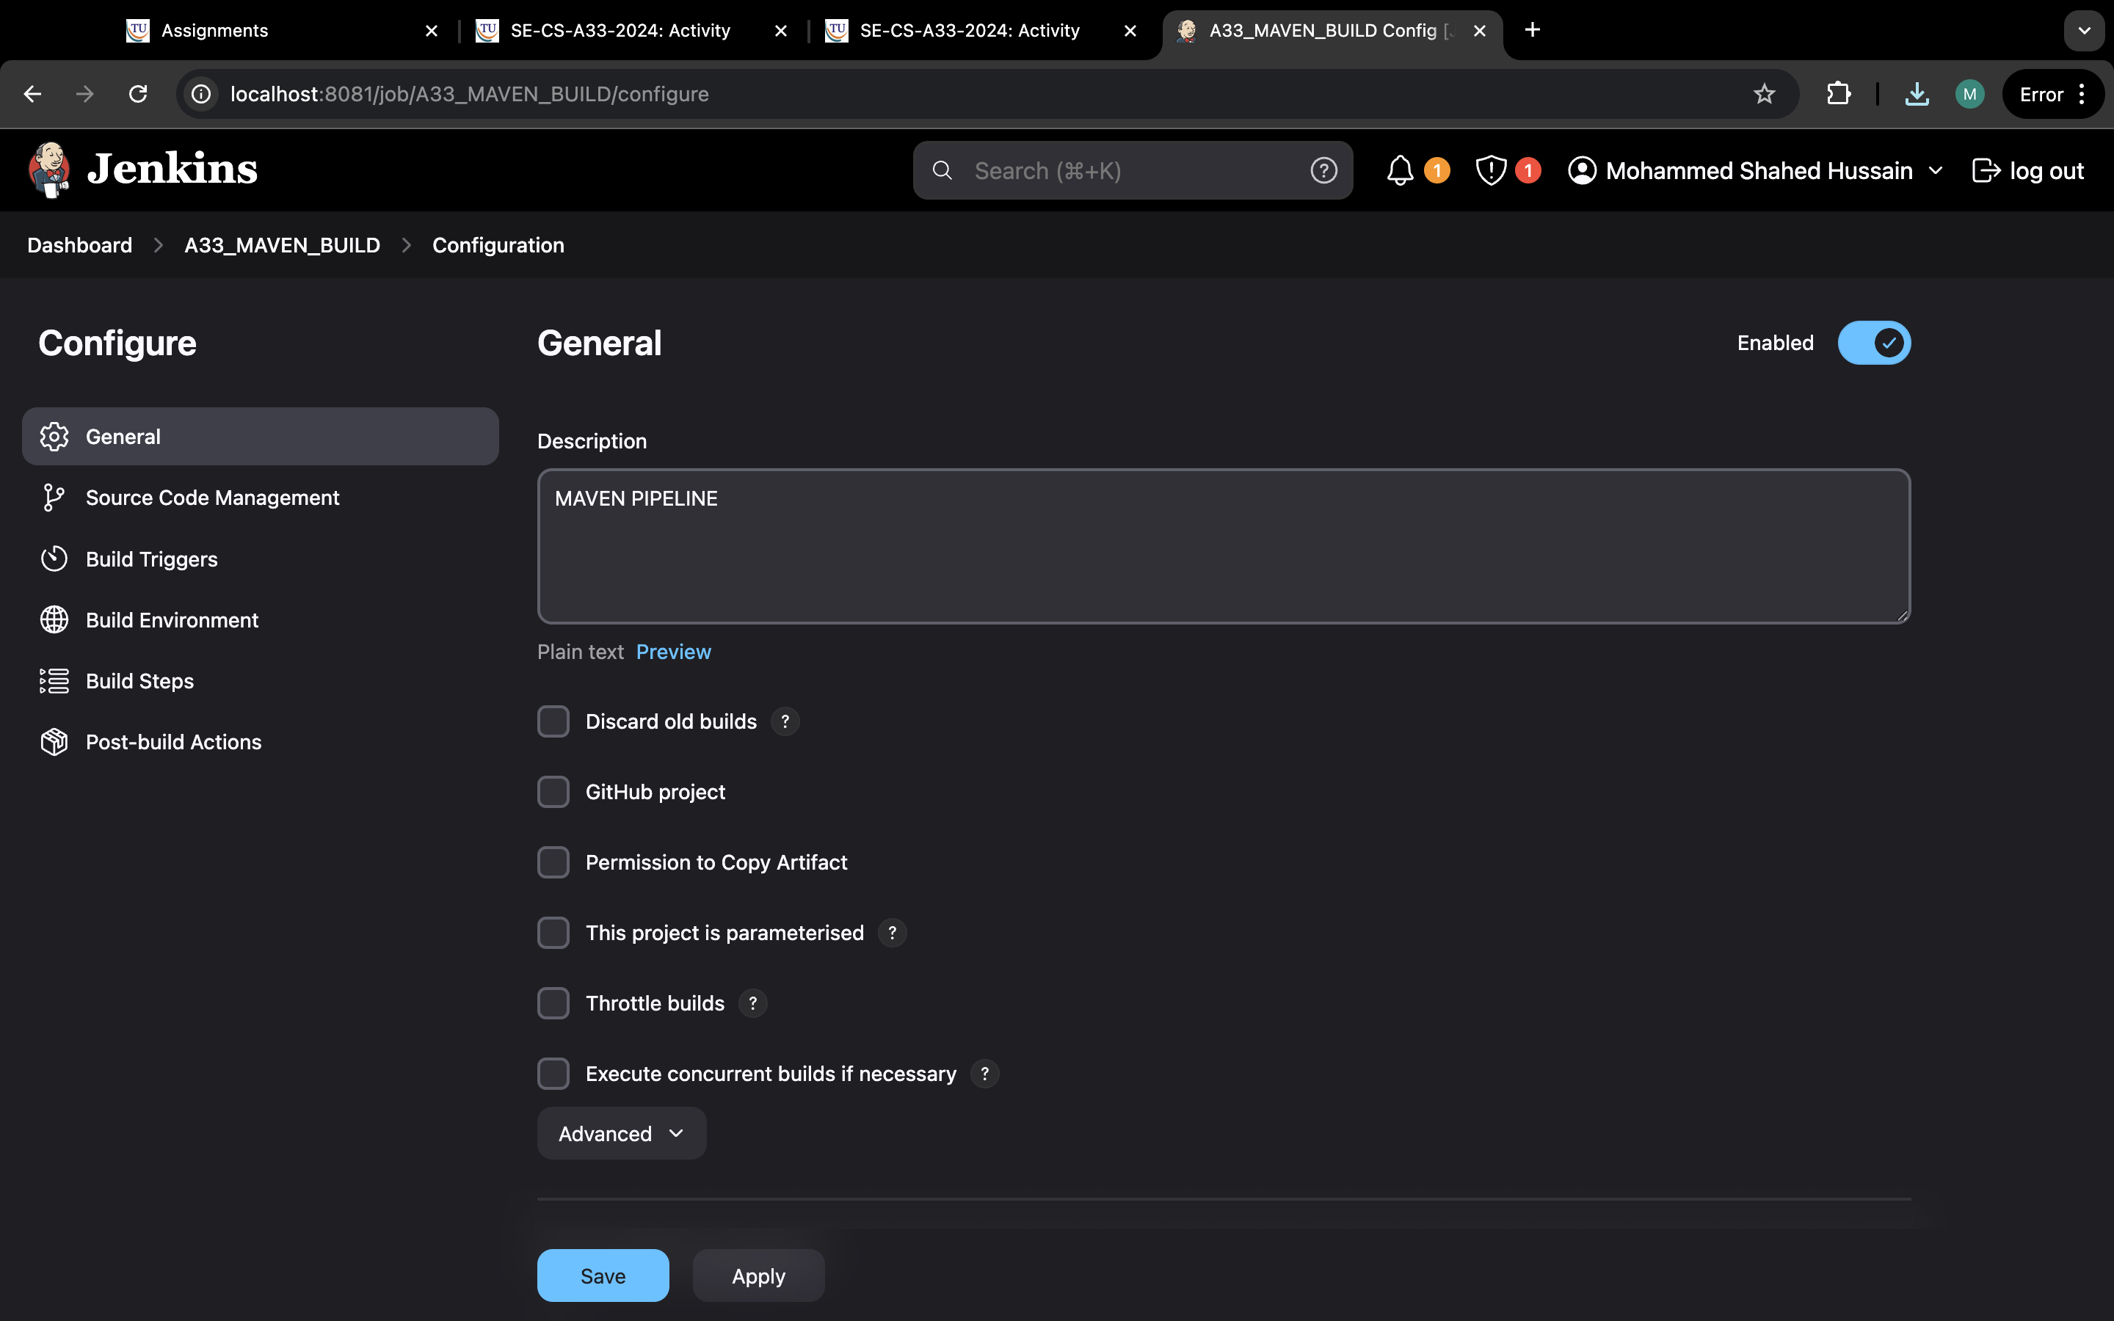

Step 5: paste the link in repository URL.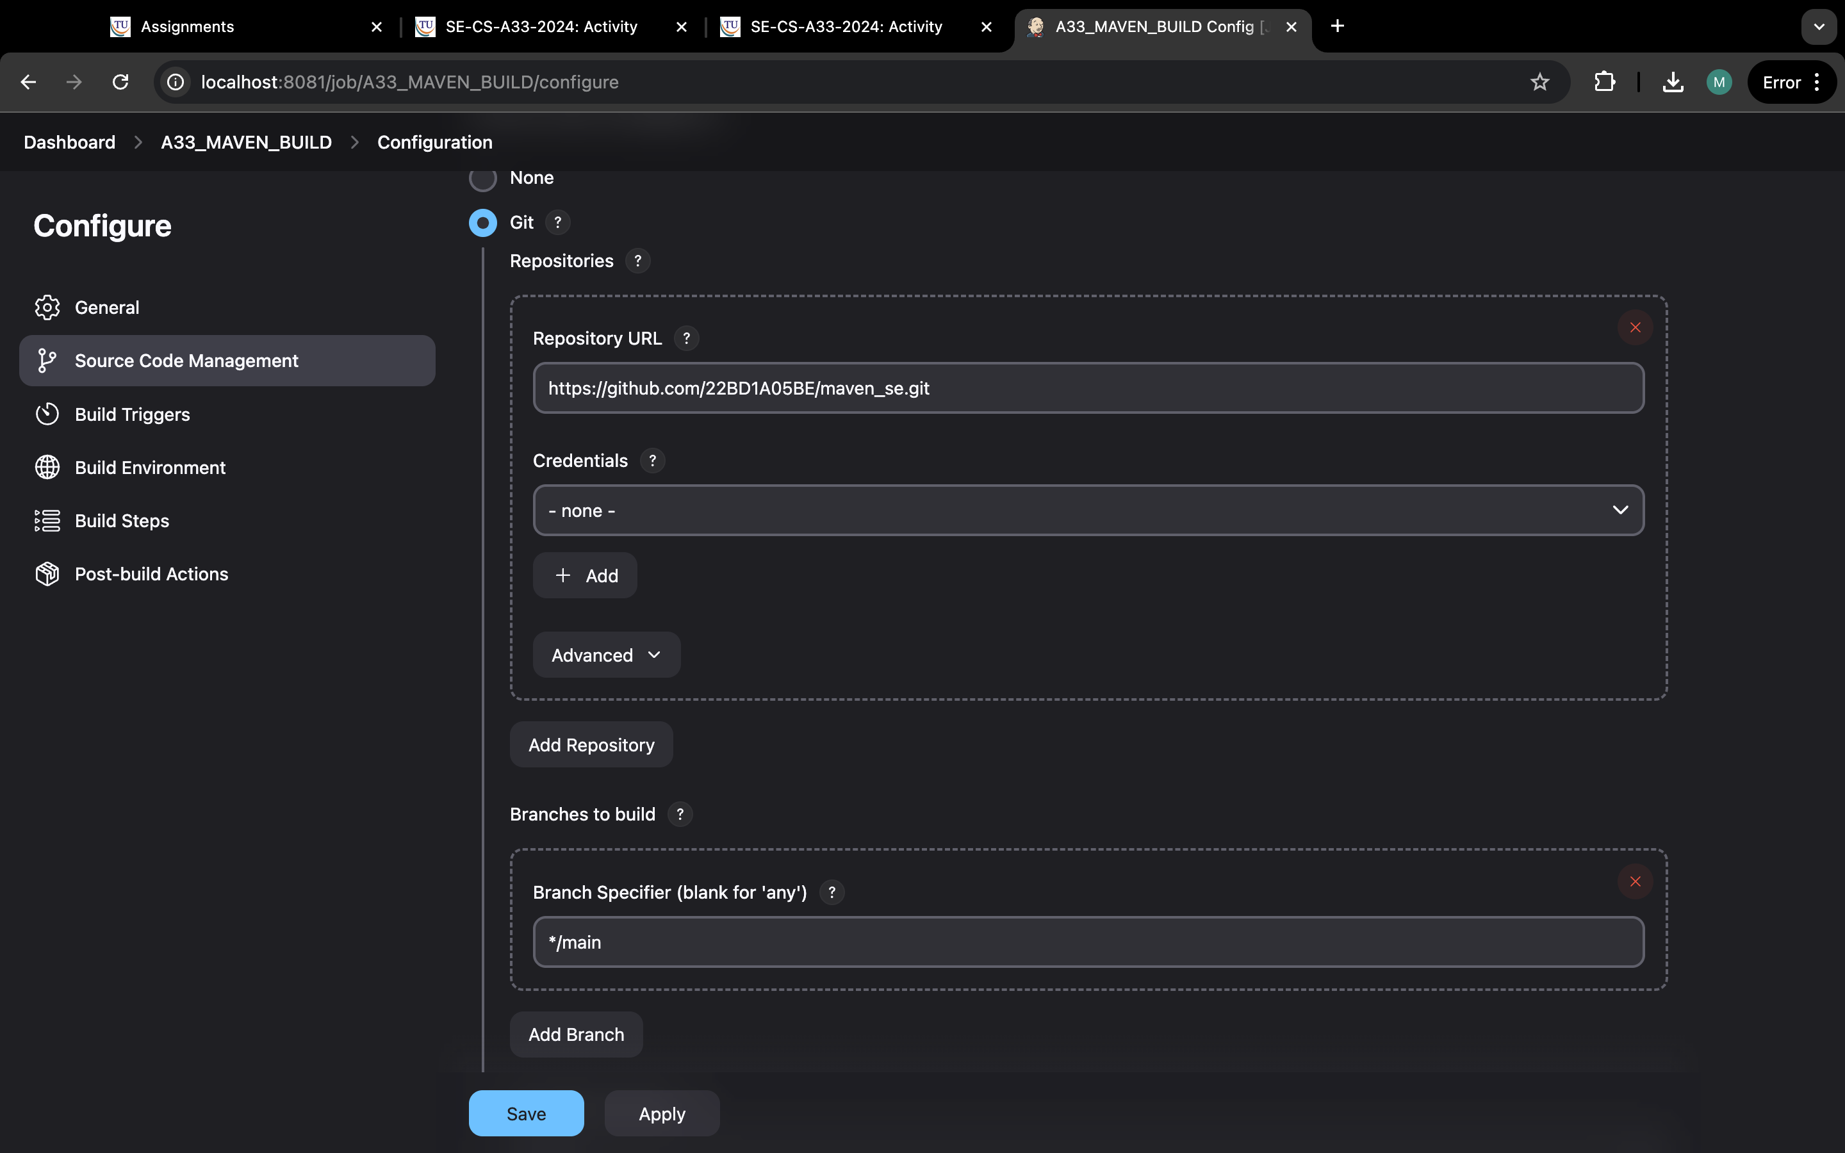

Step 6:check for which branch it is in.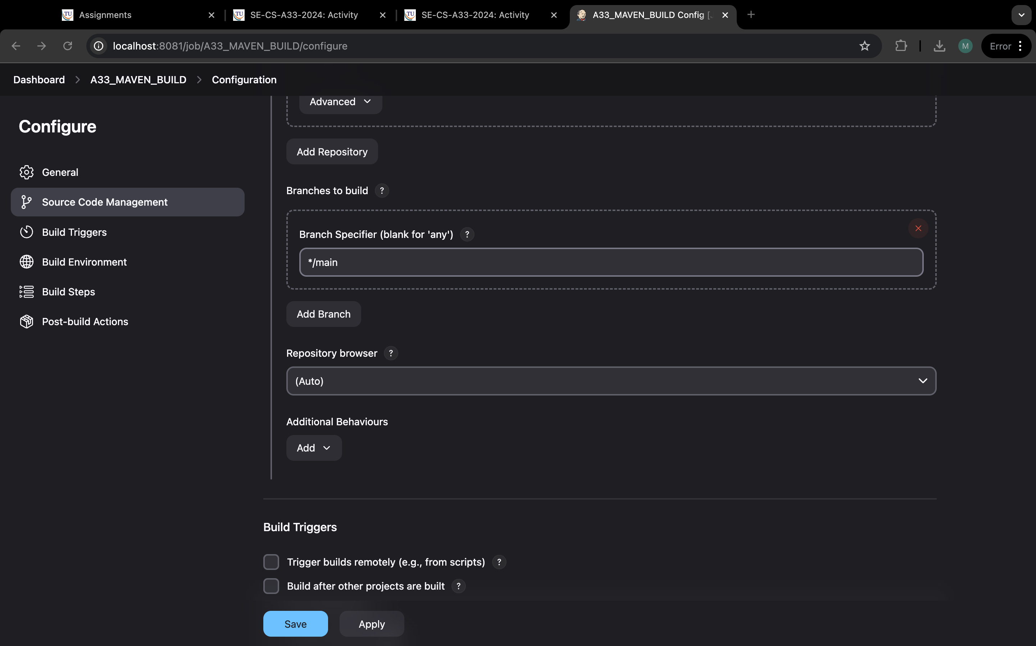

Step 7: go to build triggers and click on build periodically and type “H/5 * * * *”.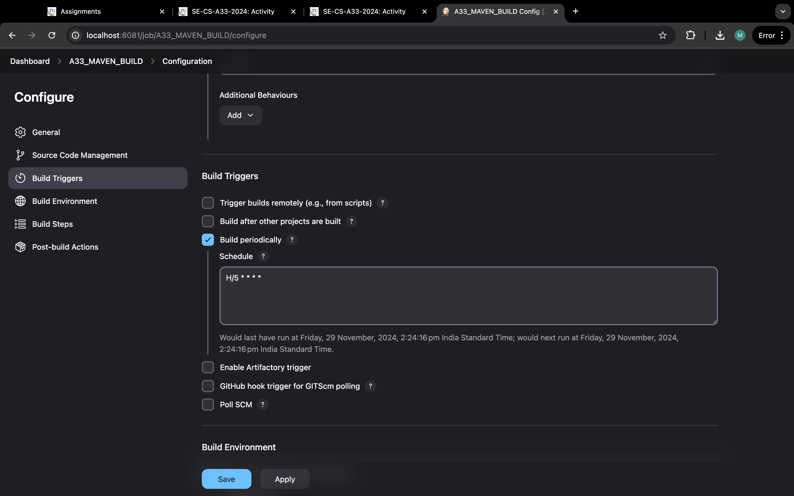

Step 8: Now go build environment and select delete workspace before build starts.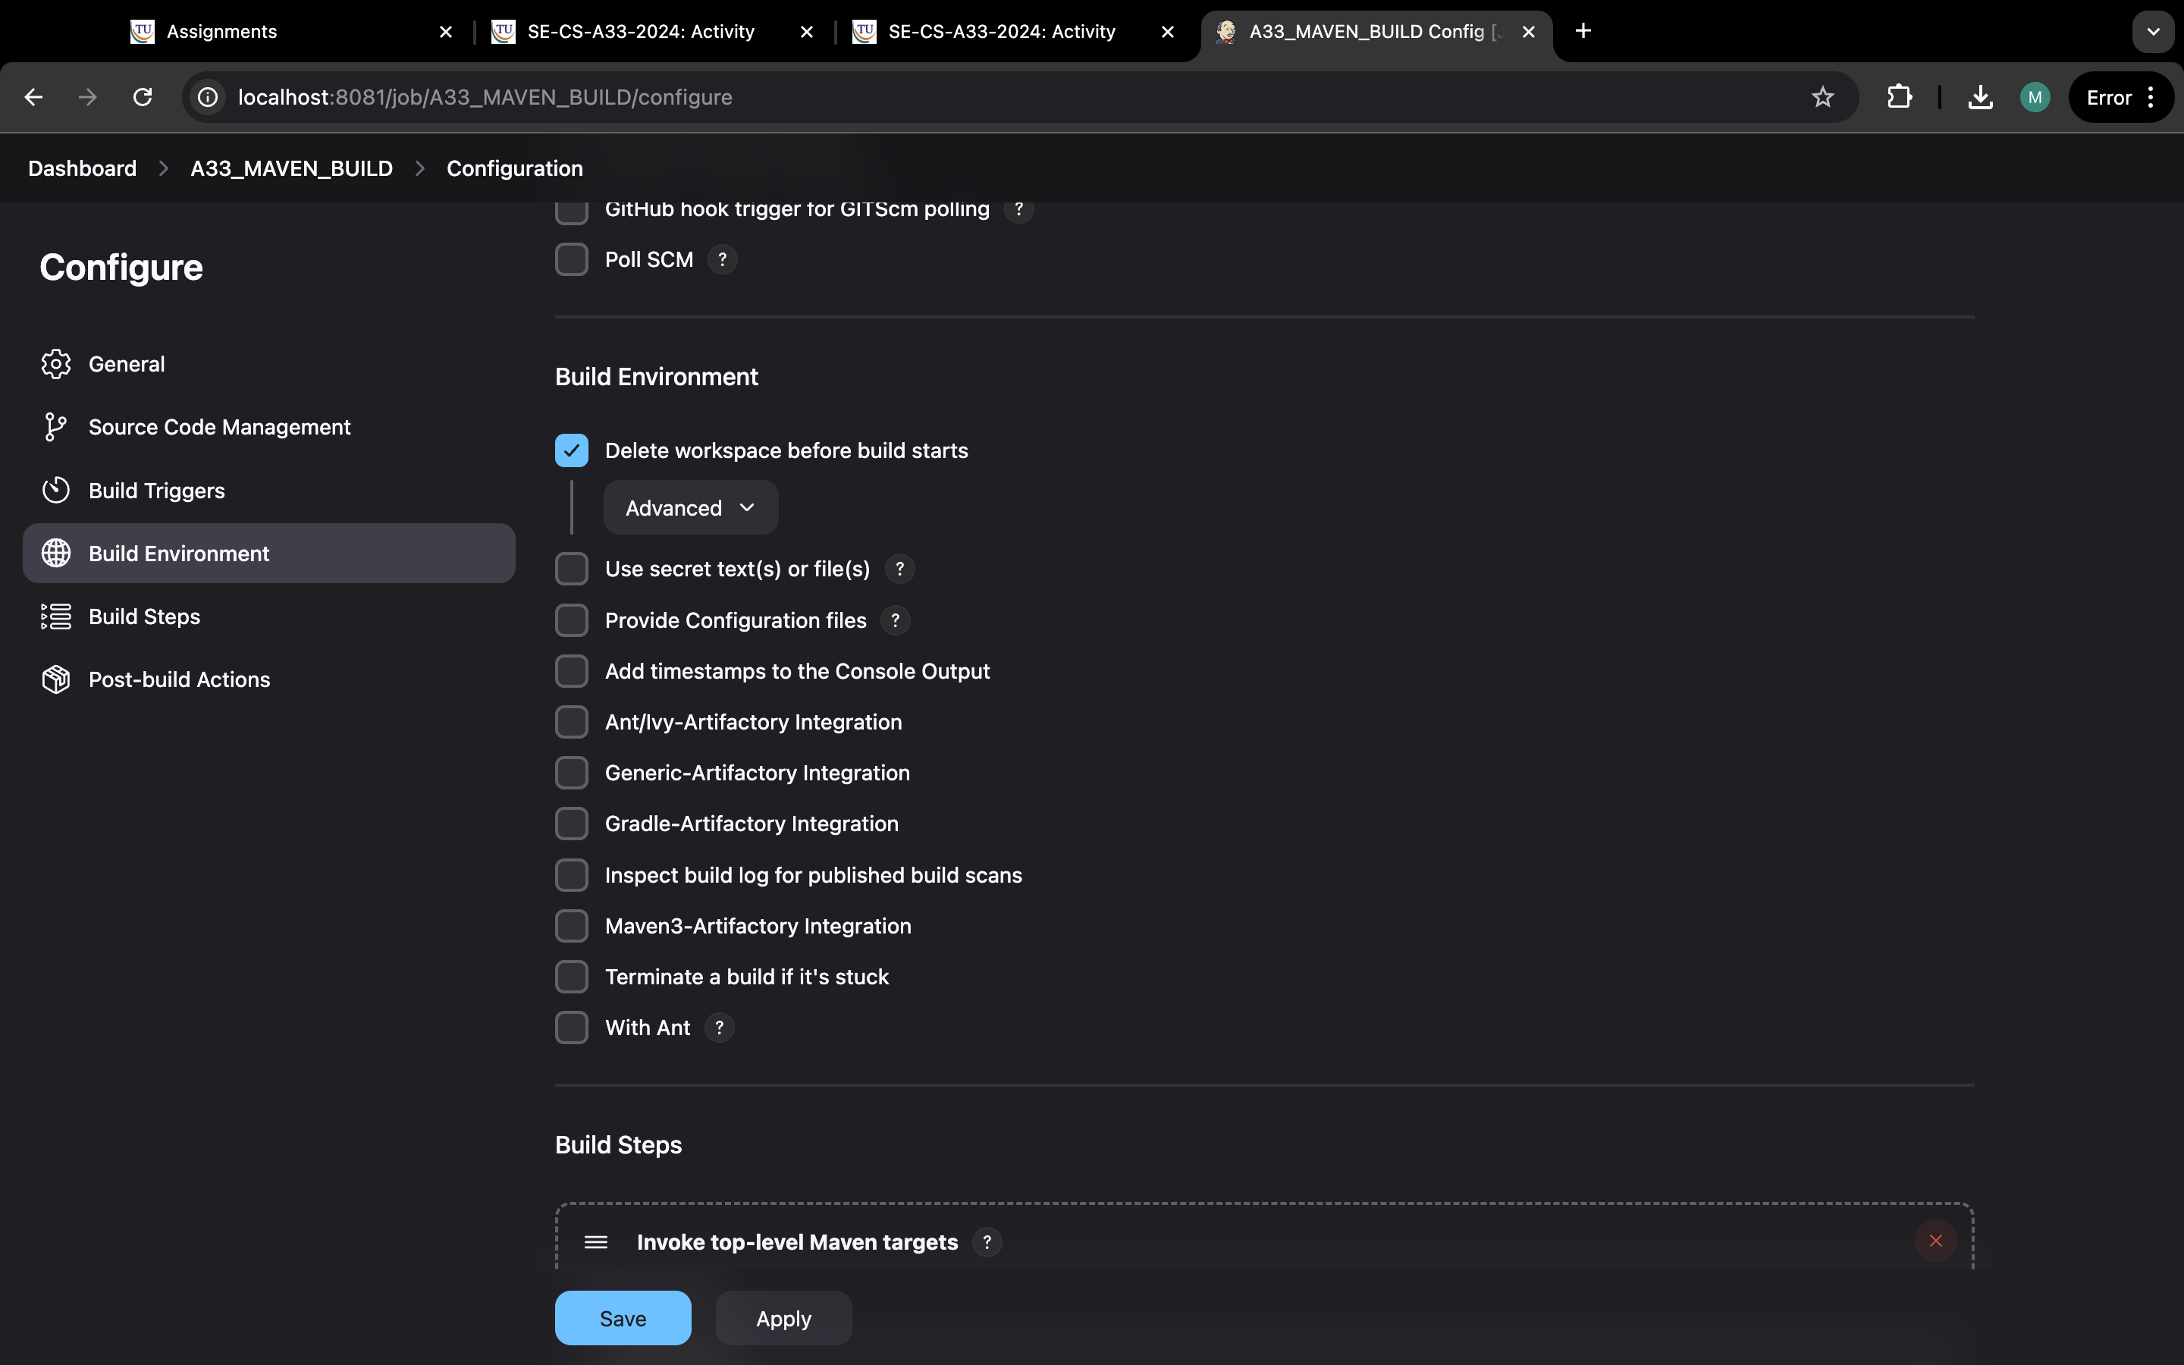

Step 9:click on build step and select invoke top-level maven targets.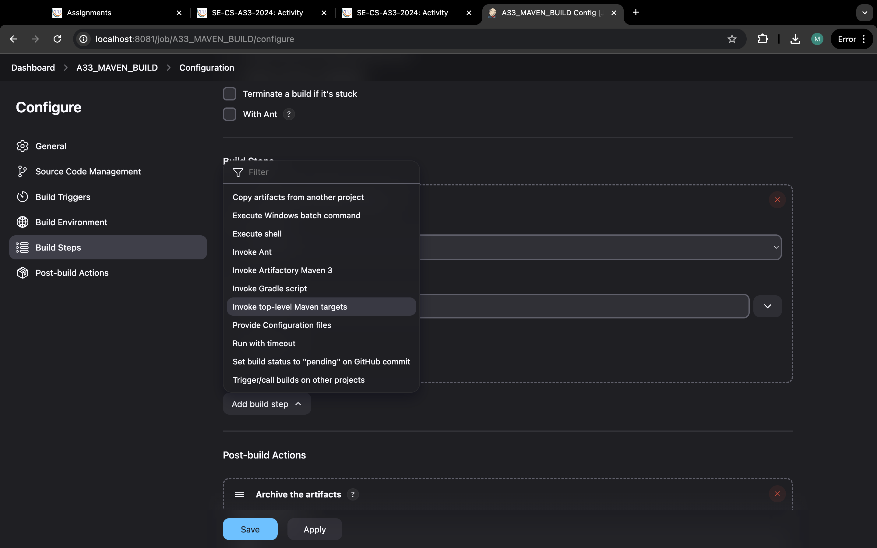

Step 10:select maven home and in goals type “clean install”.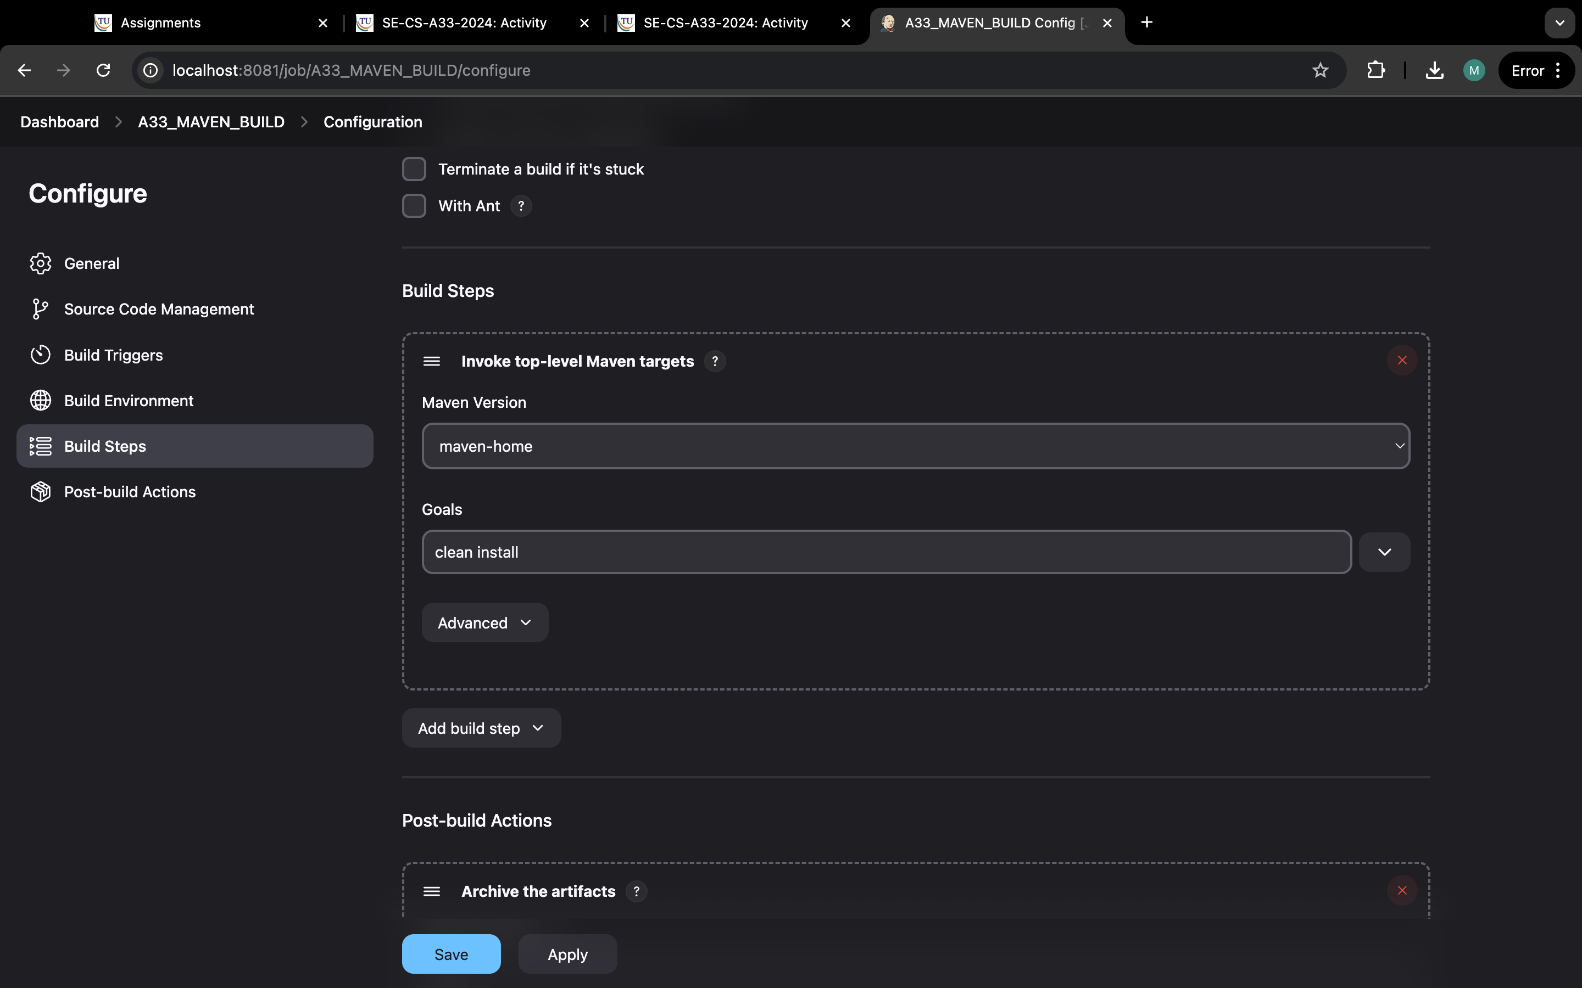

Step11:click in post build actions and select archive the artifacts.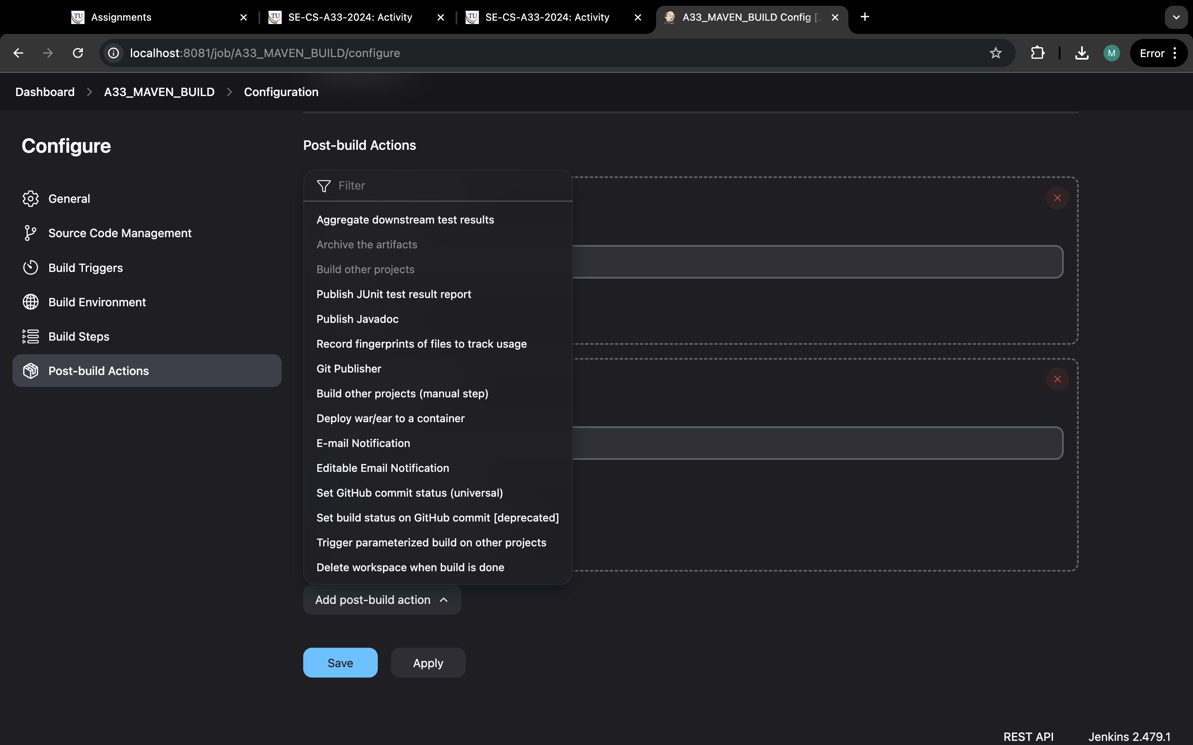

Step12:now, type “*/**”.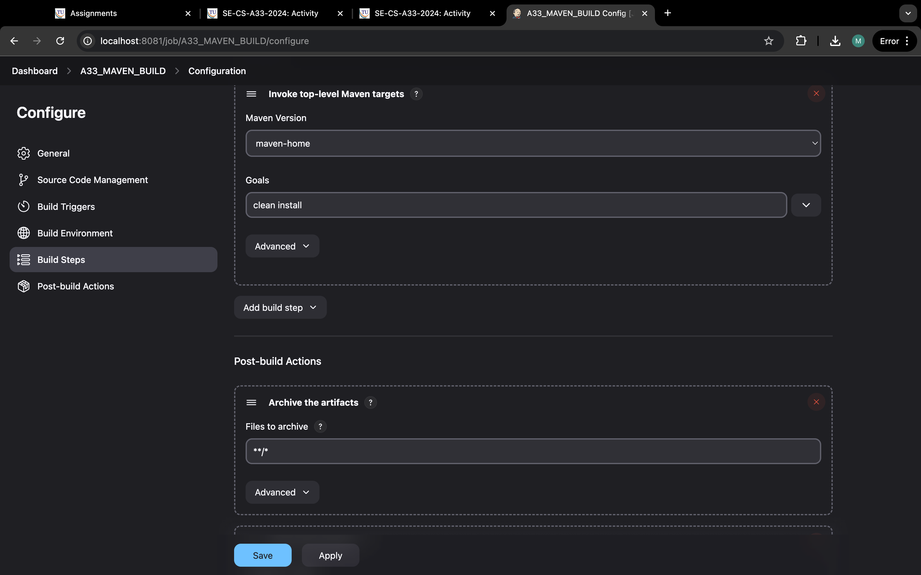

Step 13:Now, same but select build other projects.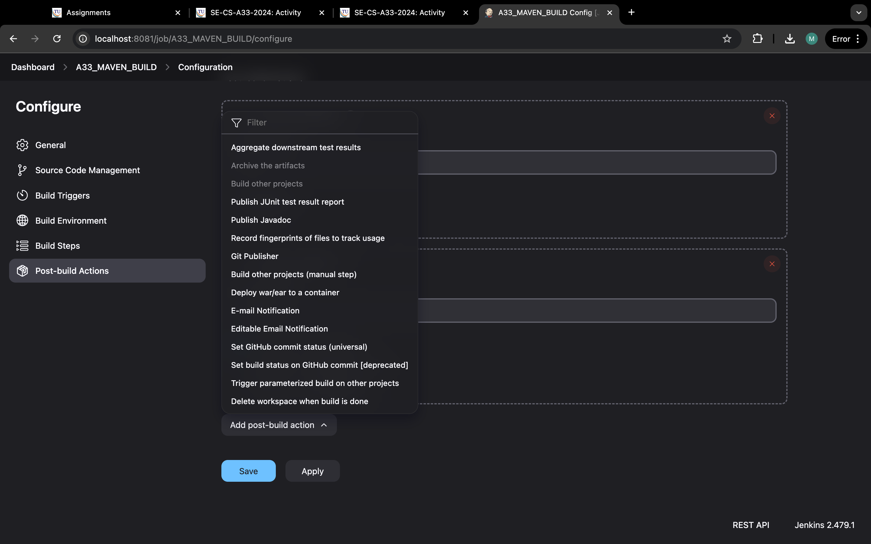

Step 14:type “a33-maven-test” and select tigger onlyif build is stable and apply and save.

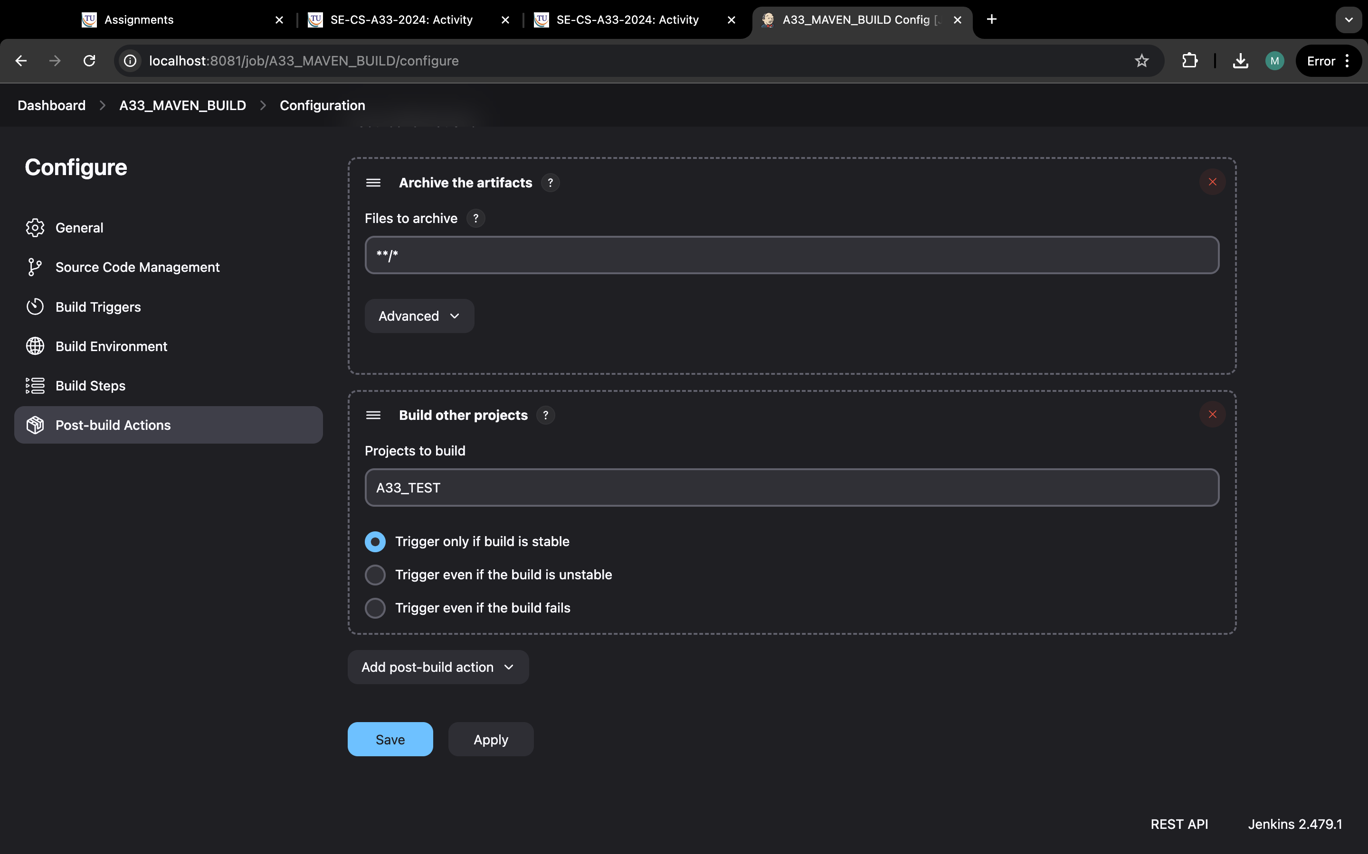

Step 15: it should look link this.

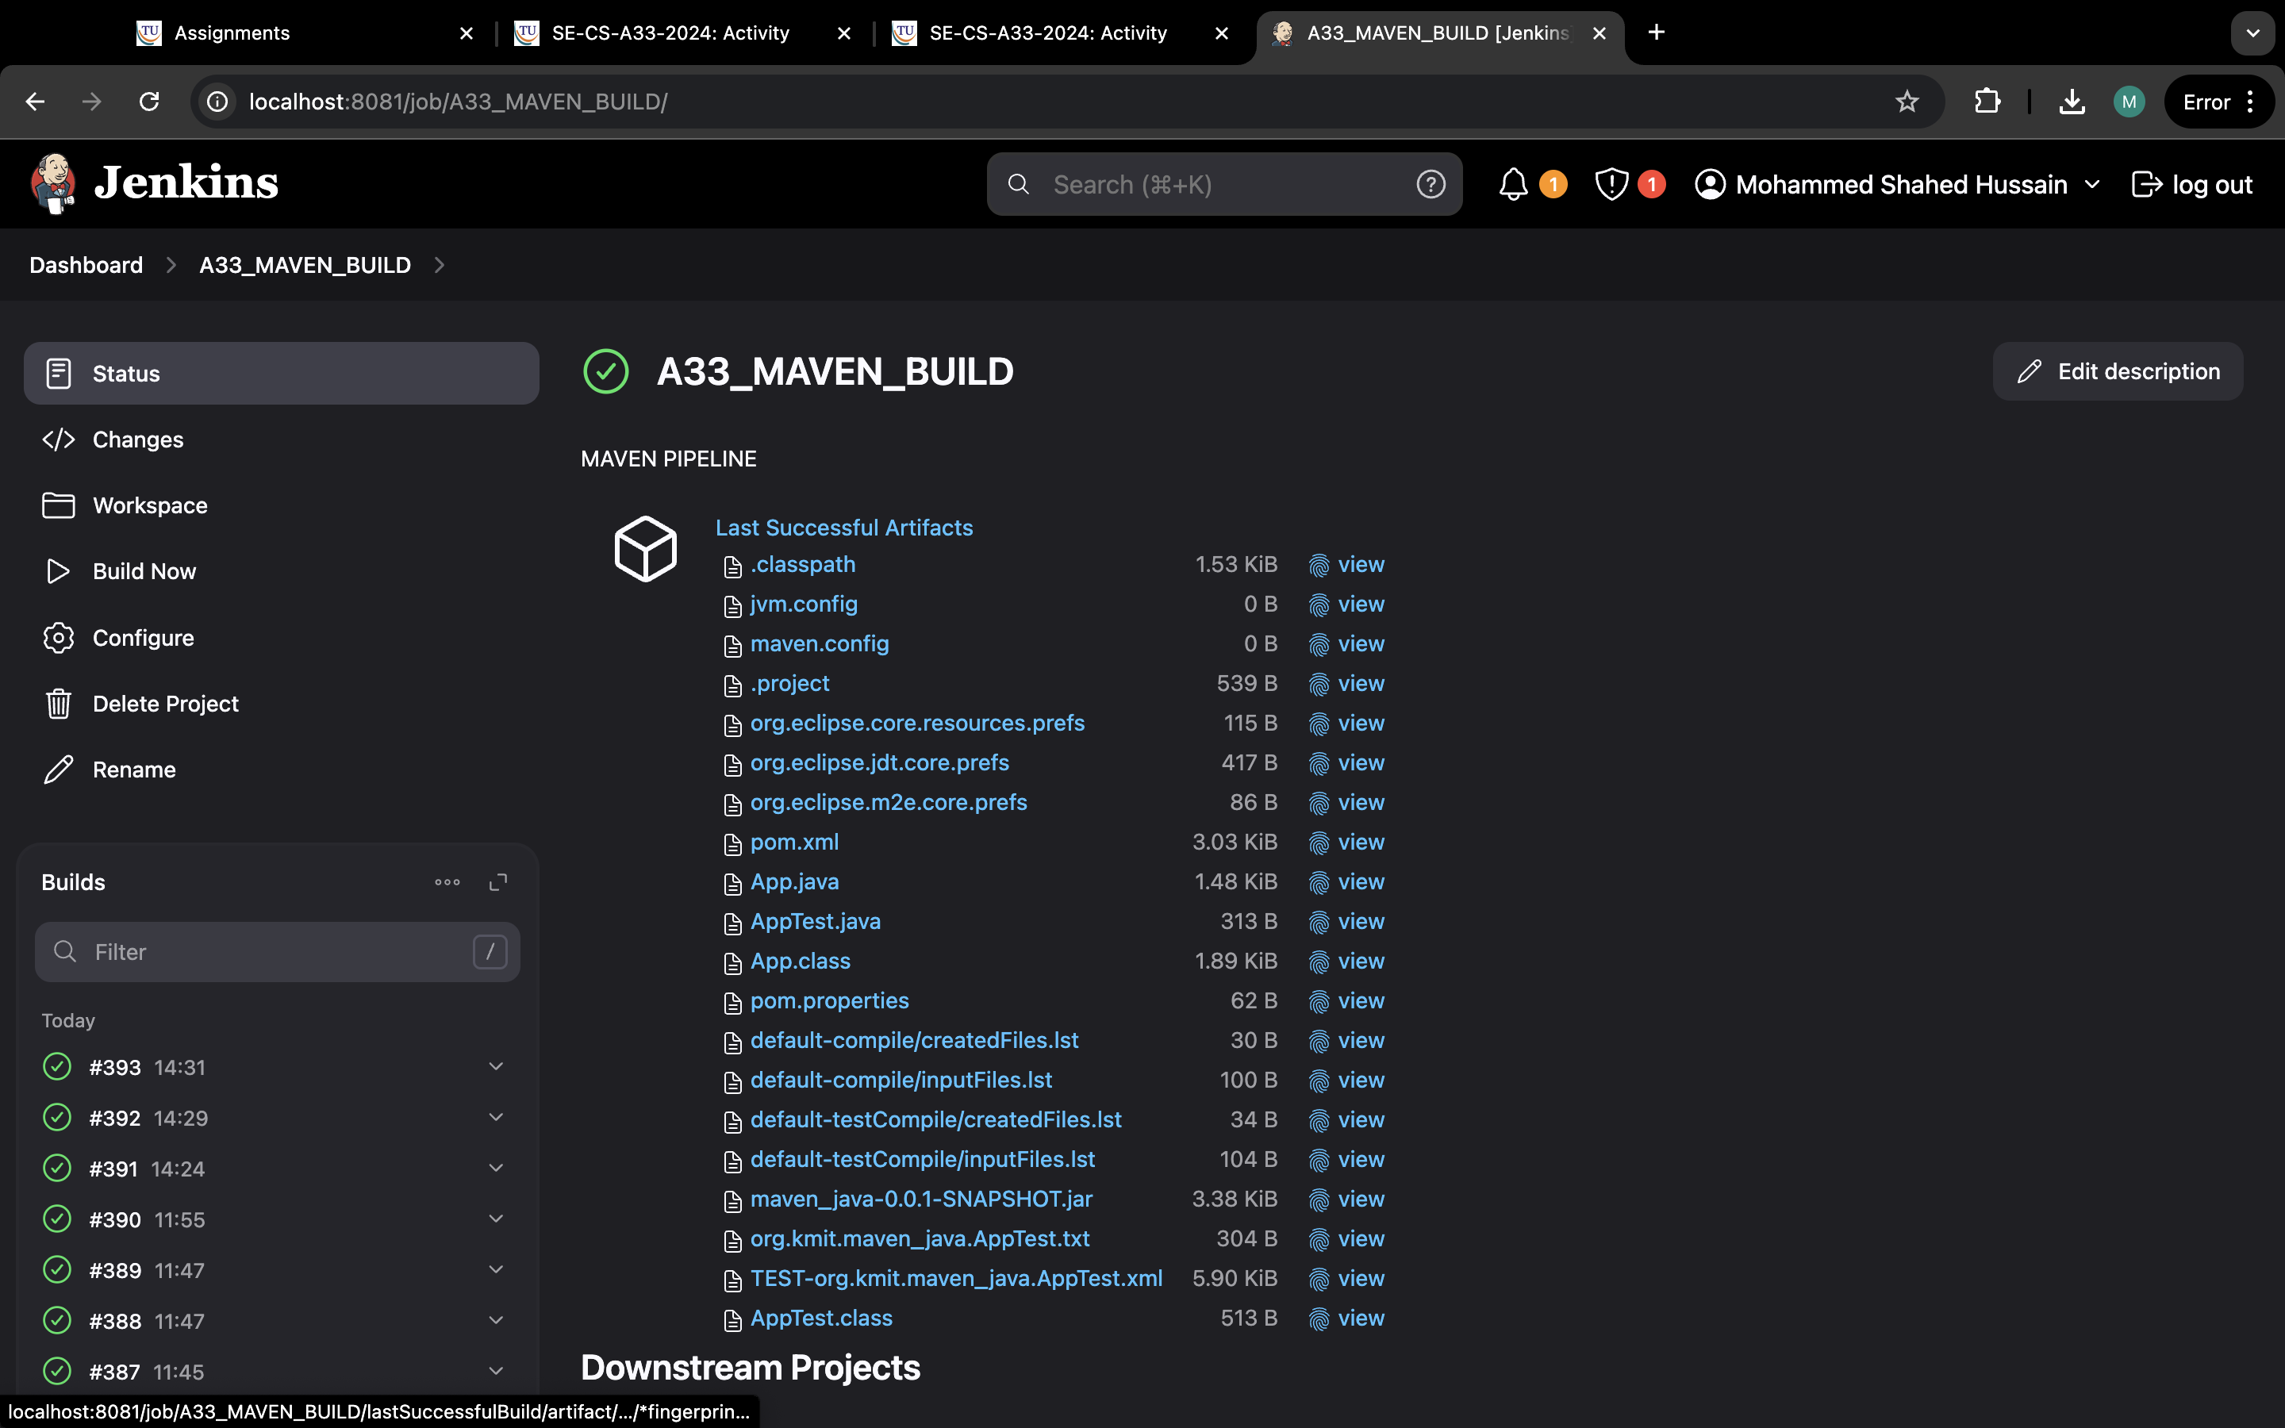

Step 16: now we make “maven-test” and click on new item.

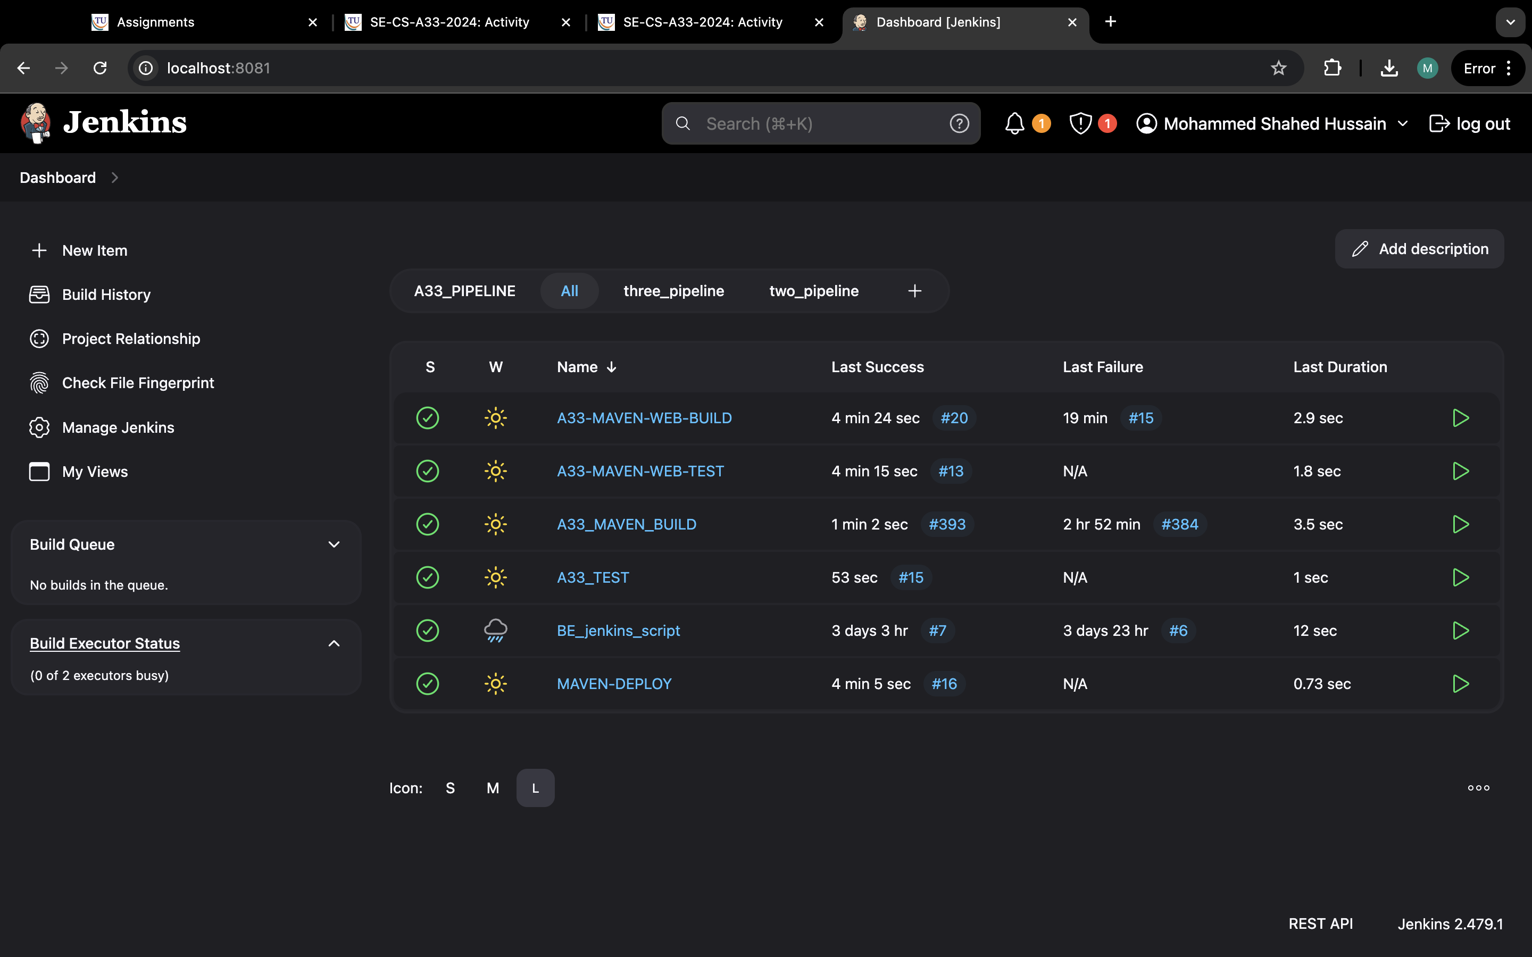

Step 17: now type a33-maven-web-test and select free style and ok.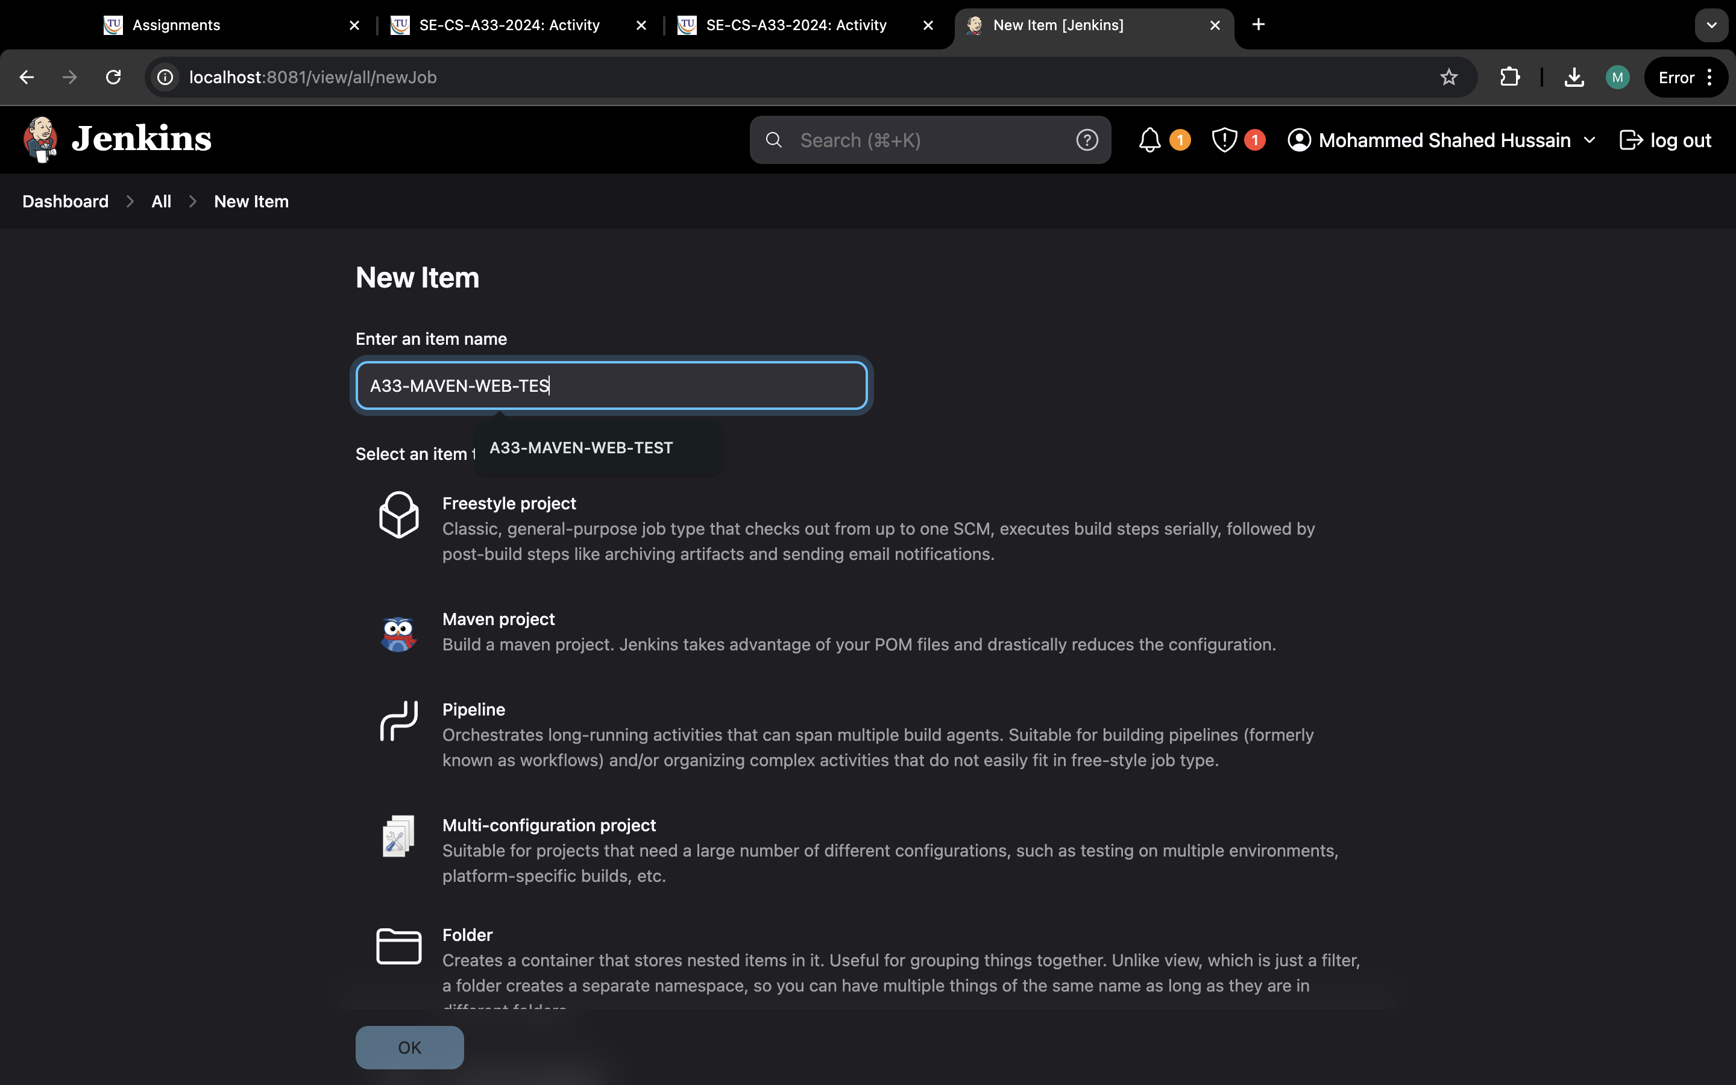

Step 18:now in source code management and select none.

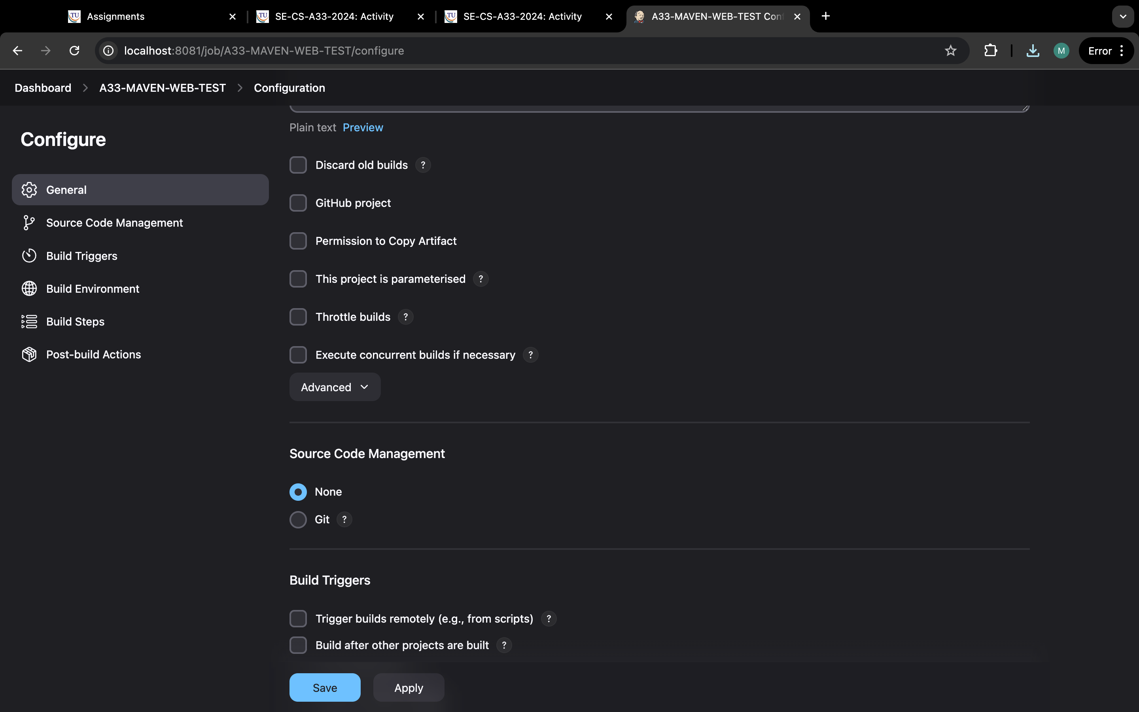

Step 19: go to build environment and select delete workspace.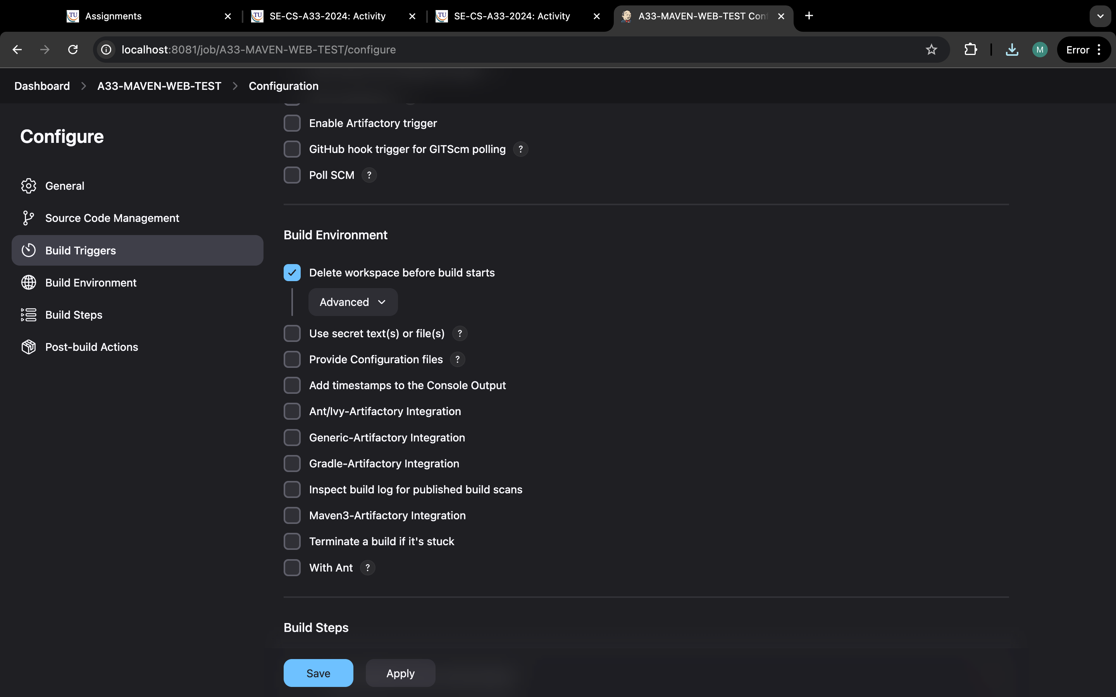

Step 20:go to build steps and select invoke top-level and select maven-home and in goals type test.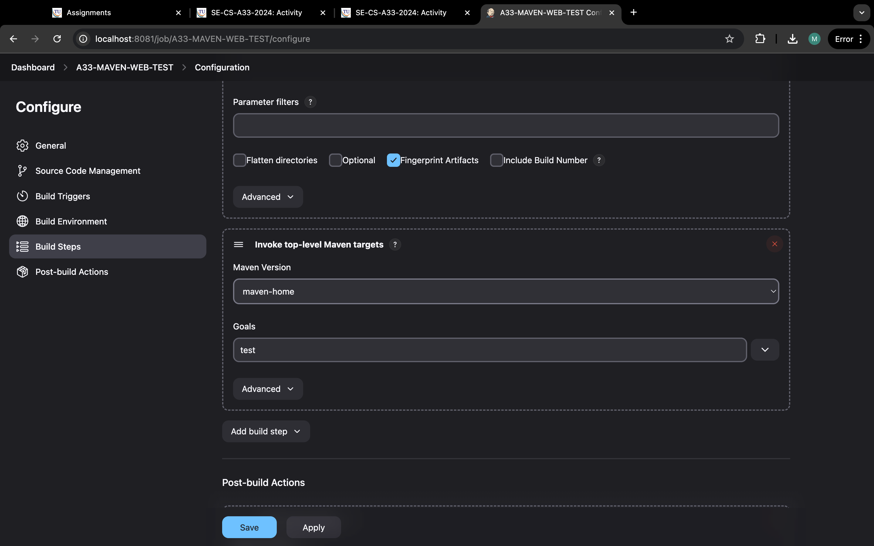

Step 21: same step but select copy artifacts and select maven build and type “*/**’ in artifacts to copy .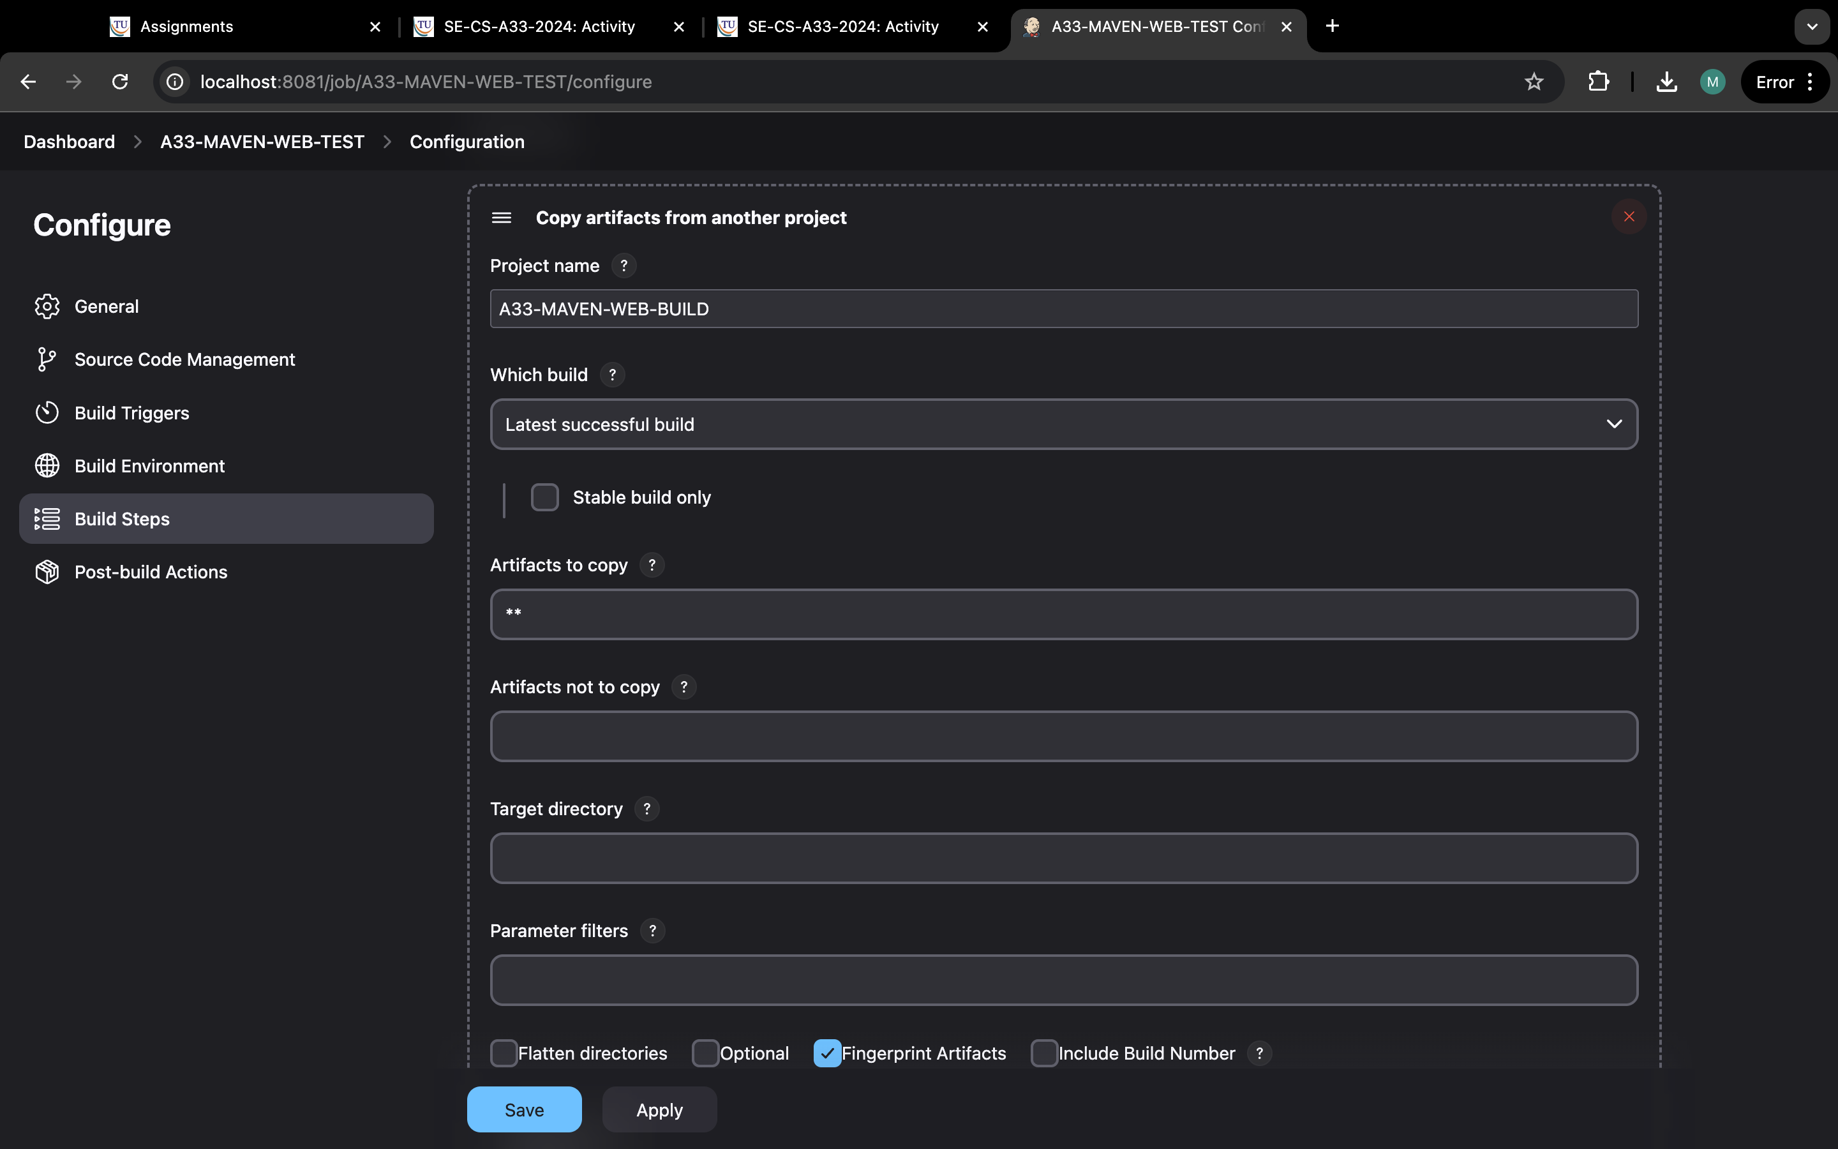

Step 22: got post build and select to archive the artifacts and type “*/**” and apply and save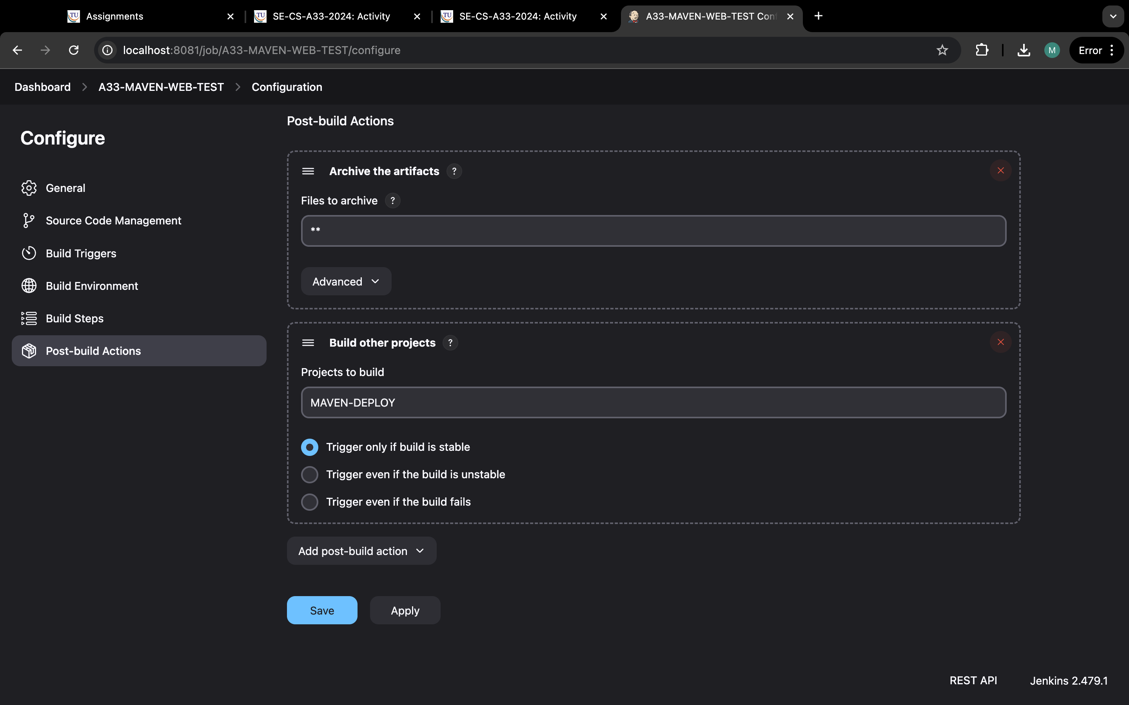

.

Step 23:go to dashboard and click on + to create pipeline.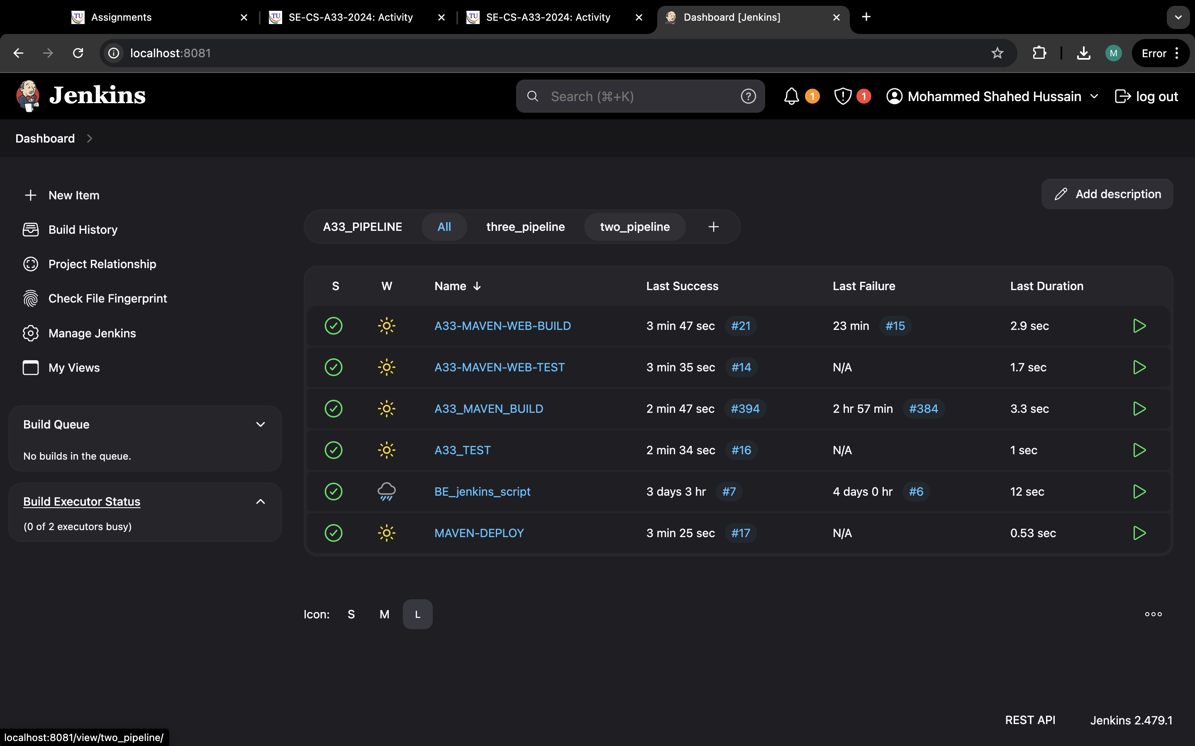

Step 24: name it and select the maven build and apply and ok.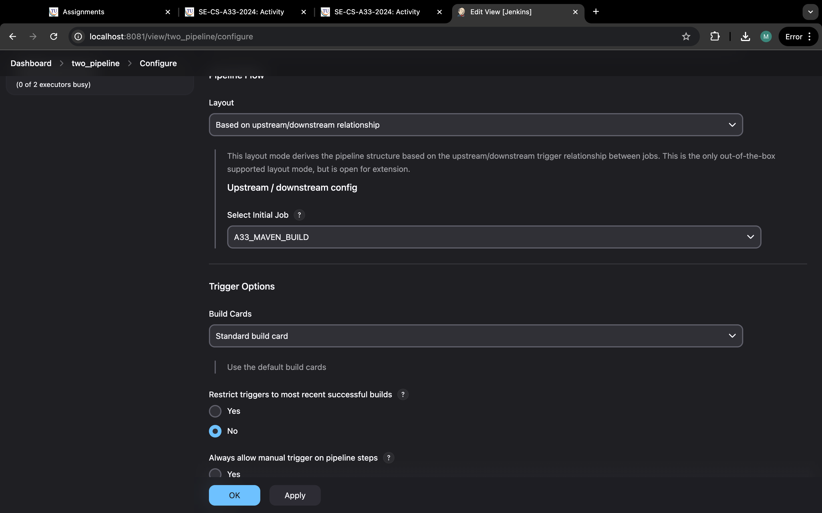

Step 25:this two pipeline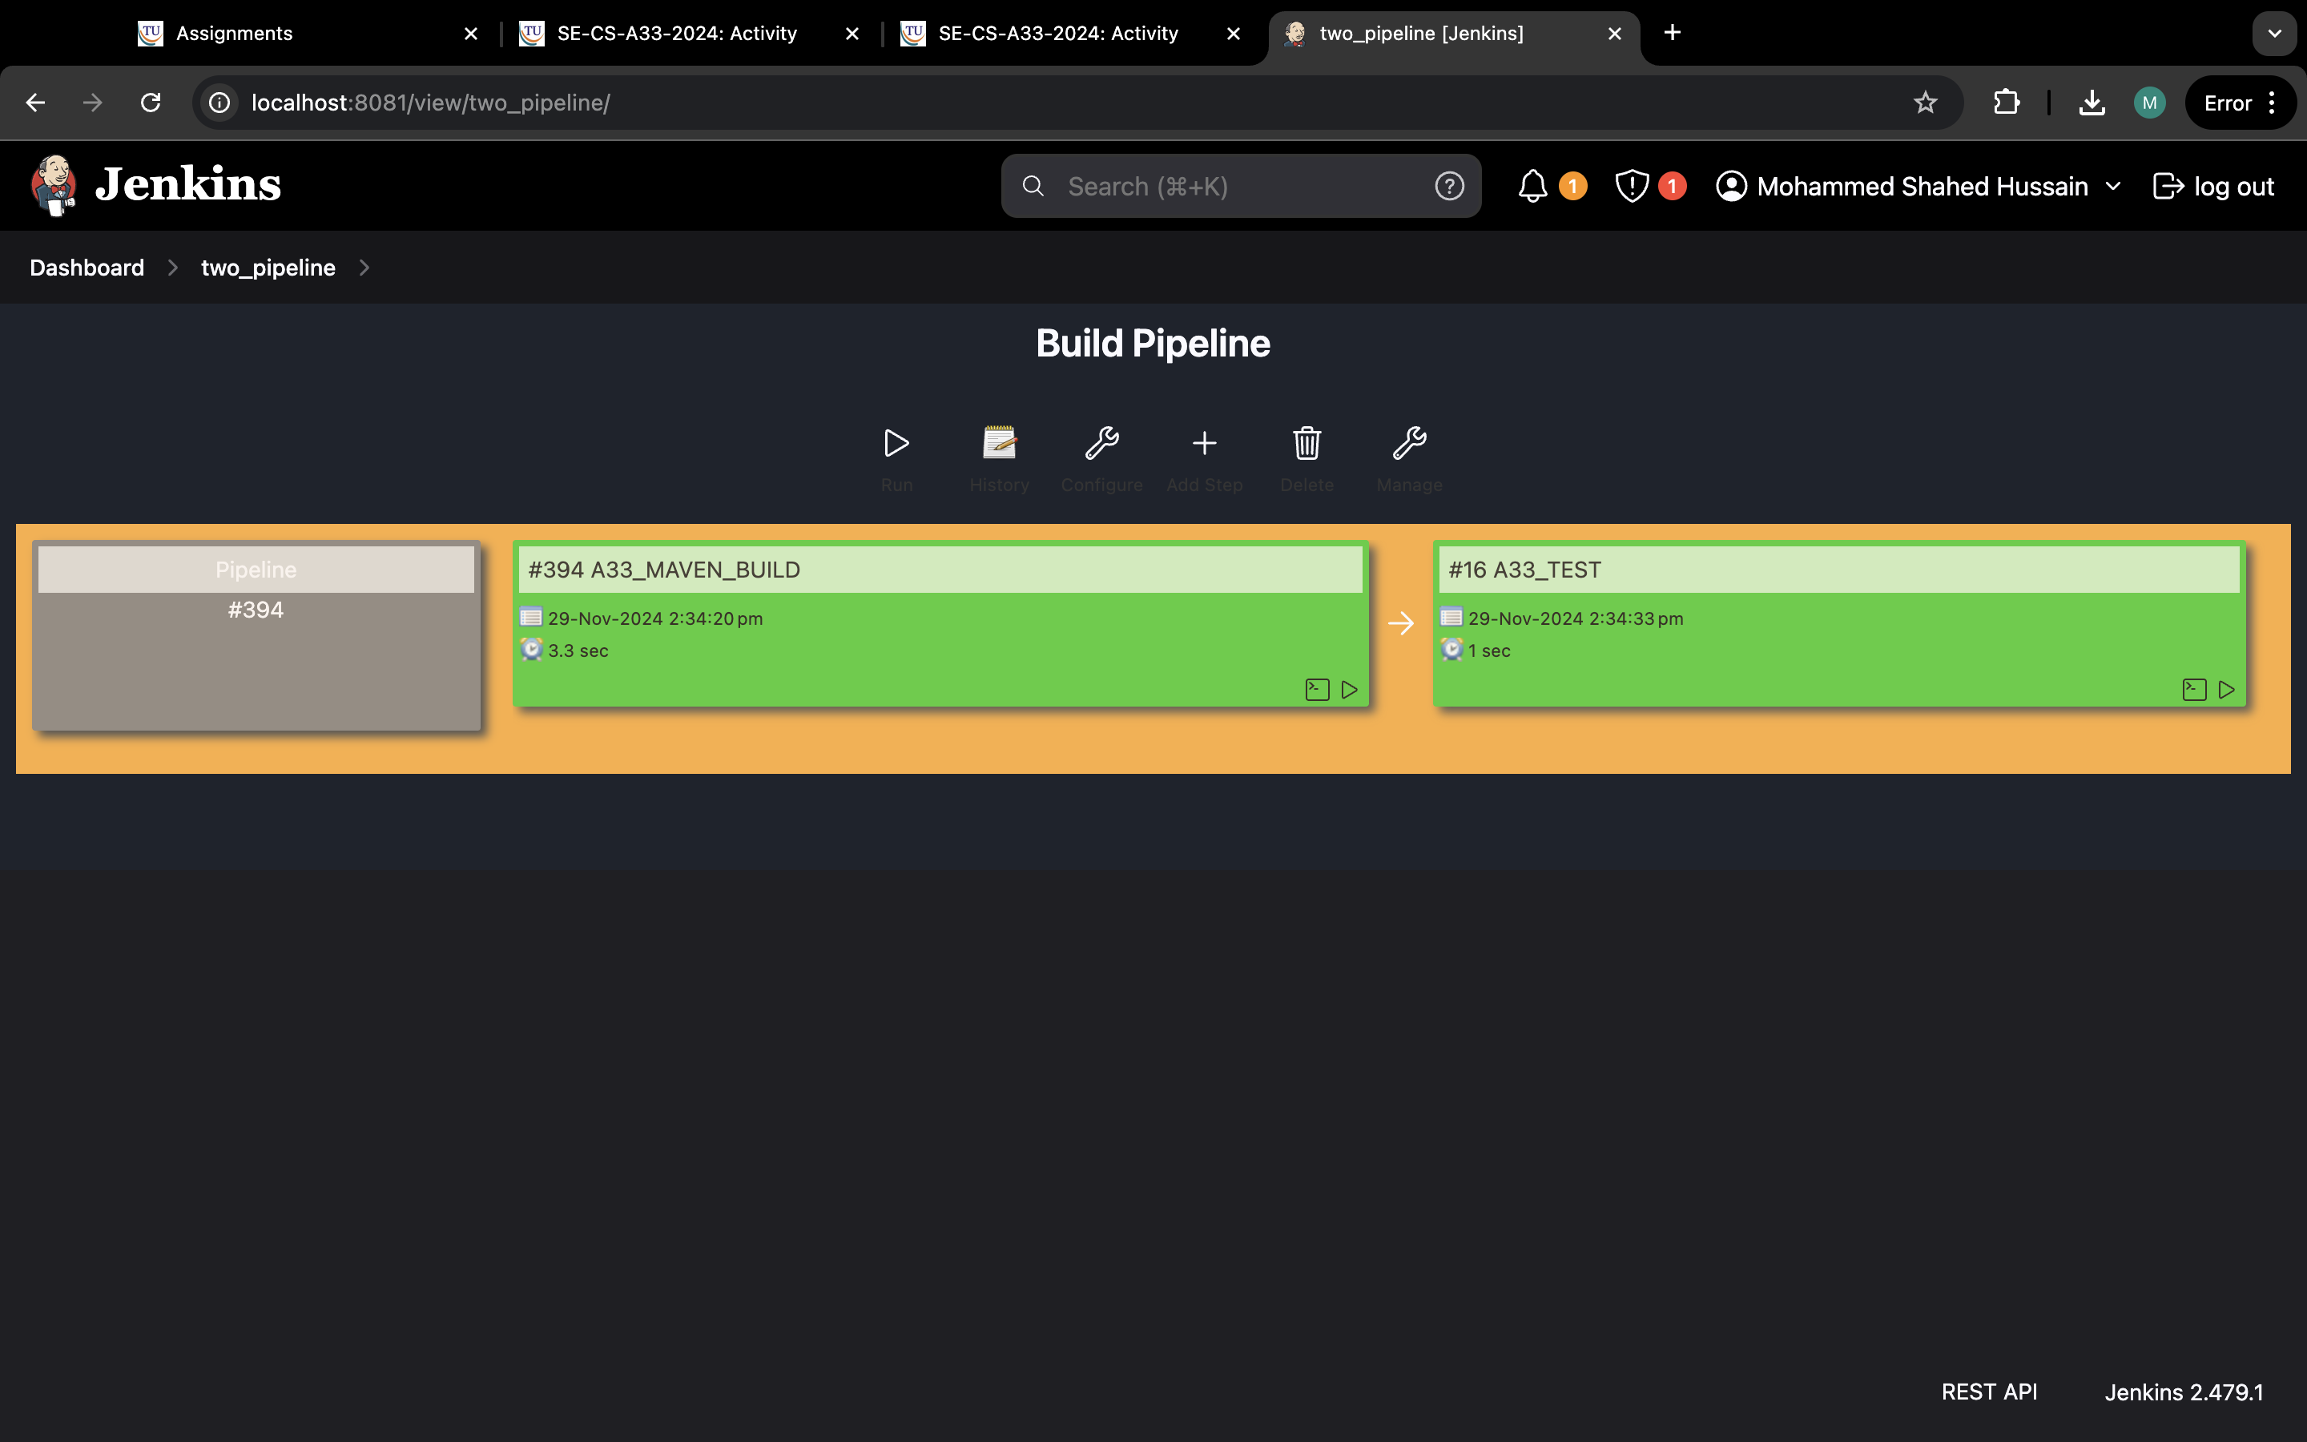

# Creating three pipeline in Jenkins

Step 1:open Jenkins and click on new item.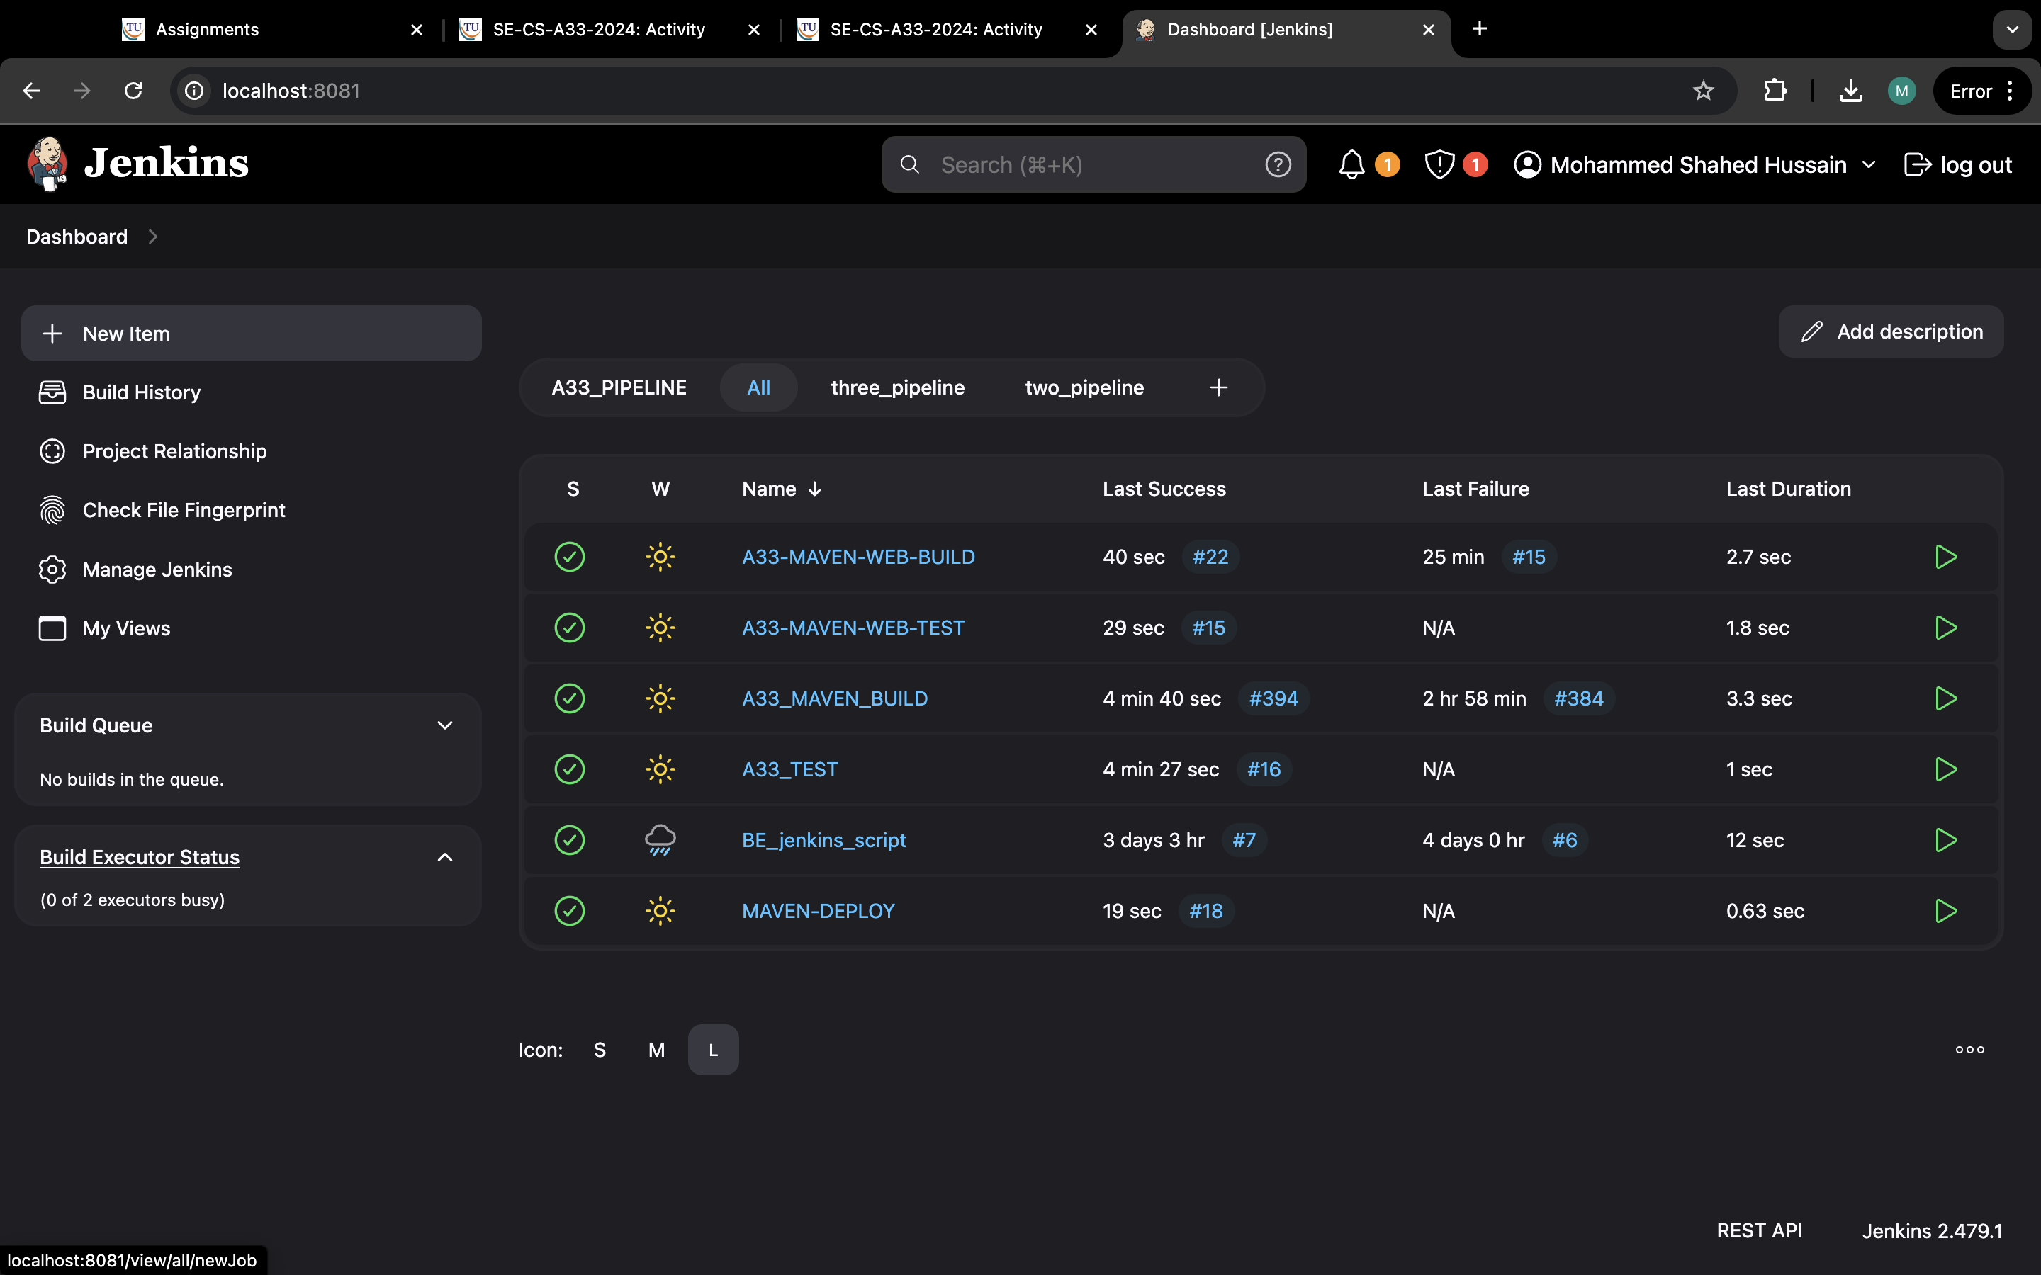

Step 2: enter the item as “name-build” and select freestyle and ok.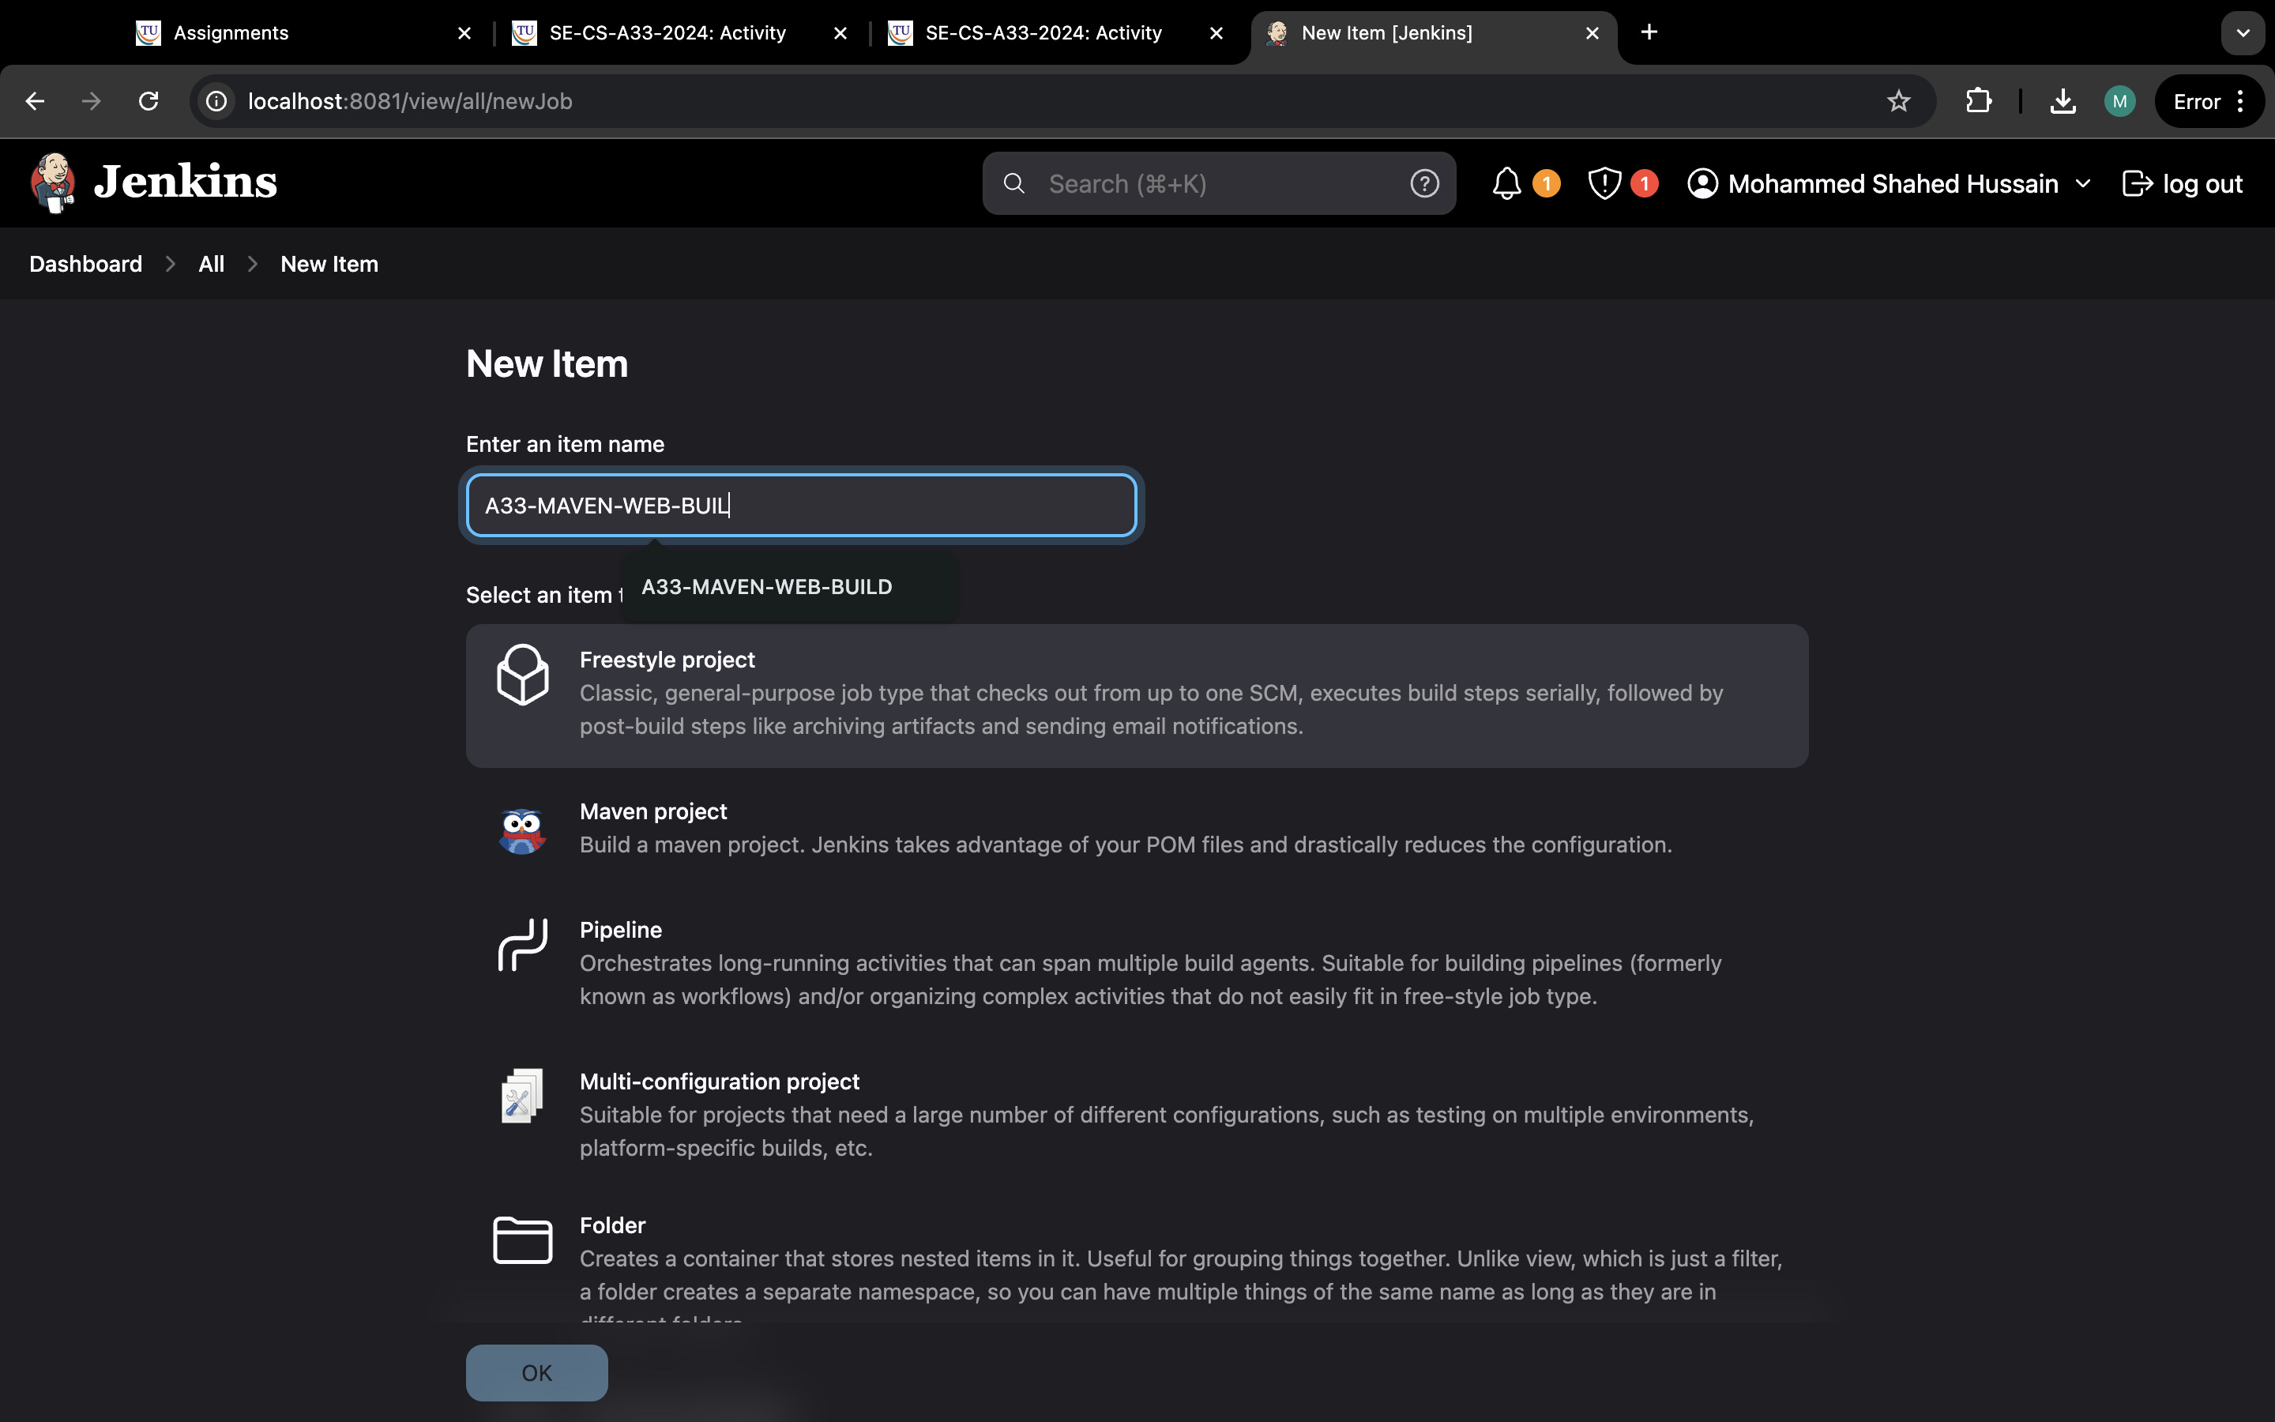

Step 3: Now go to GitHub and copy the https link from code.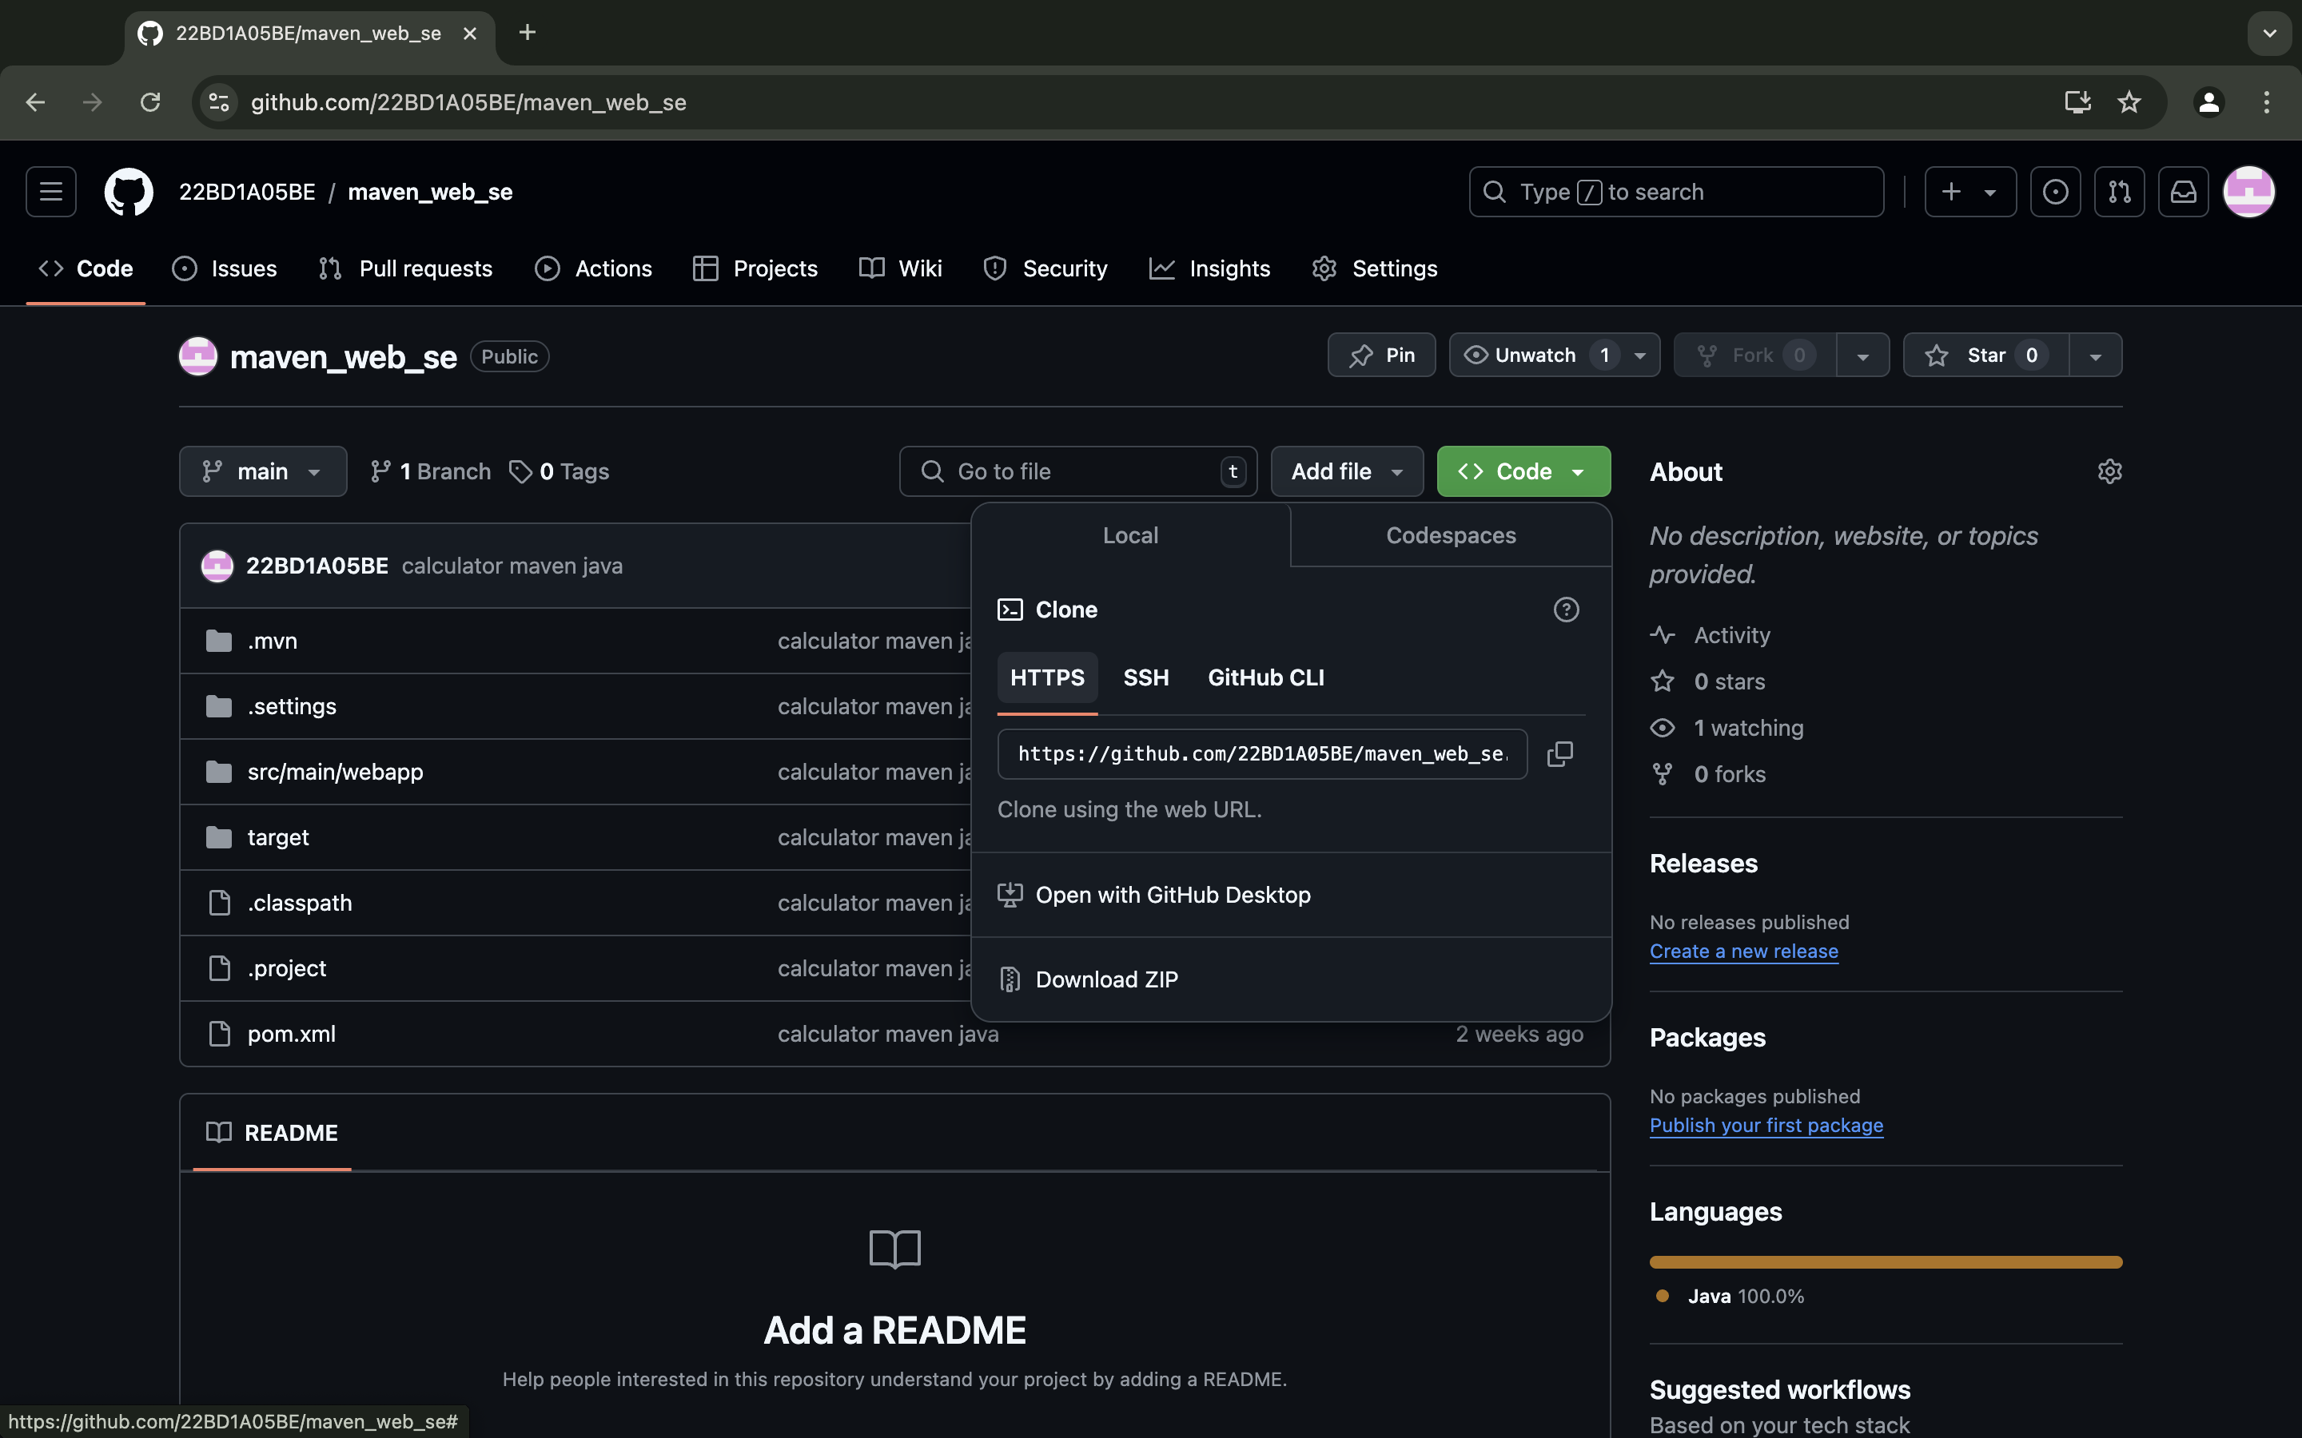

Step 4: write something in description.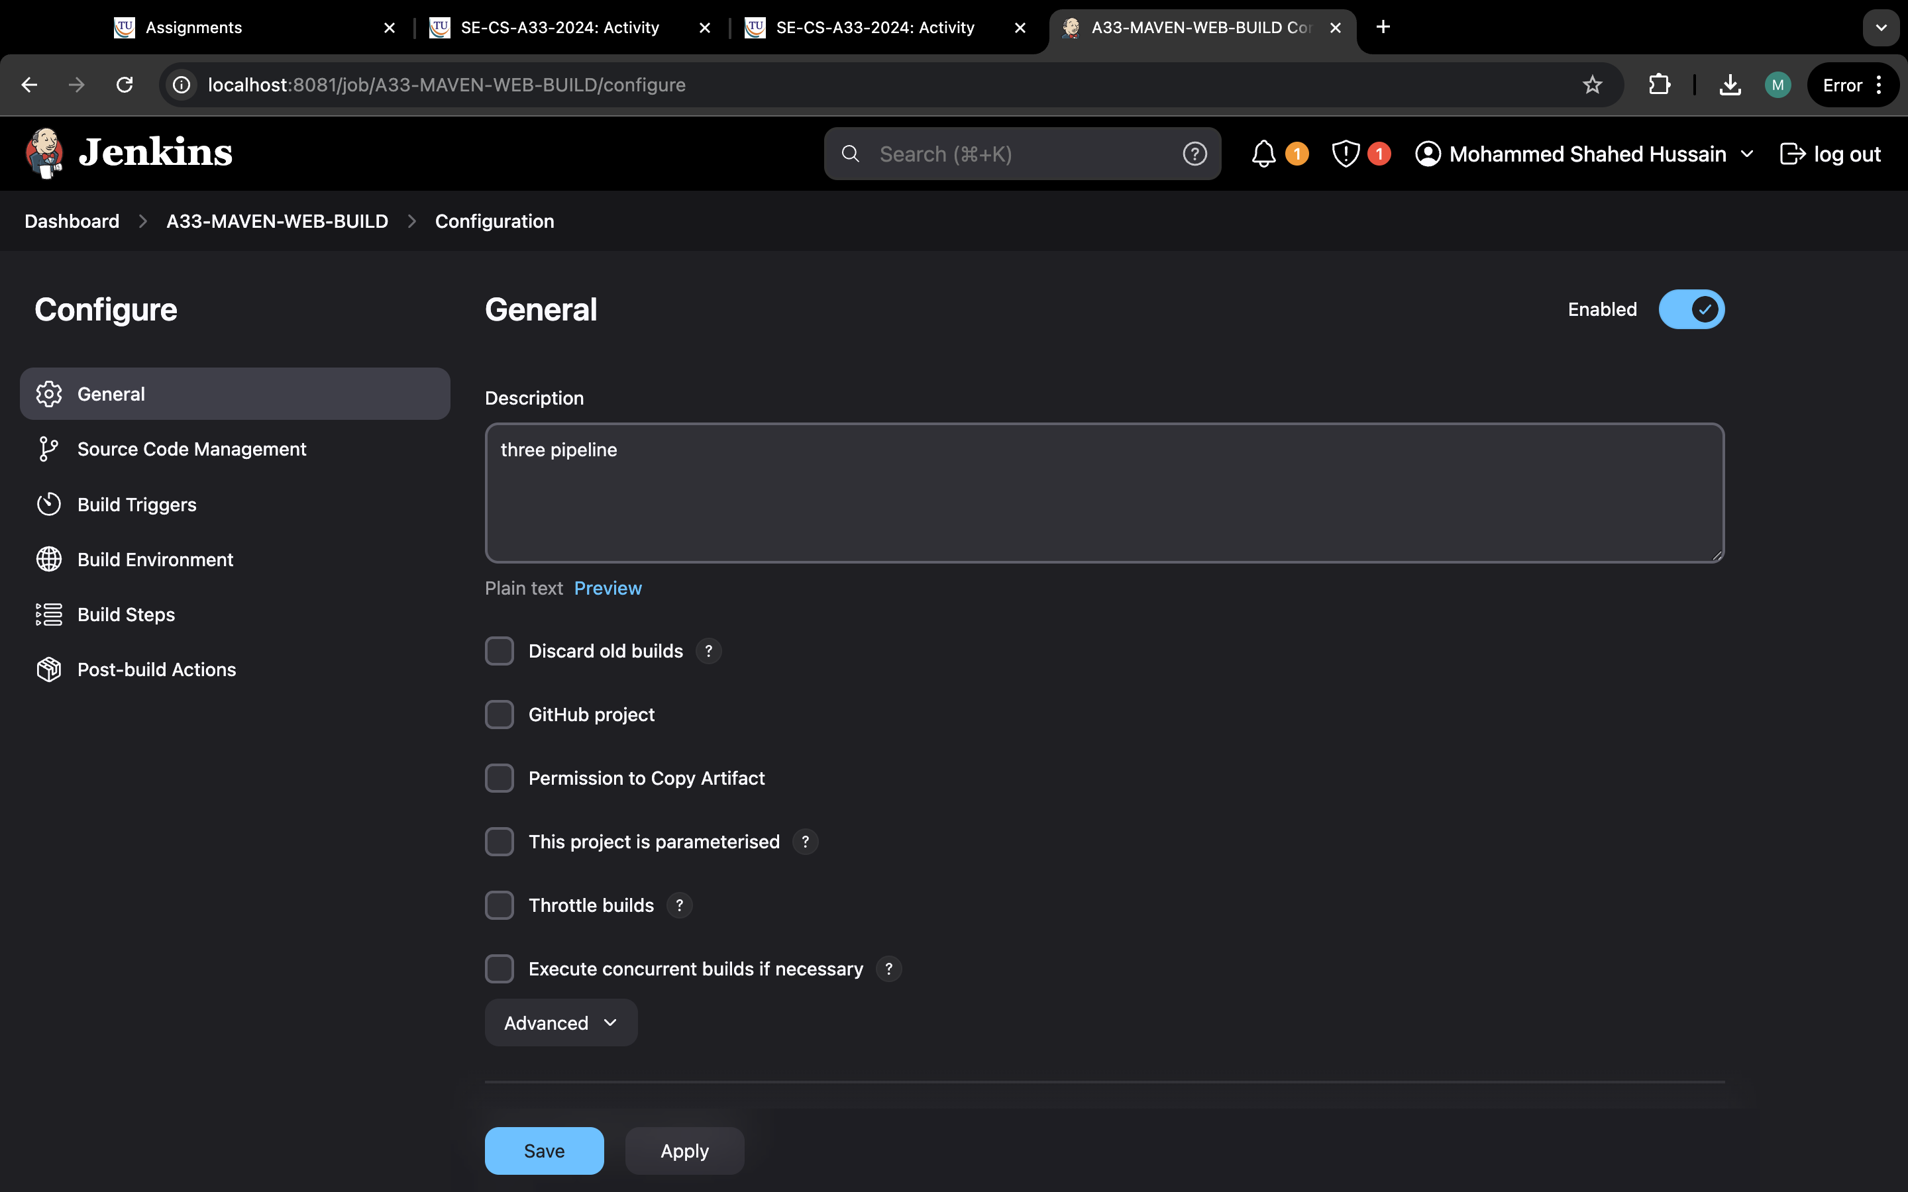

Step 5: paste the link in repository URL.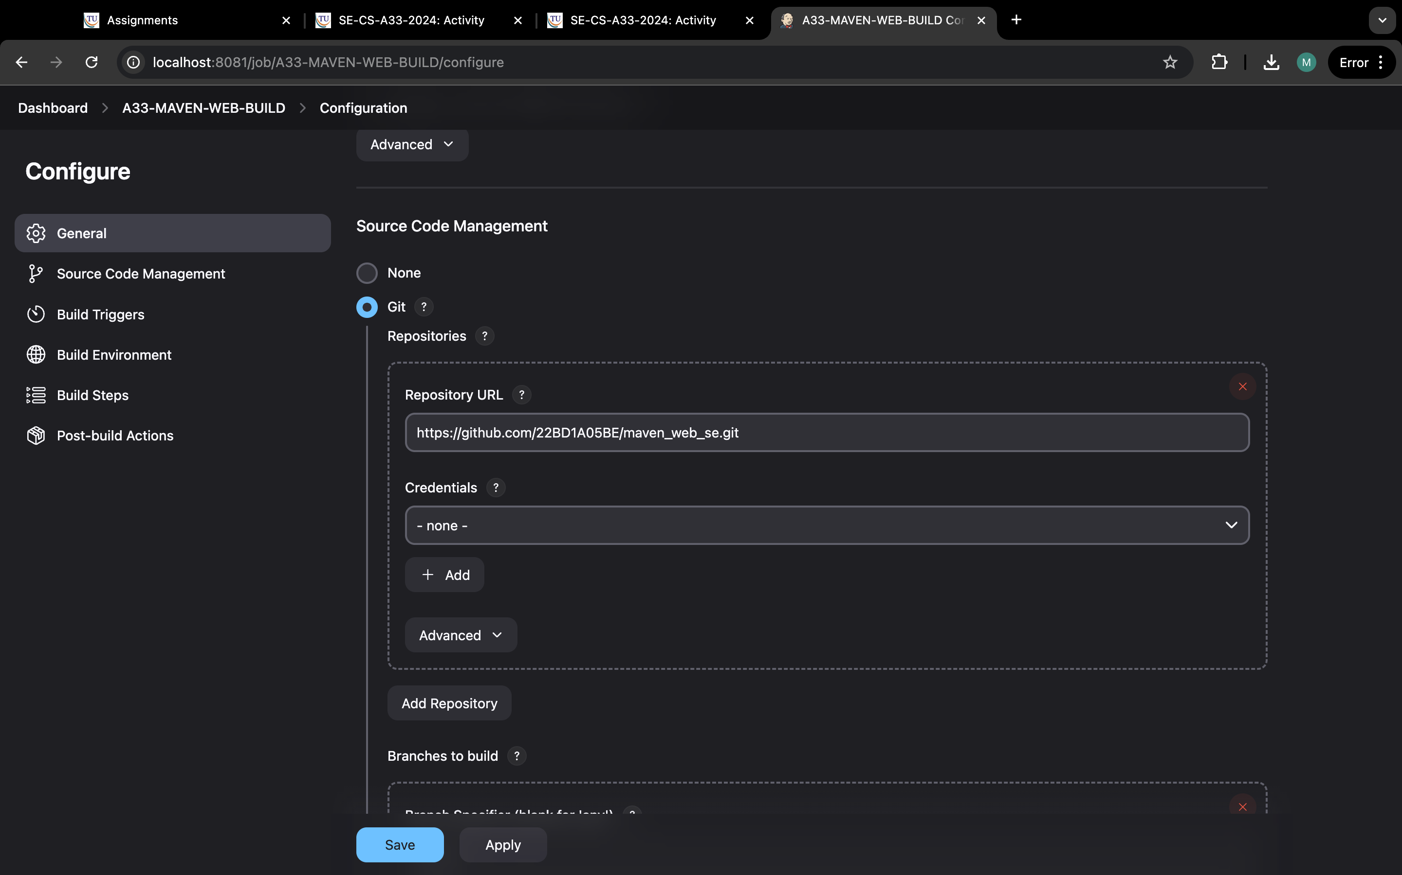

Step 6:check for which branch it is in.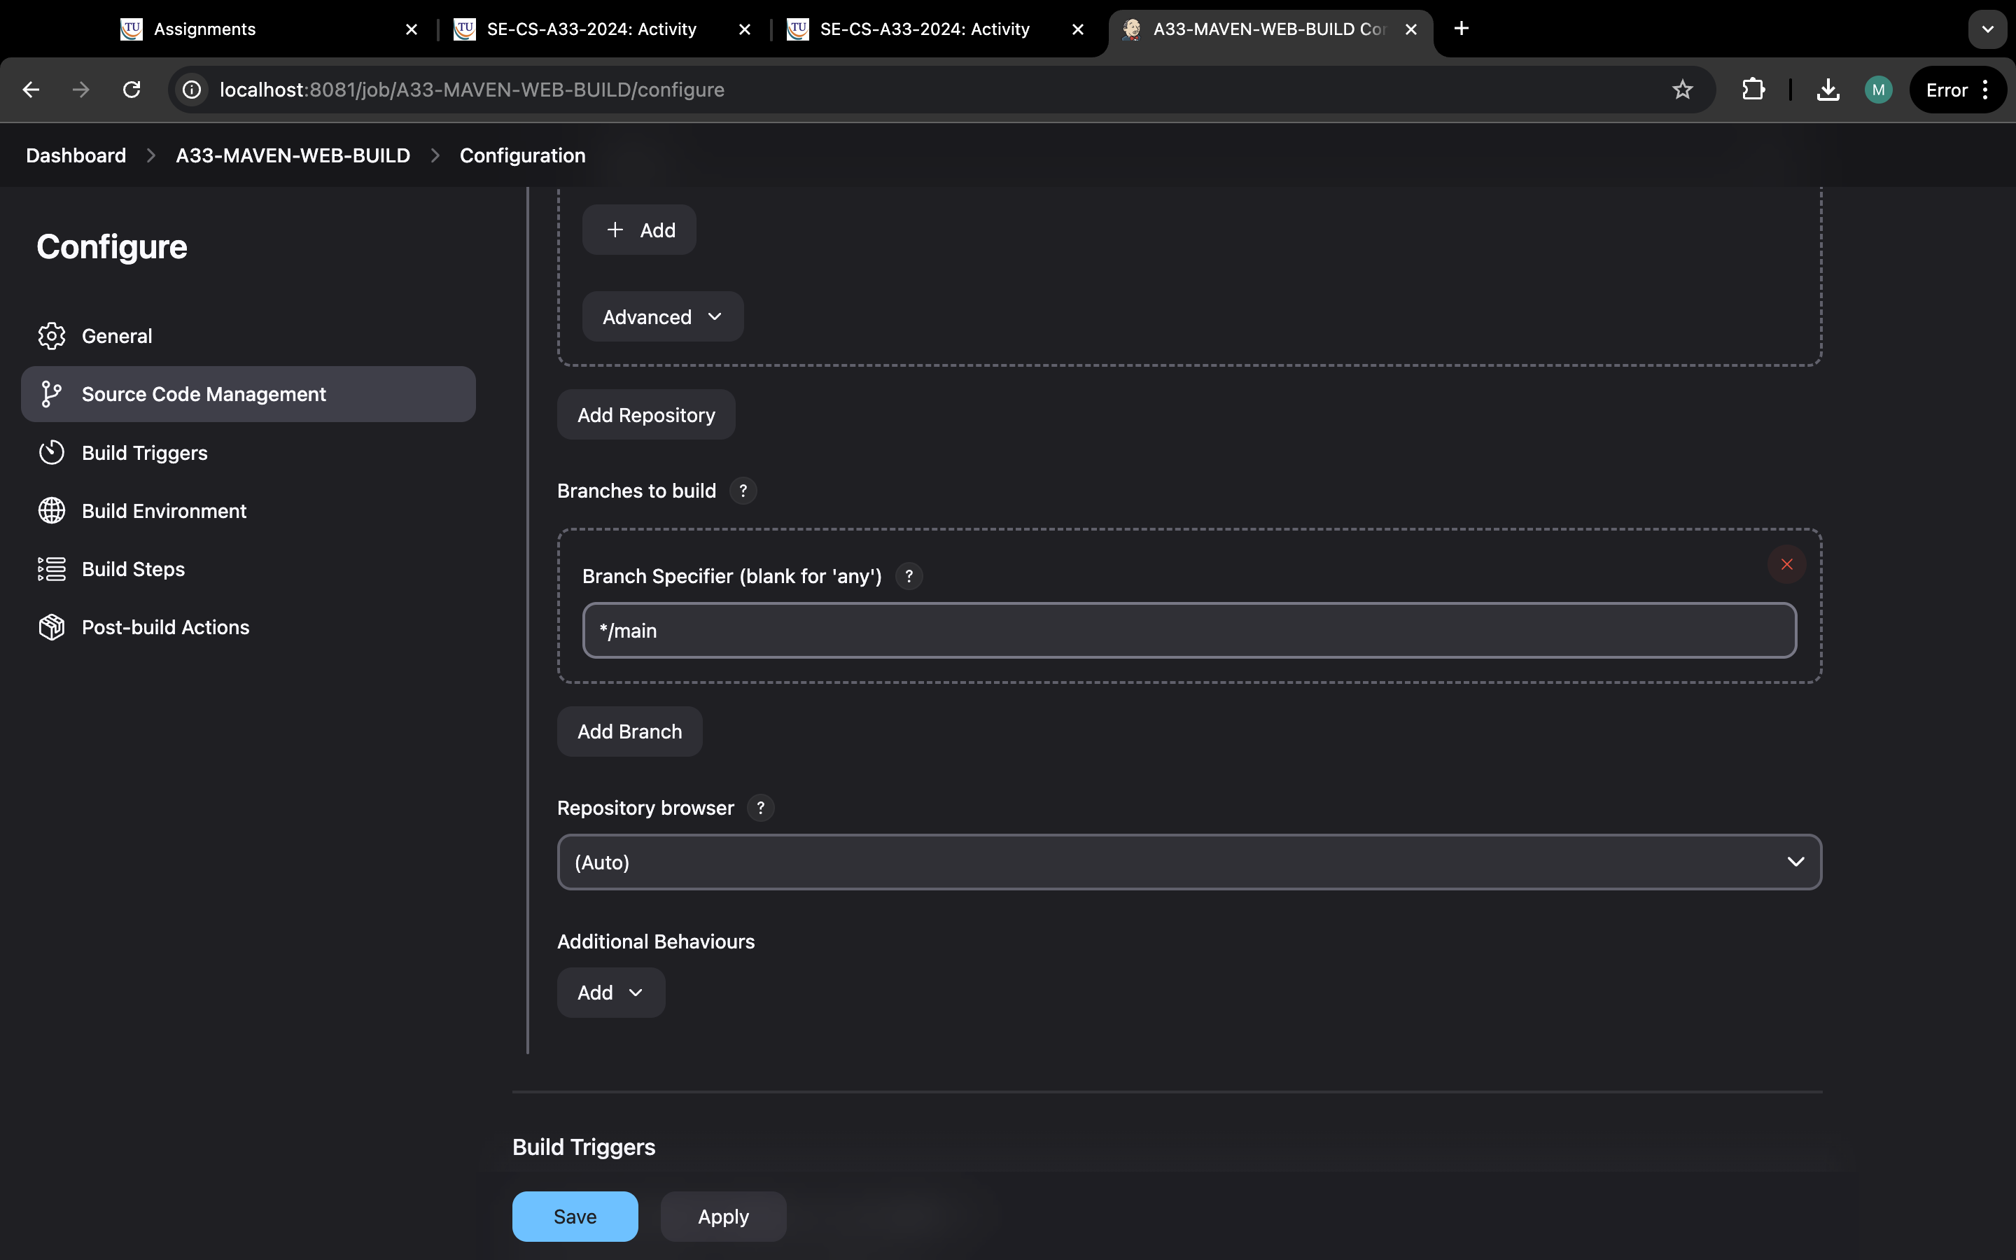

Step 7: go to build triggers and click on build periodically and type “H/5 * * * *”.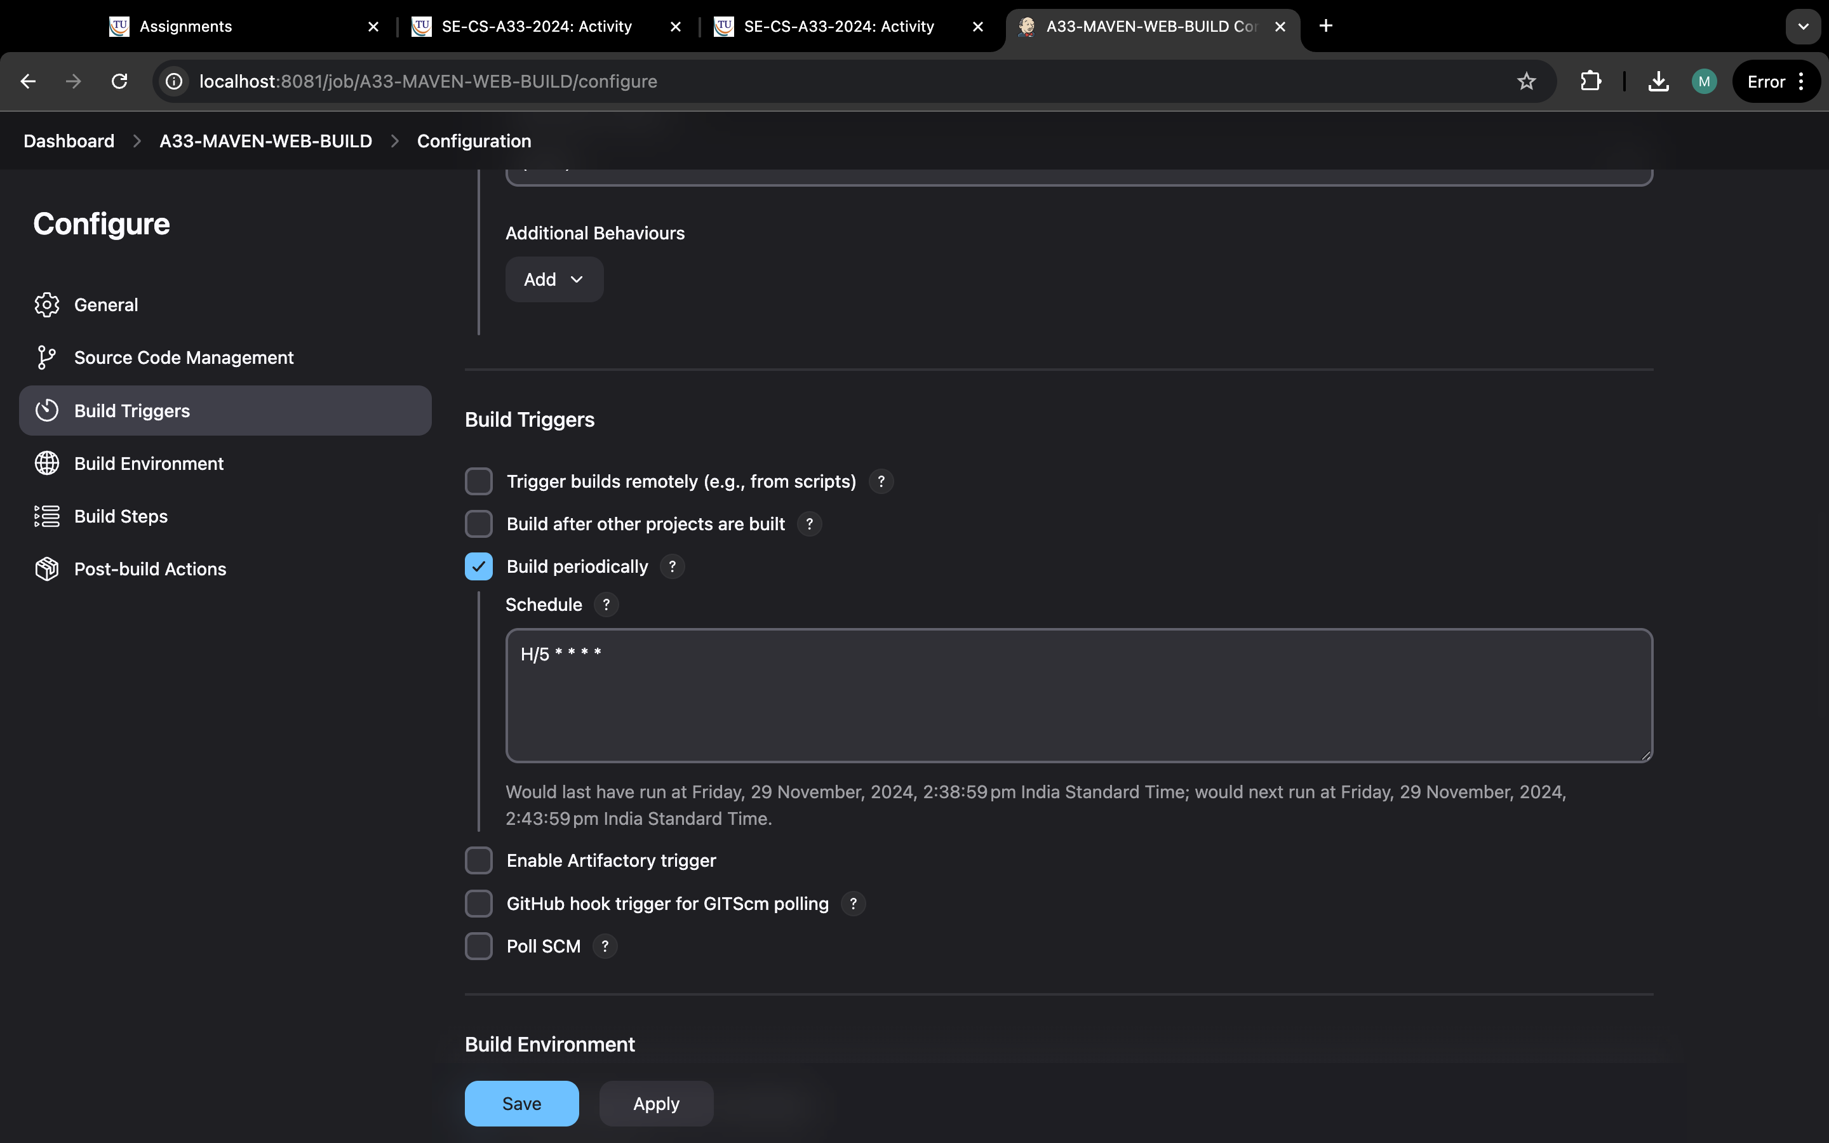

Step 8: Now go build environment and select delete workspace before build starts.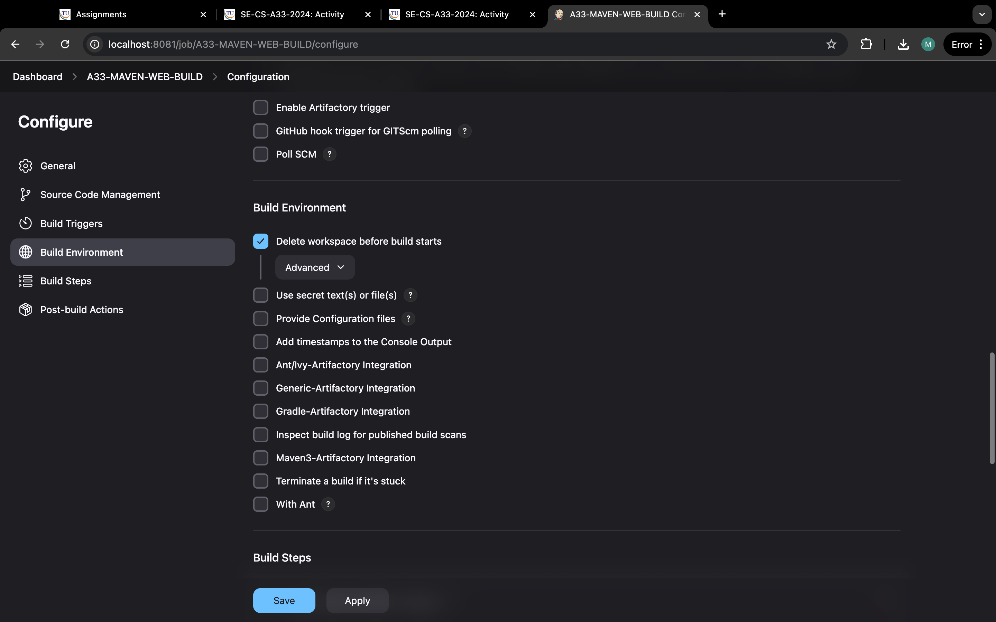

Step 9:click on build step and select invoke top-level maven targets.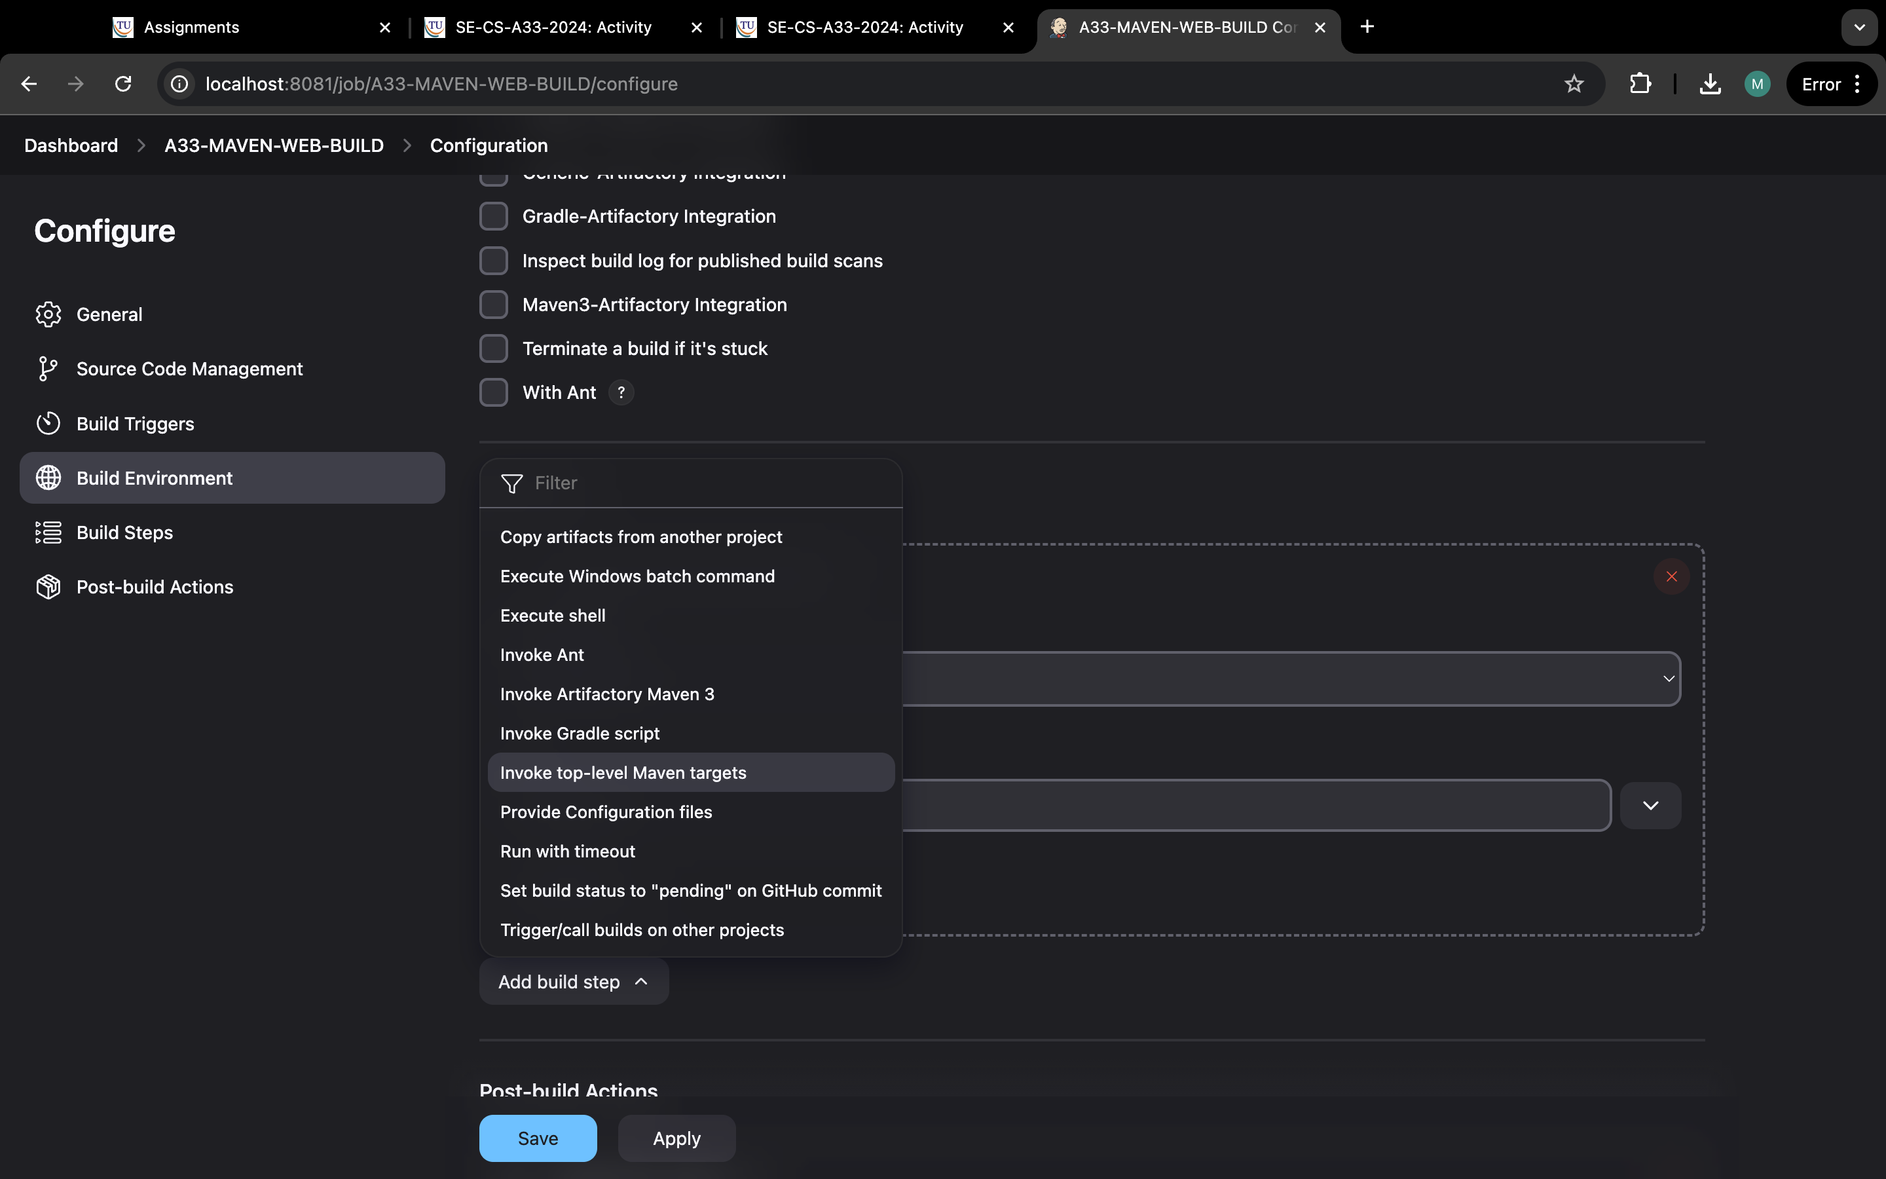

Step 10:select maven home and in goals type “clean install”.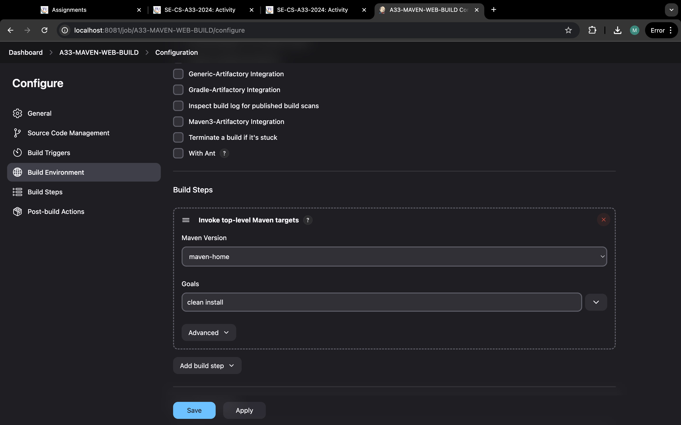

Step11:click in post build actions and select archive the artifacts.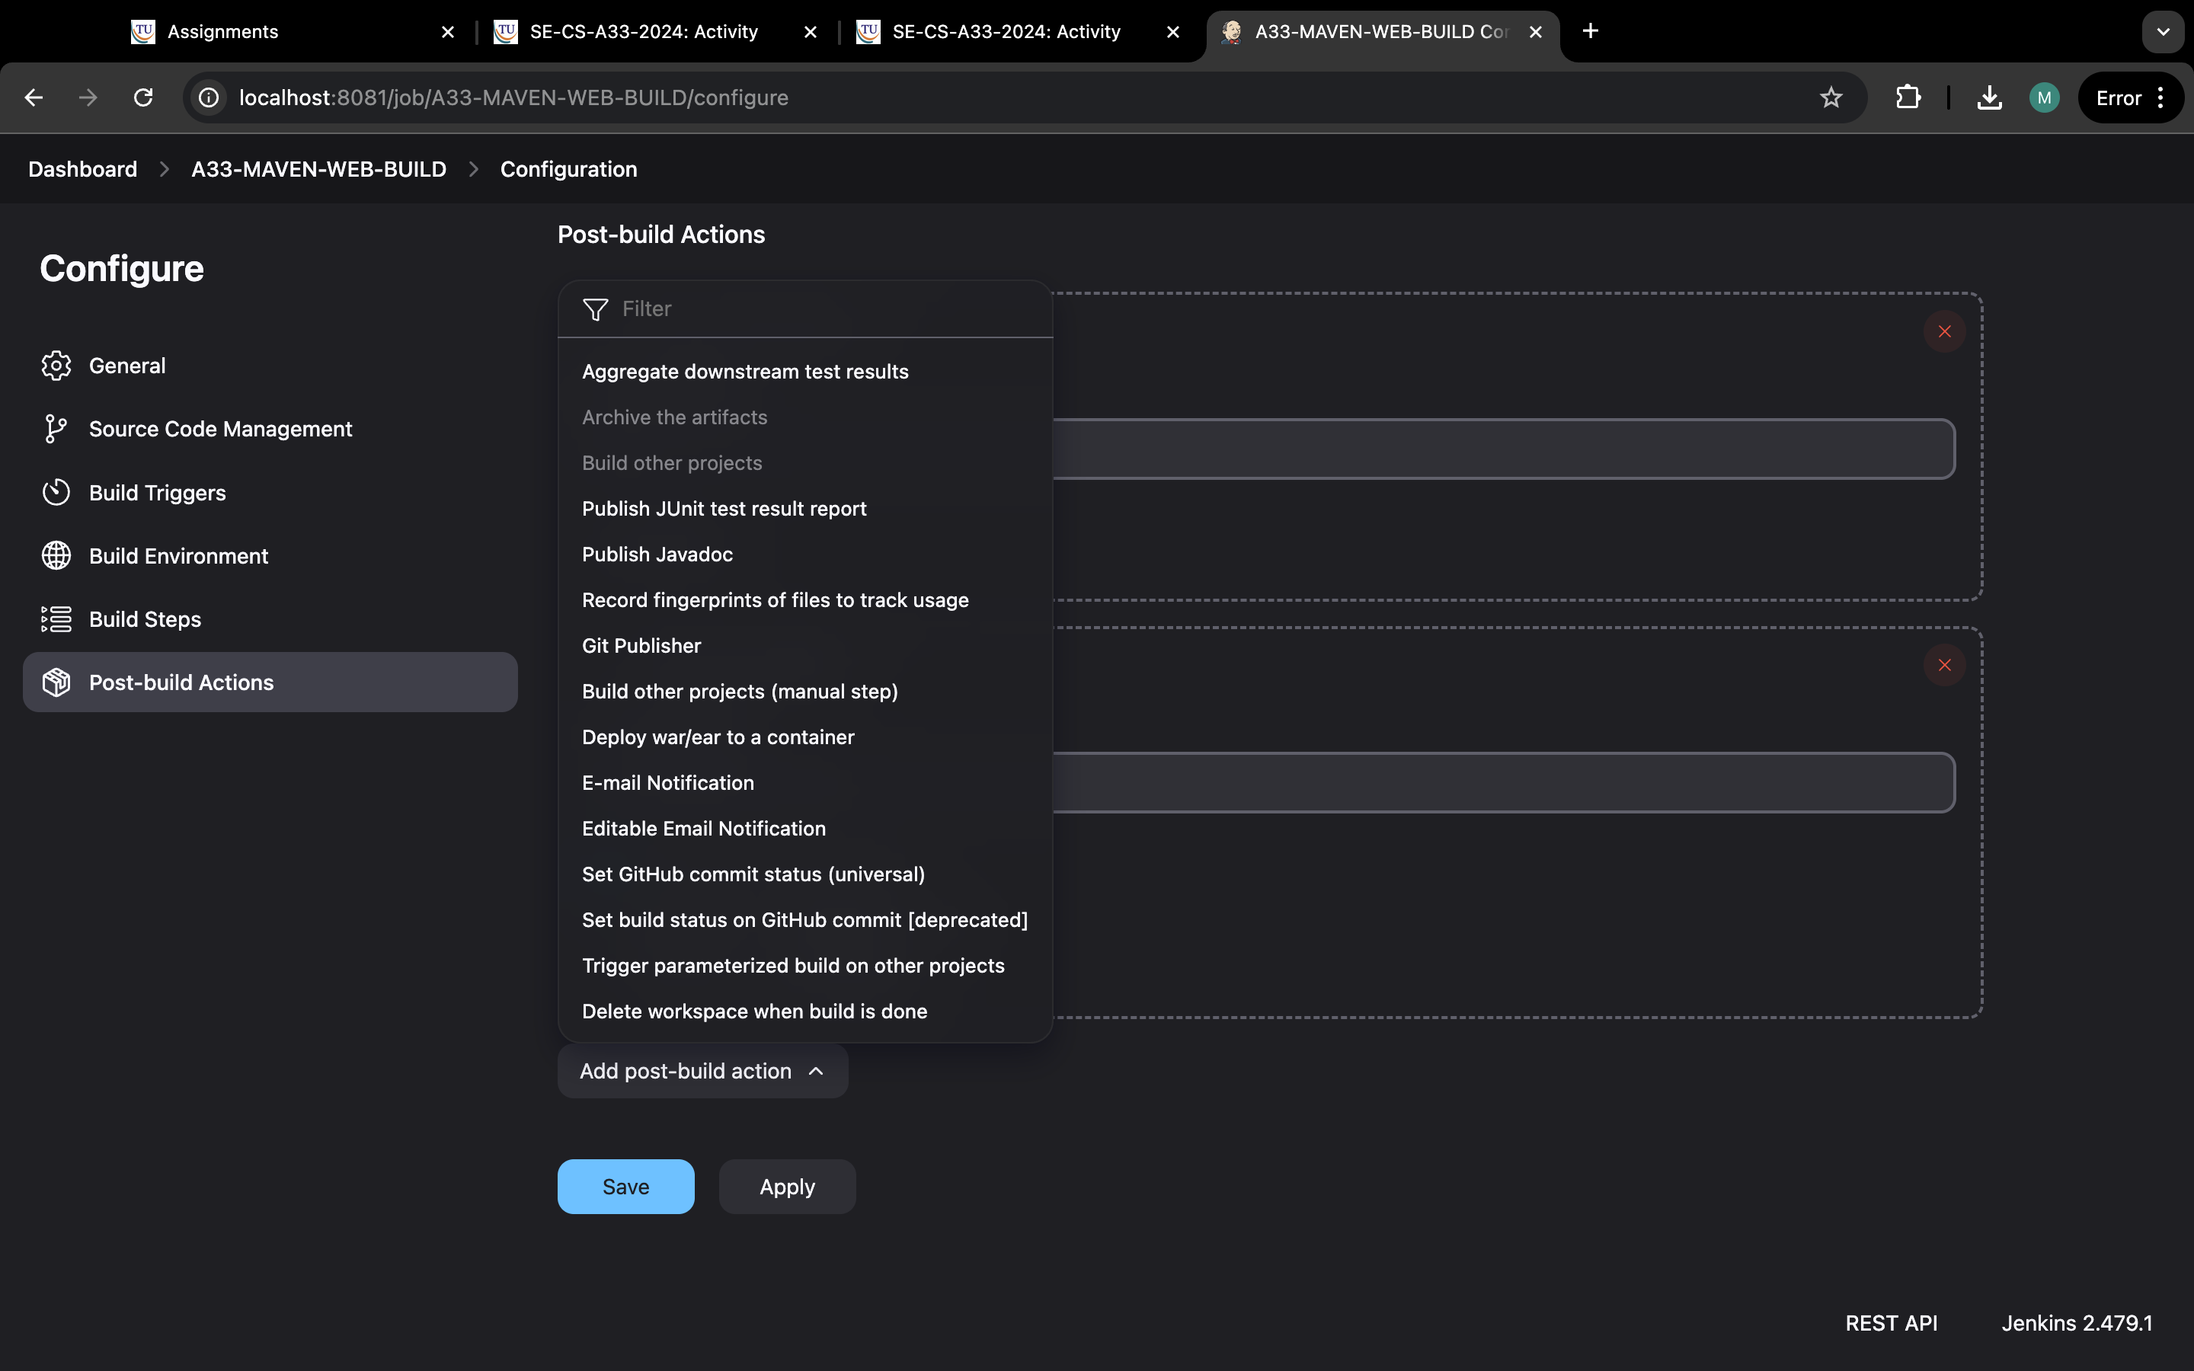

Step12:now, type “*/**”.

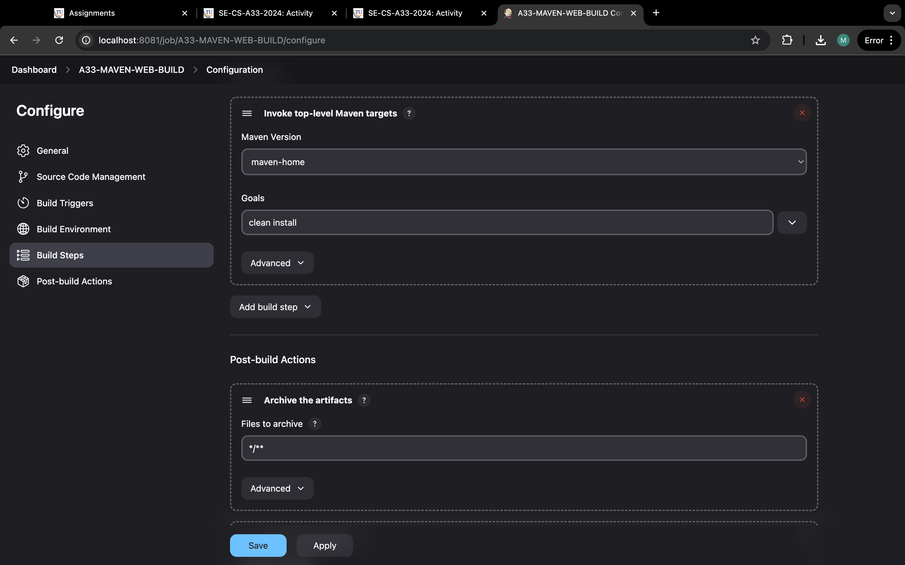

Step 13:Now, same but select build other projects.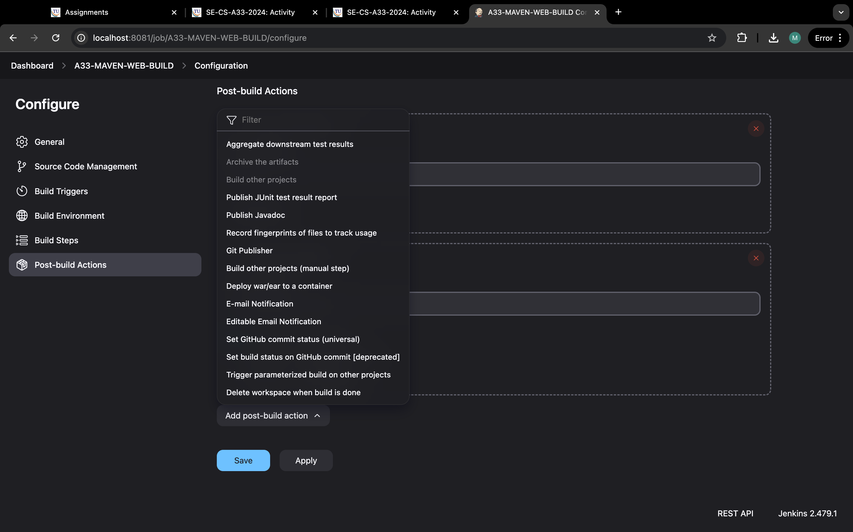

Step 14:type “a33-maven-test” and select tigger onlyif build is stable and apply and save.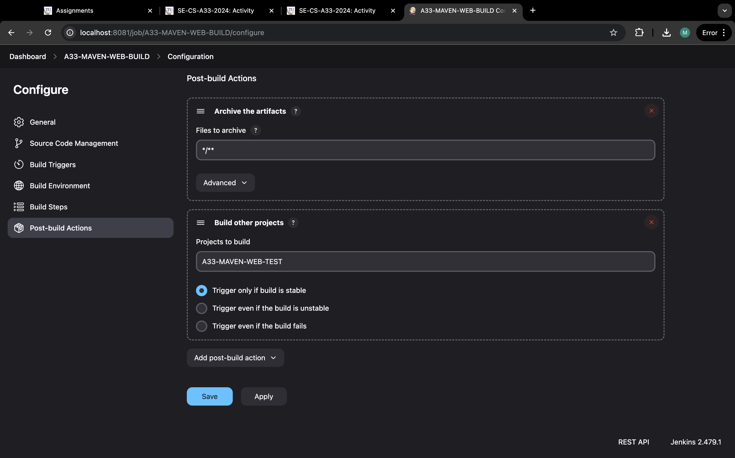

Step 15: it should look link this.

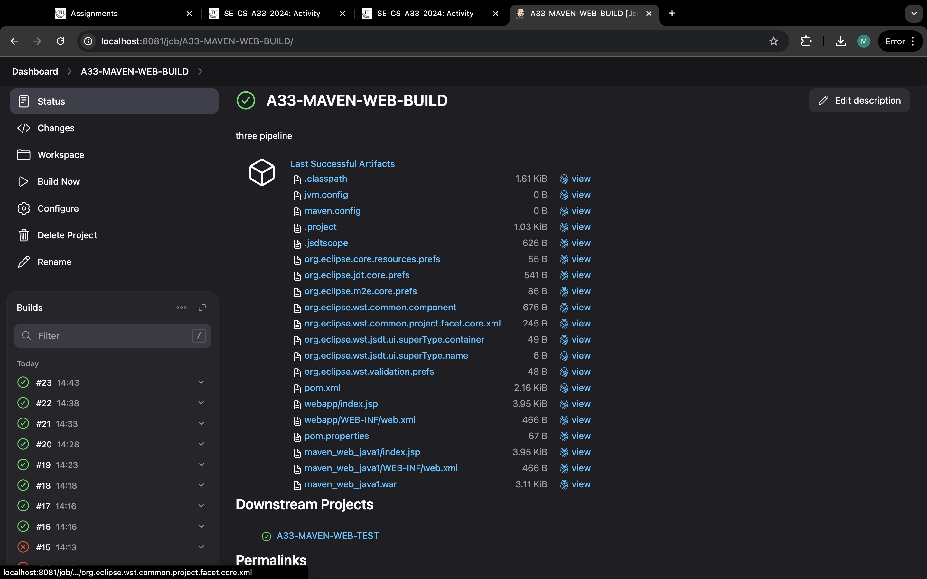

Step 16: now we make “maven-test” and click on new item.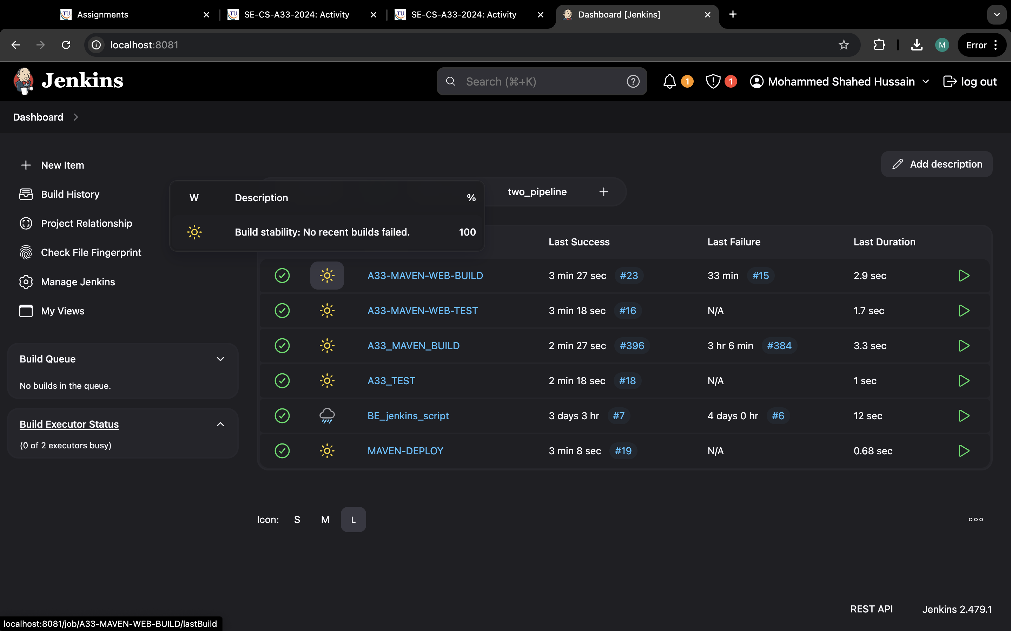

Step 17: now type maven-test and select free style and ok.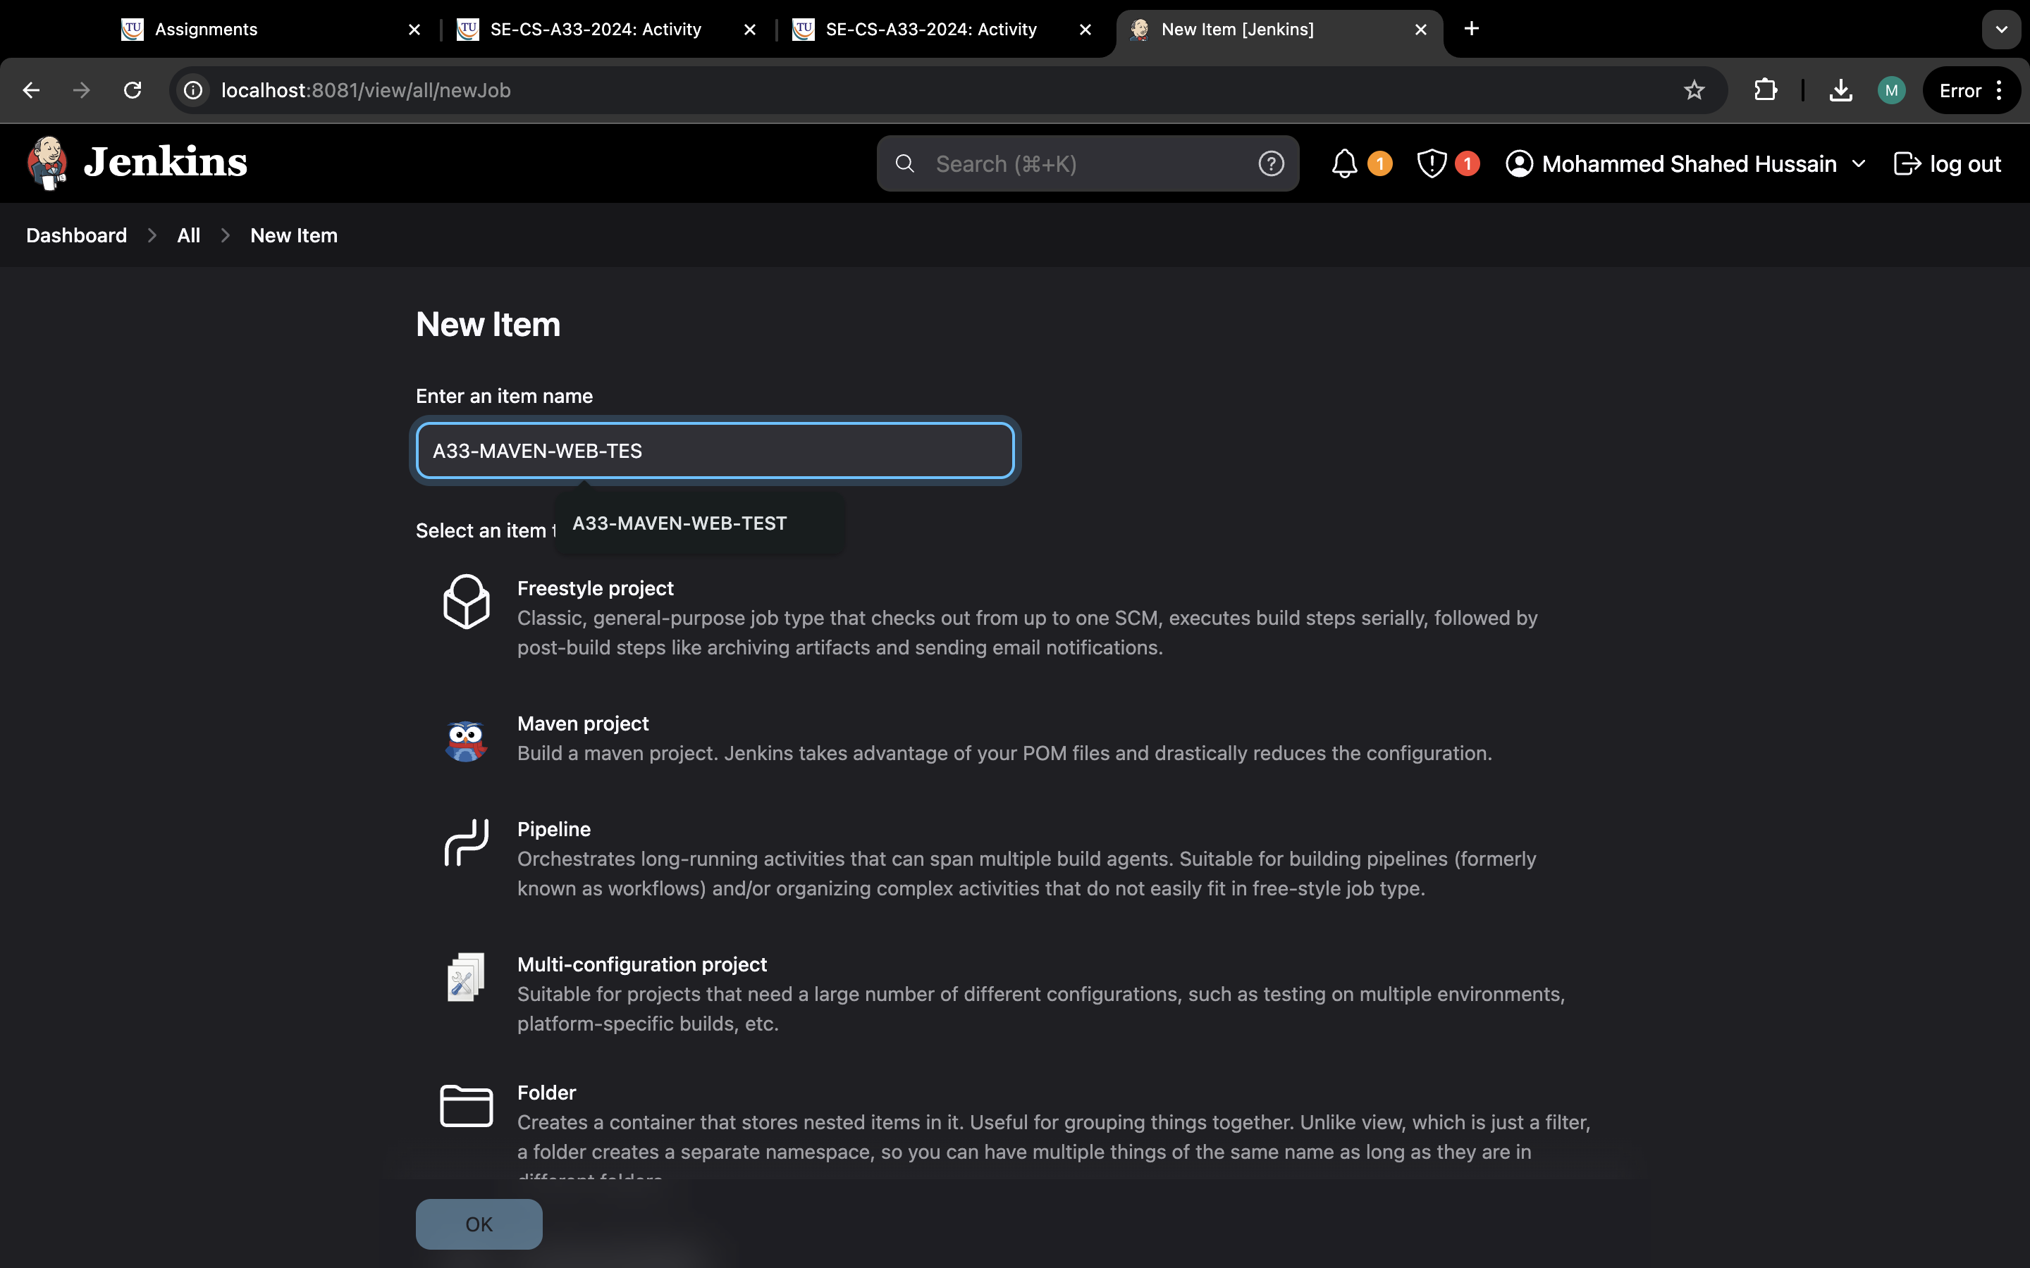

Step 18:now in source code management and select none.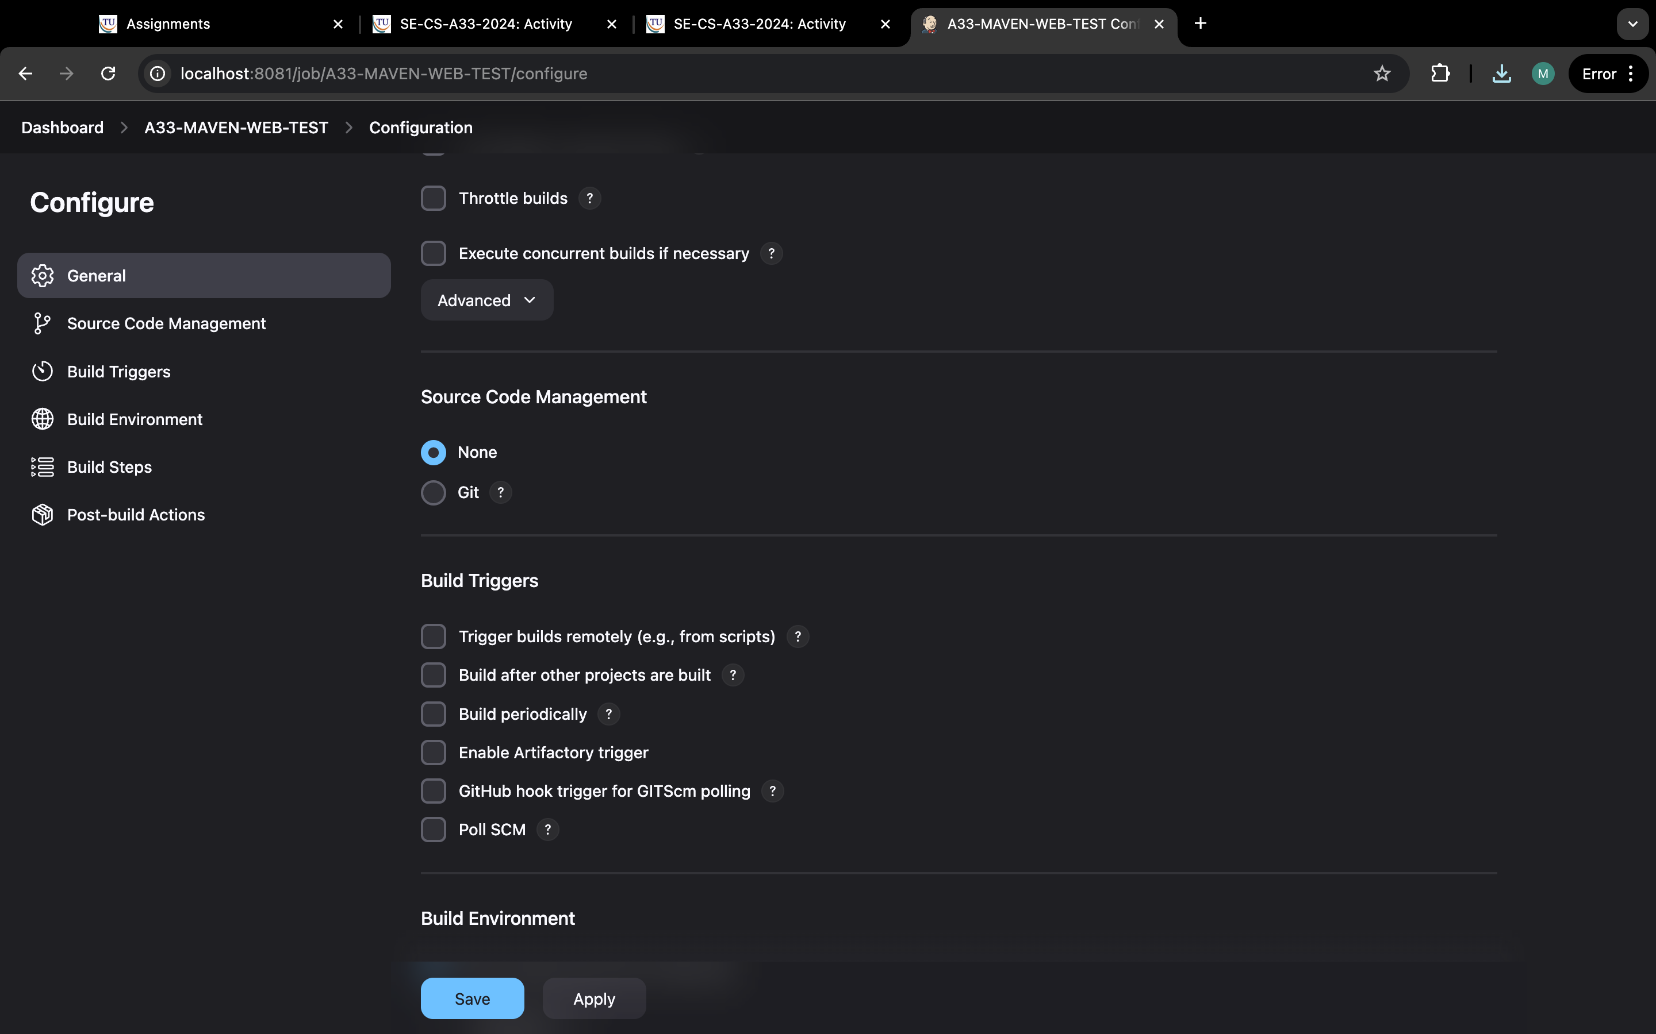

Step 19: go to build environment and select delete workspace.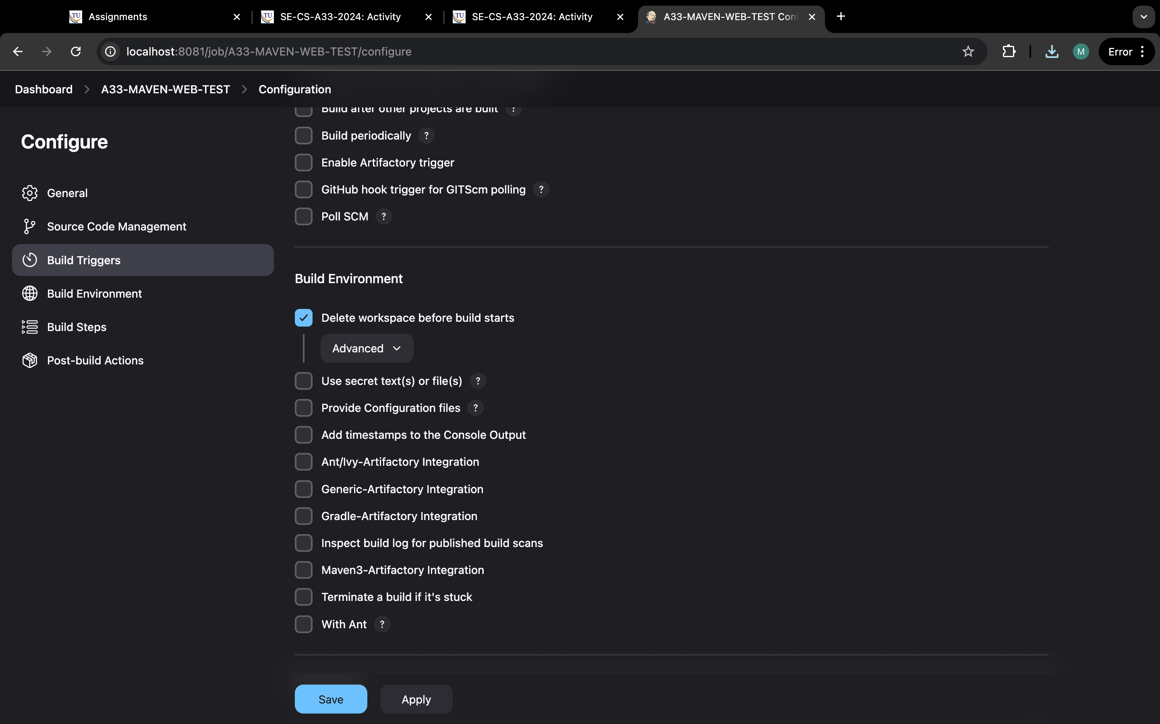

Step 20:go to build steps and select invoke top-level and select maven-home and in goals type test.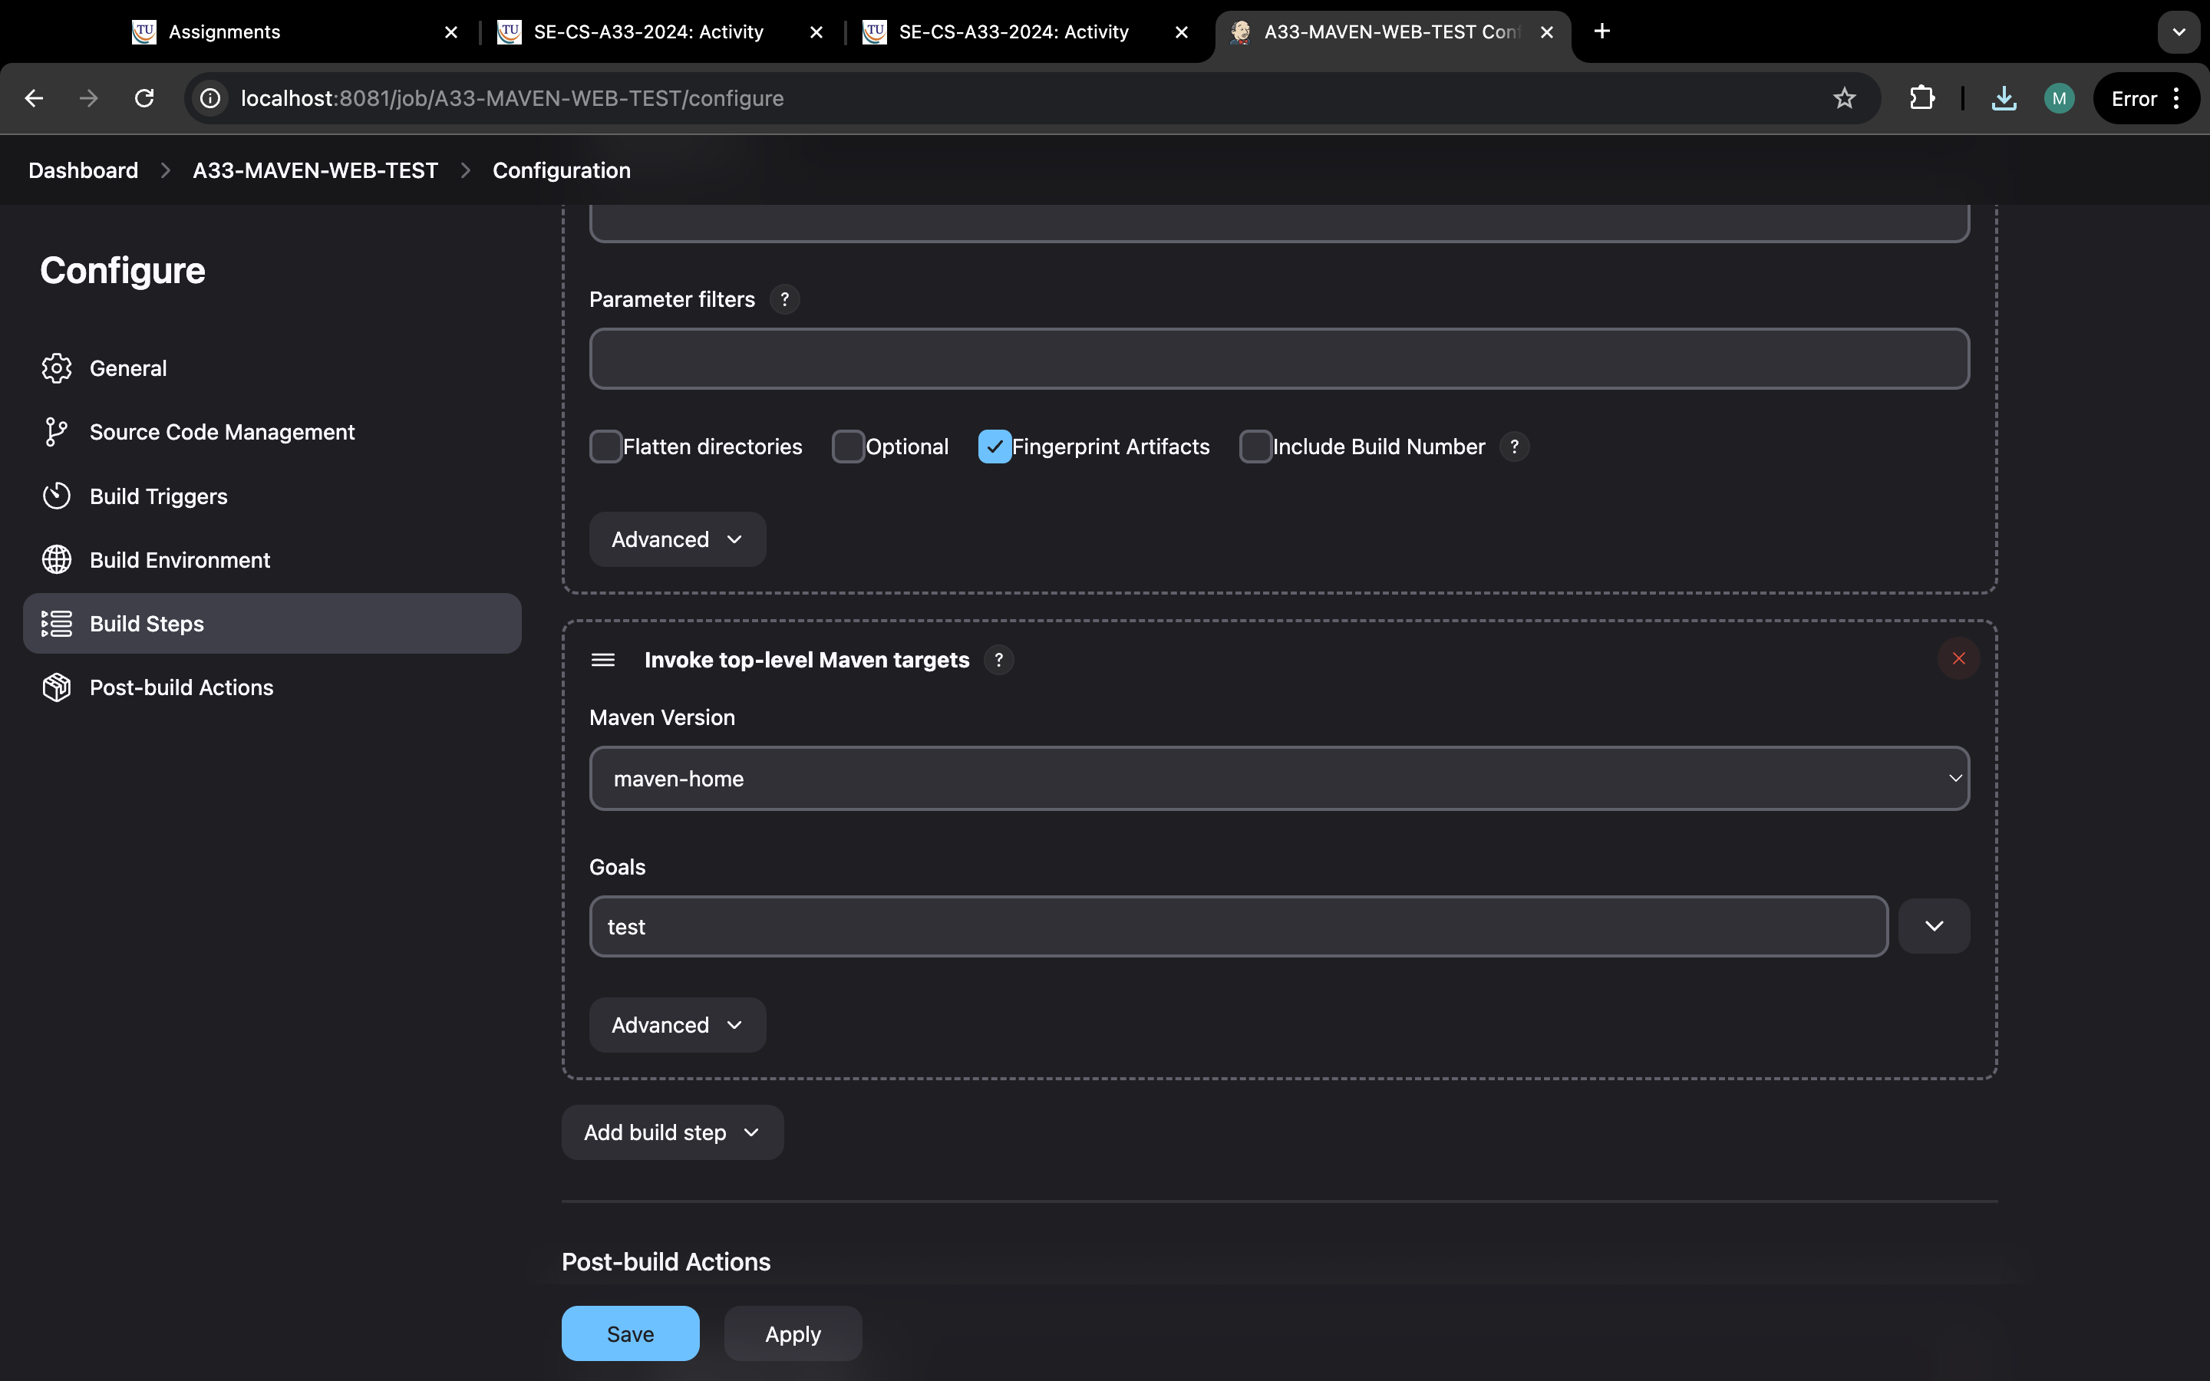

Step 21: same step but select copy artifacts and select maven build and type “*/**’ in artifacts to copy .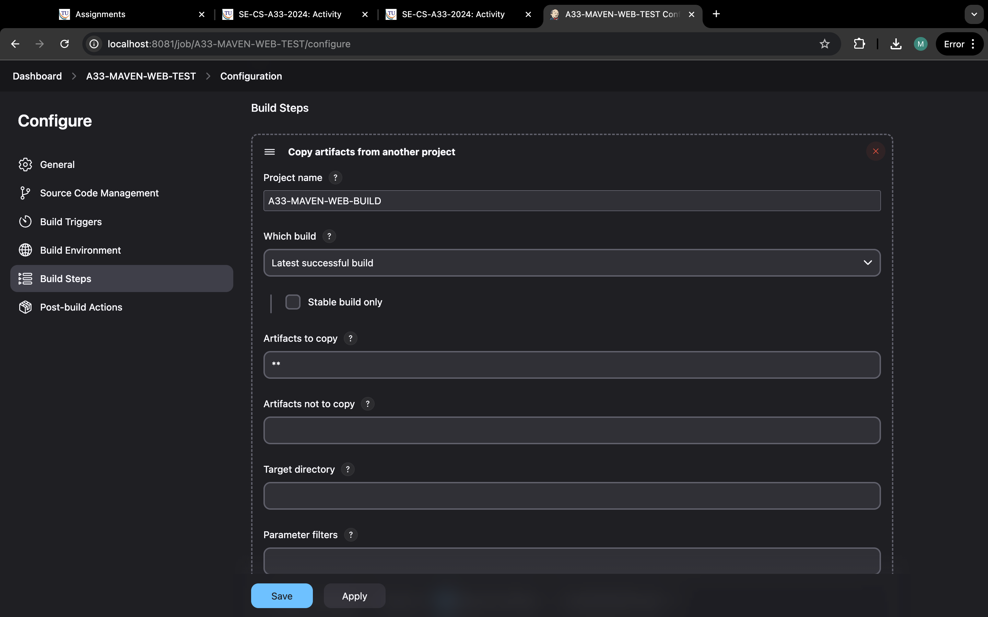

Step 22: got post build and select to archive the artifacts and type “**”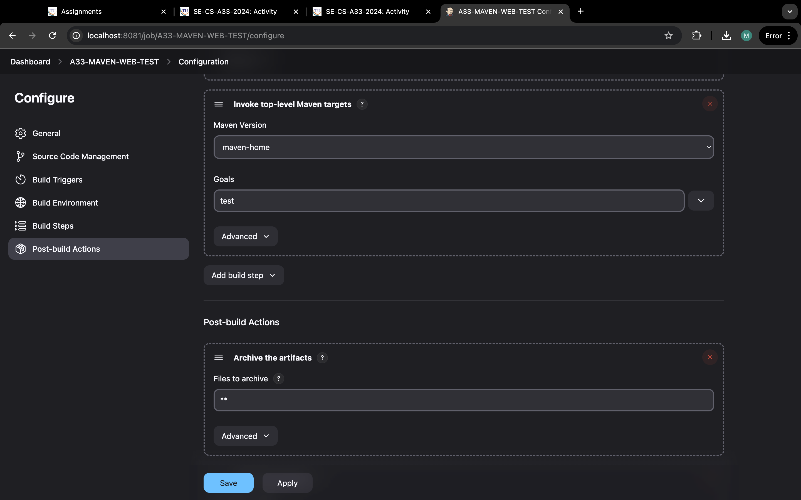

.

Step 23: same and select build other projects and type “maven-deploy” and apply and save.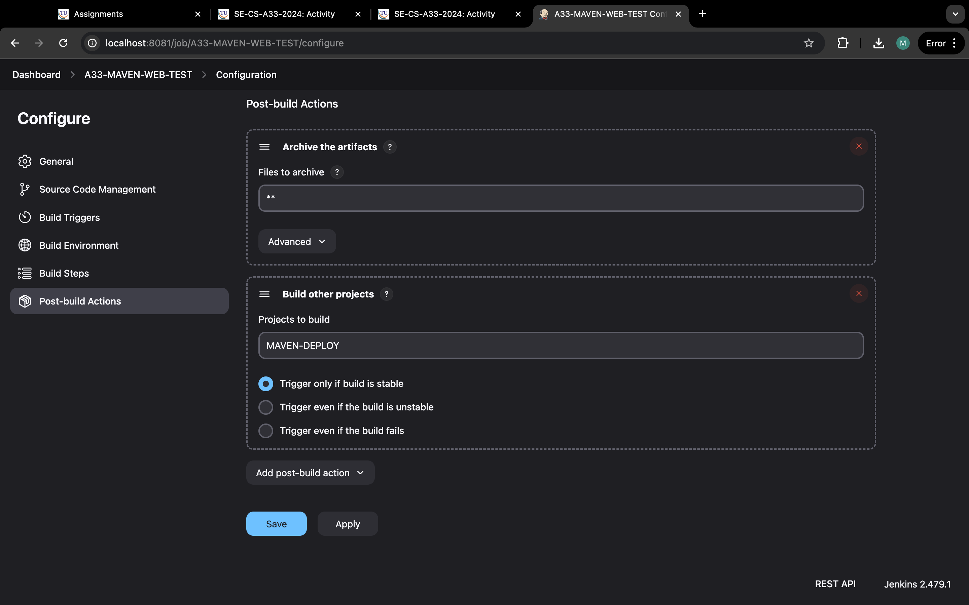

step 24:now click on build now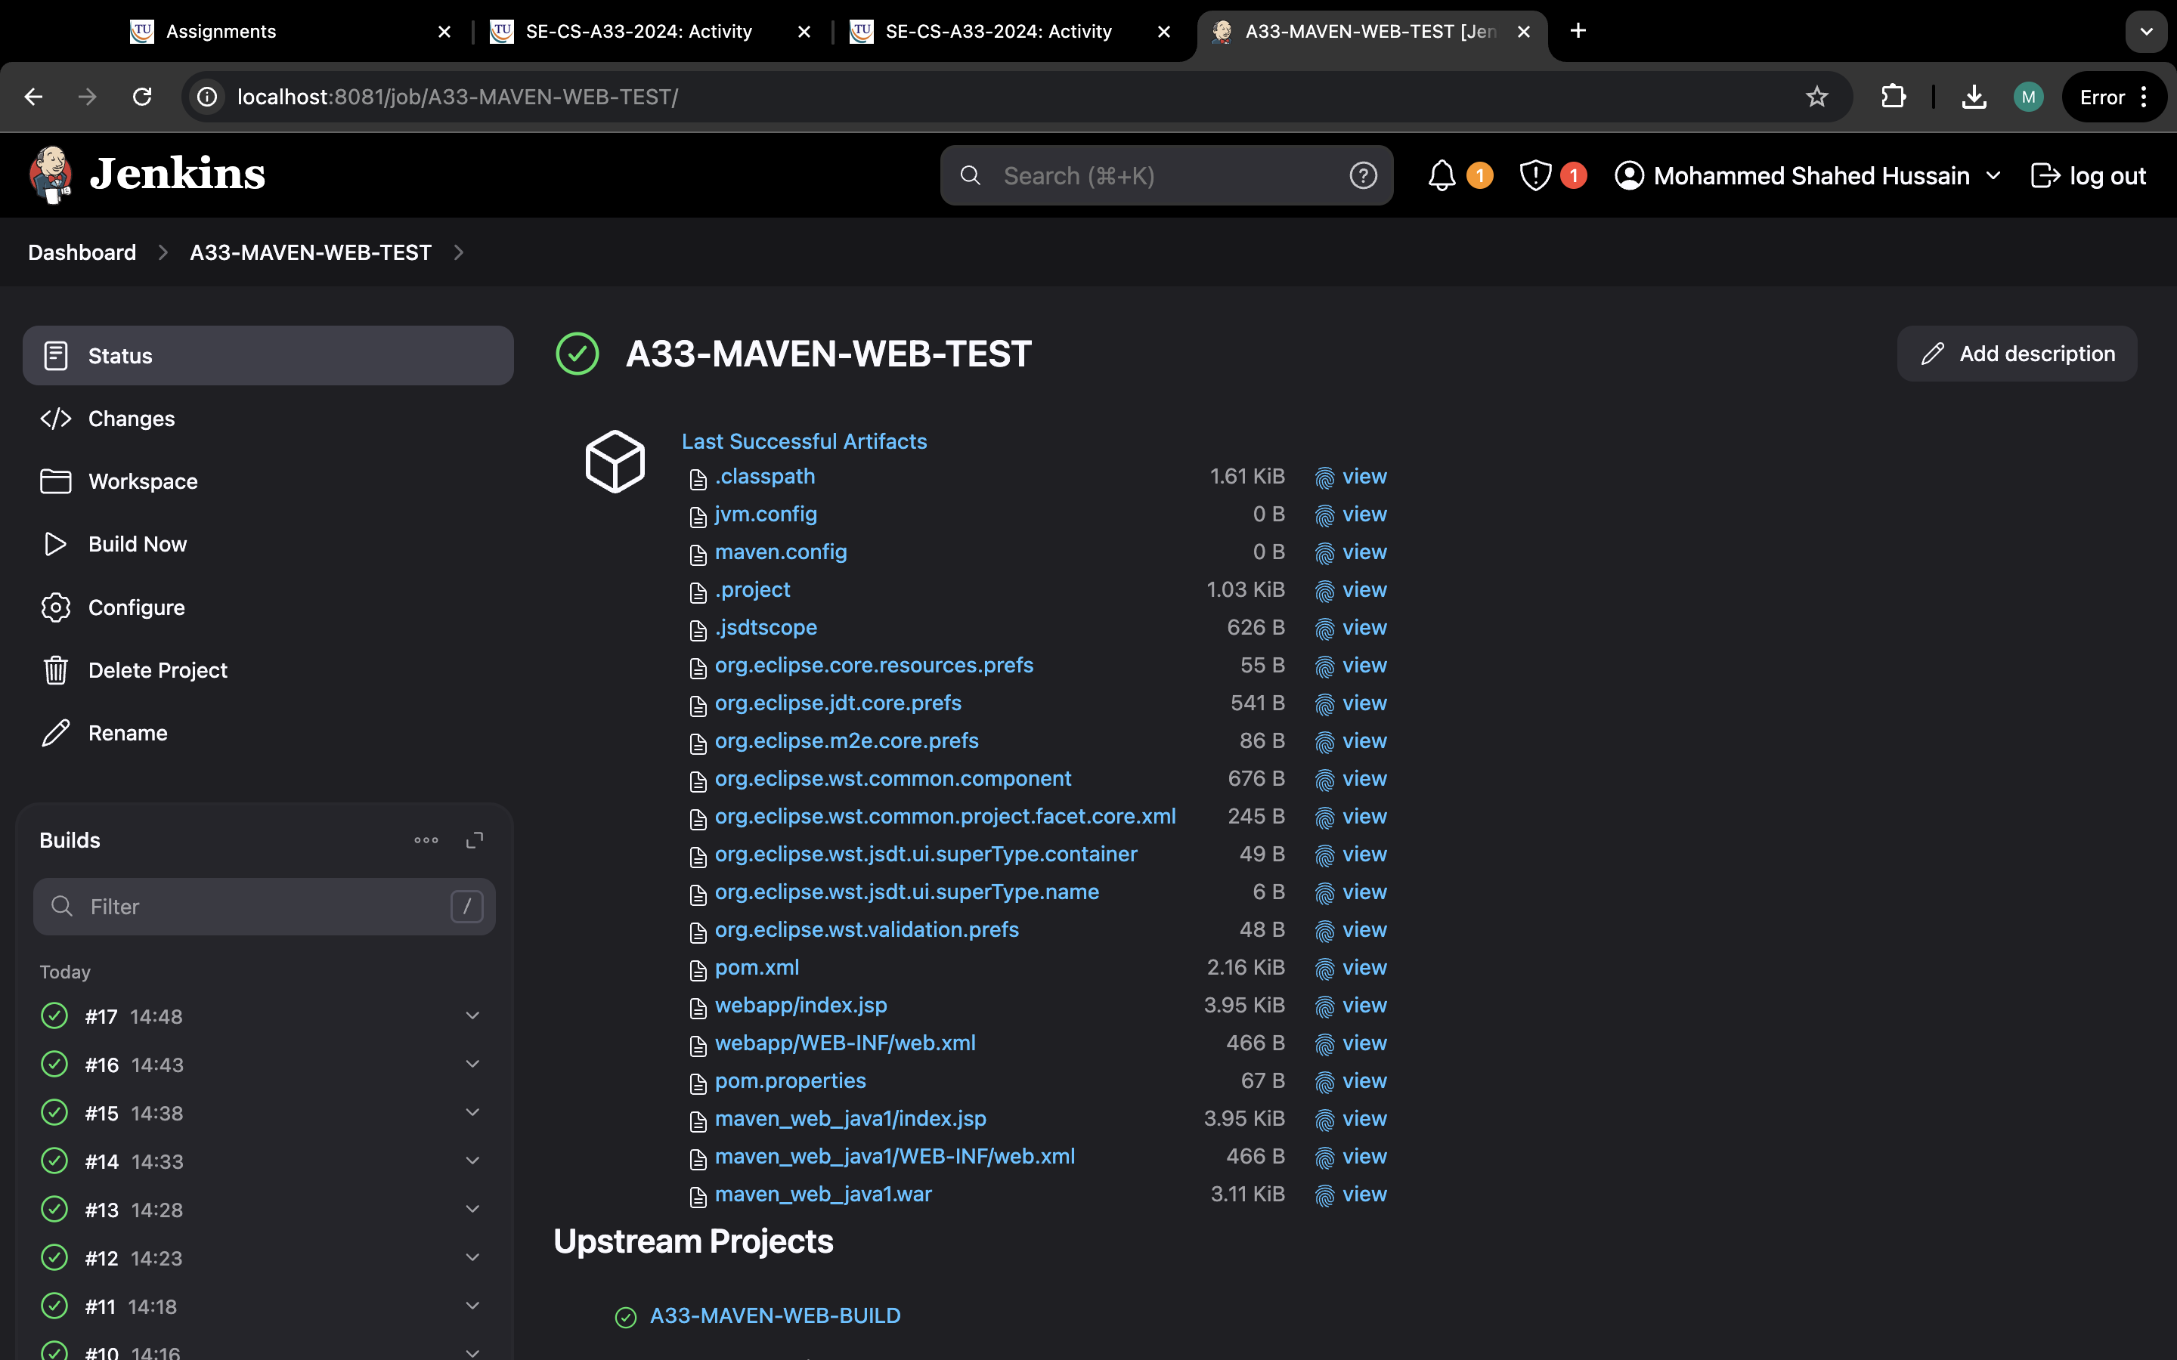

Step 25:same step to create item and name it delpoy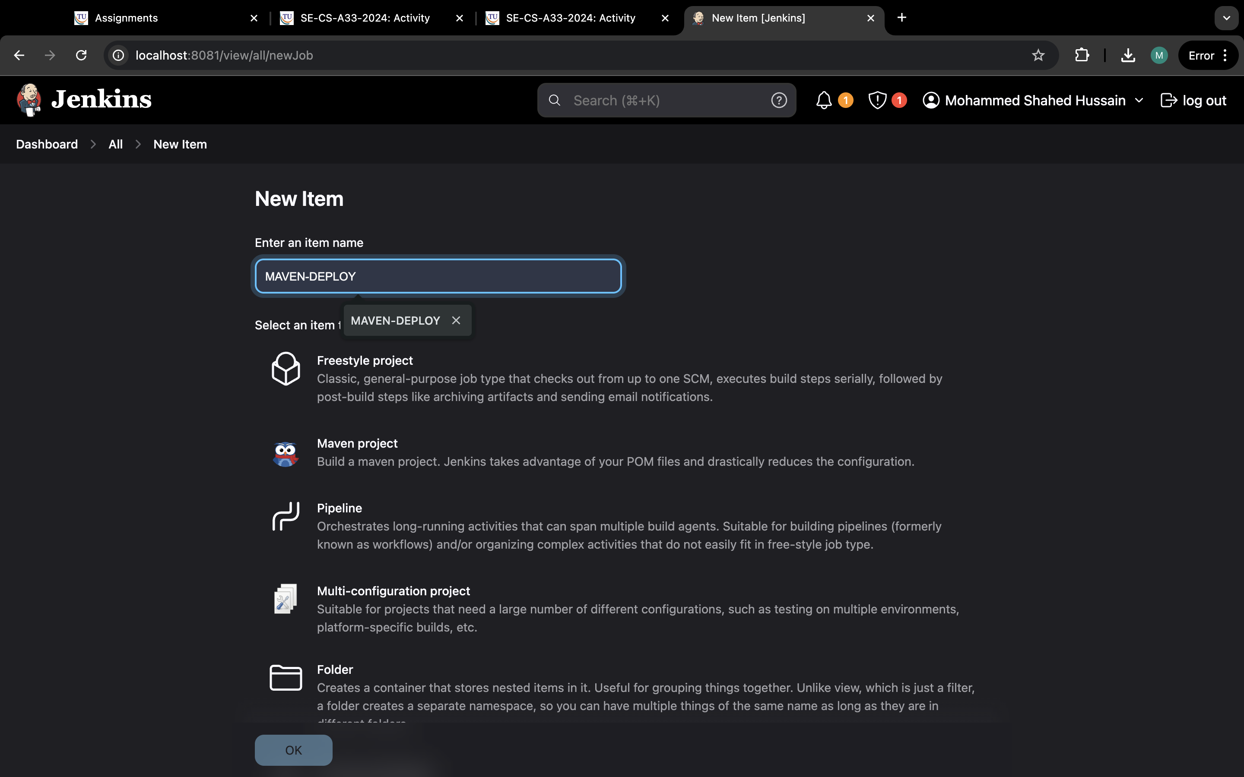

Step 26: now in source code management and select none.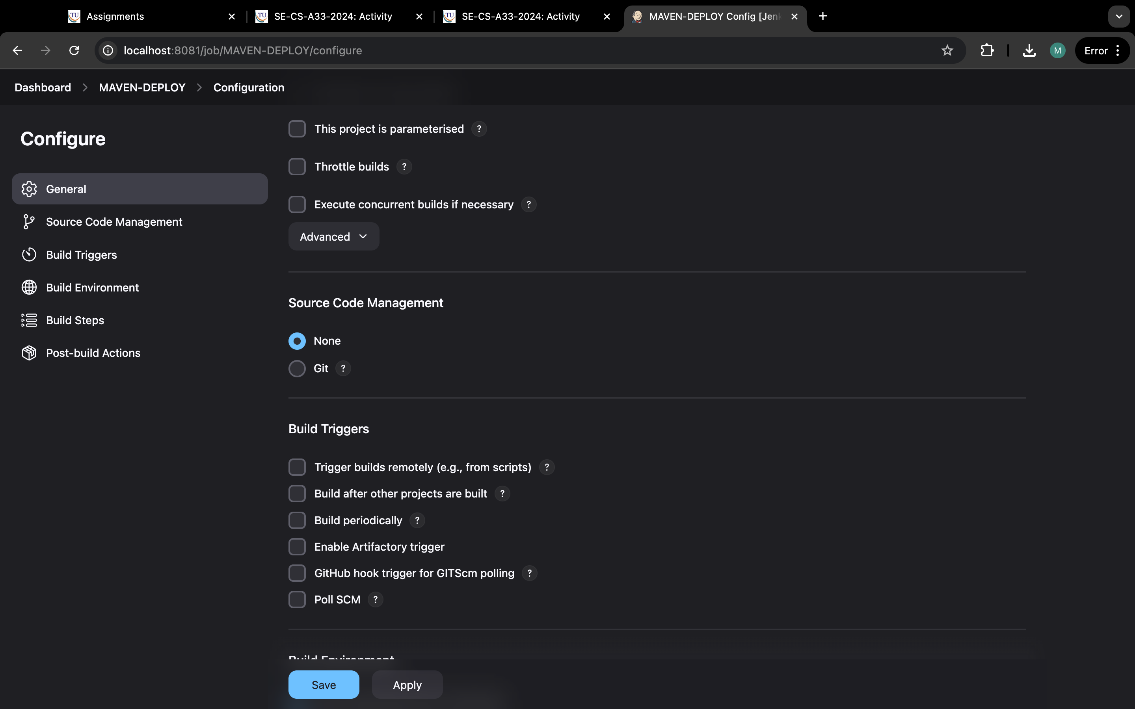

Step 27:go to build steps and select copy artifacts “ maven -test” and in artifact to copy “*/

**”.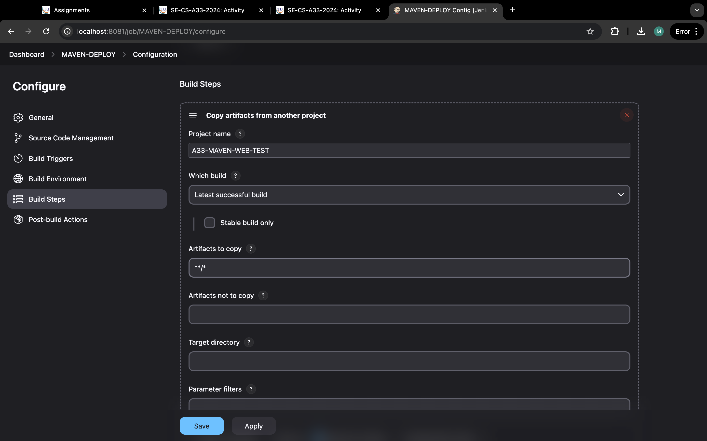

Step 28:go to post build select deploy war/ear and type webpath in context path and select tomcat 9 and credentials and url of your tomcat server and apply and save.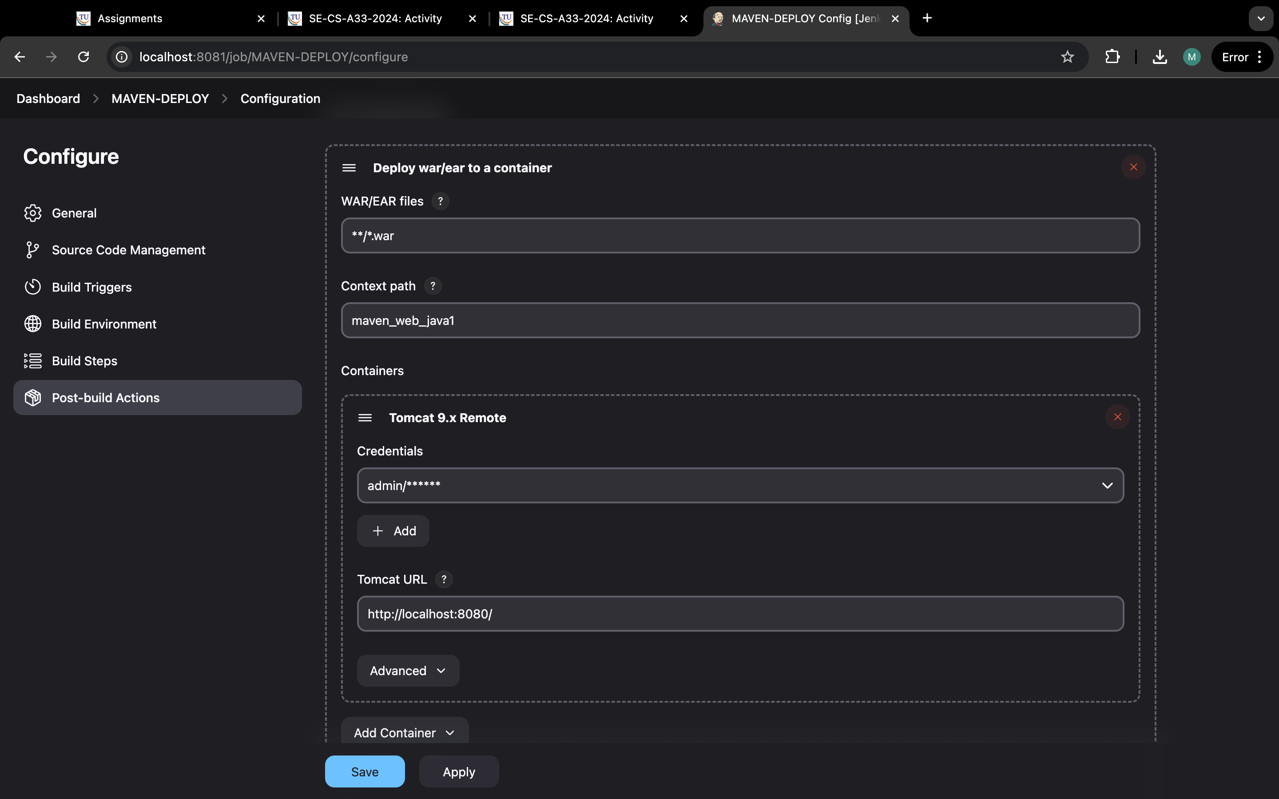

Step 29:this output and go back to dashboard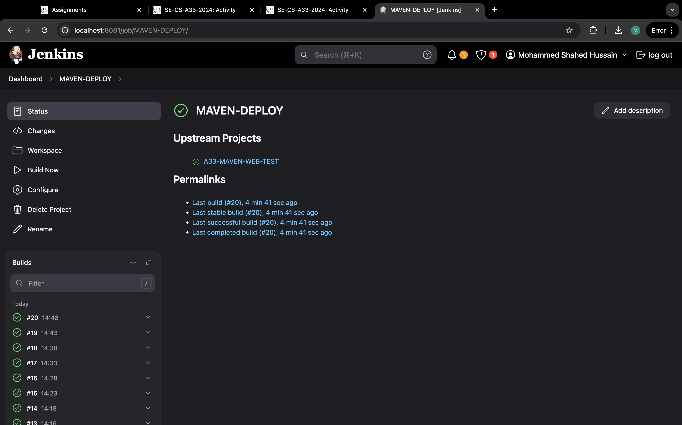

Step 30: click on + to create pipeline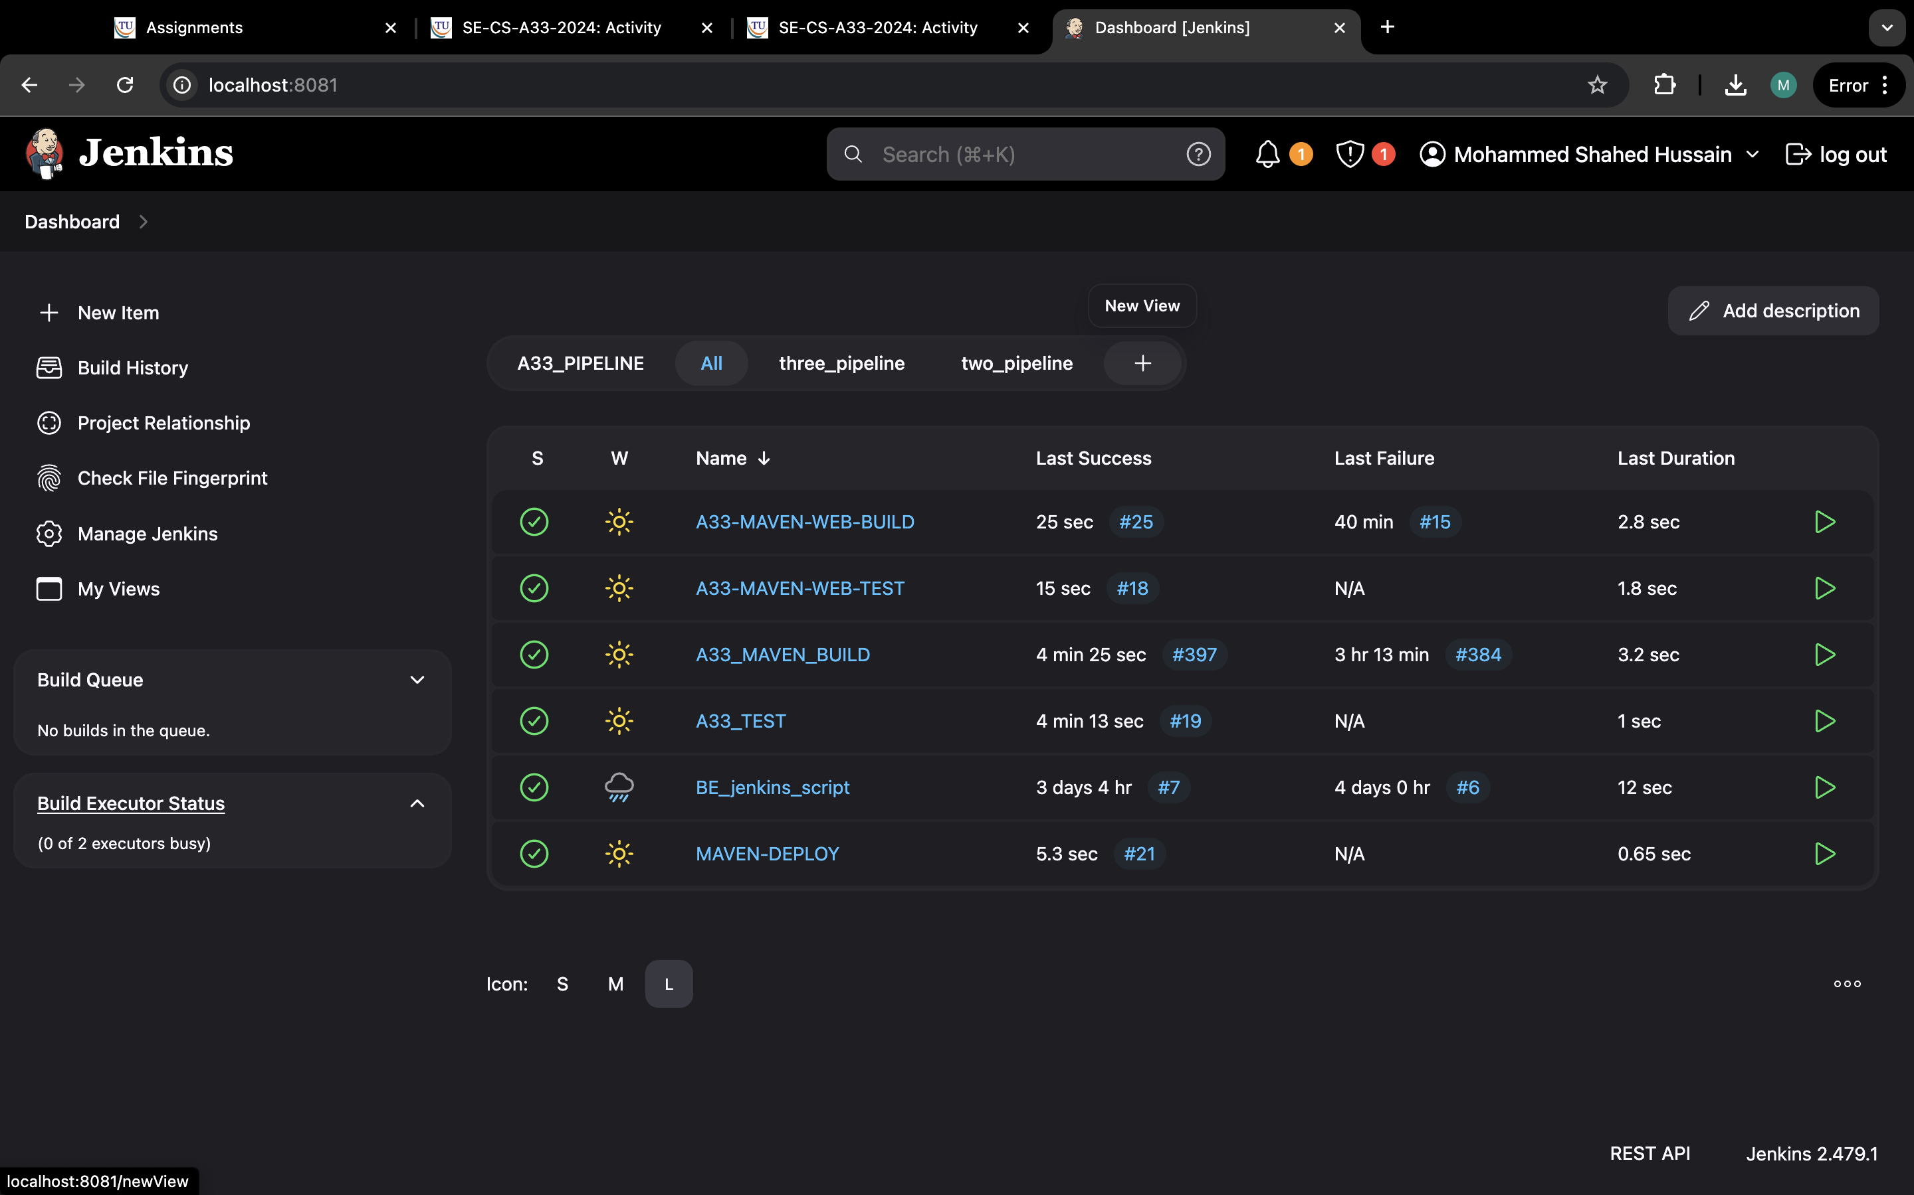

Step 31:name it three pipeline and select build pipeline view and create.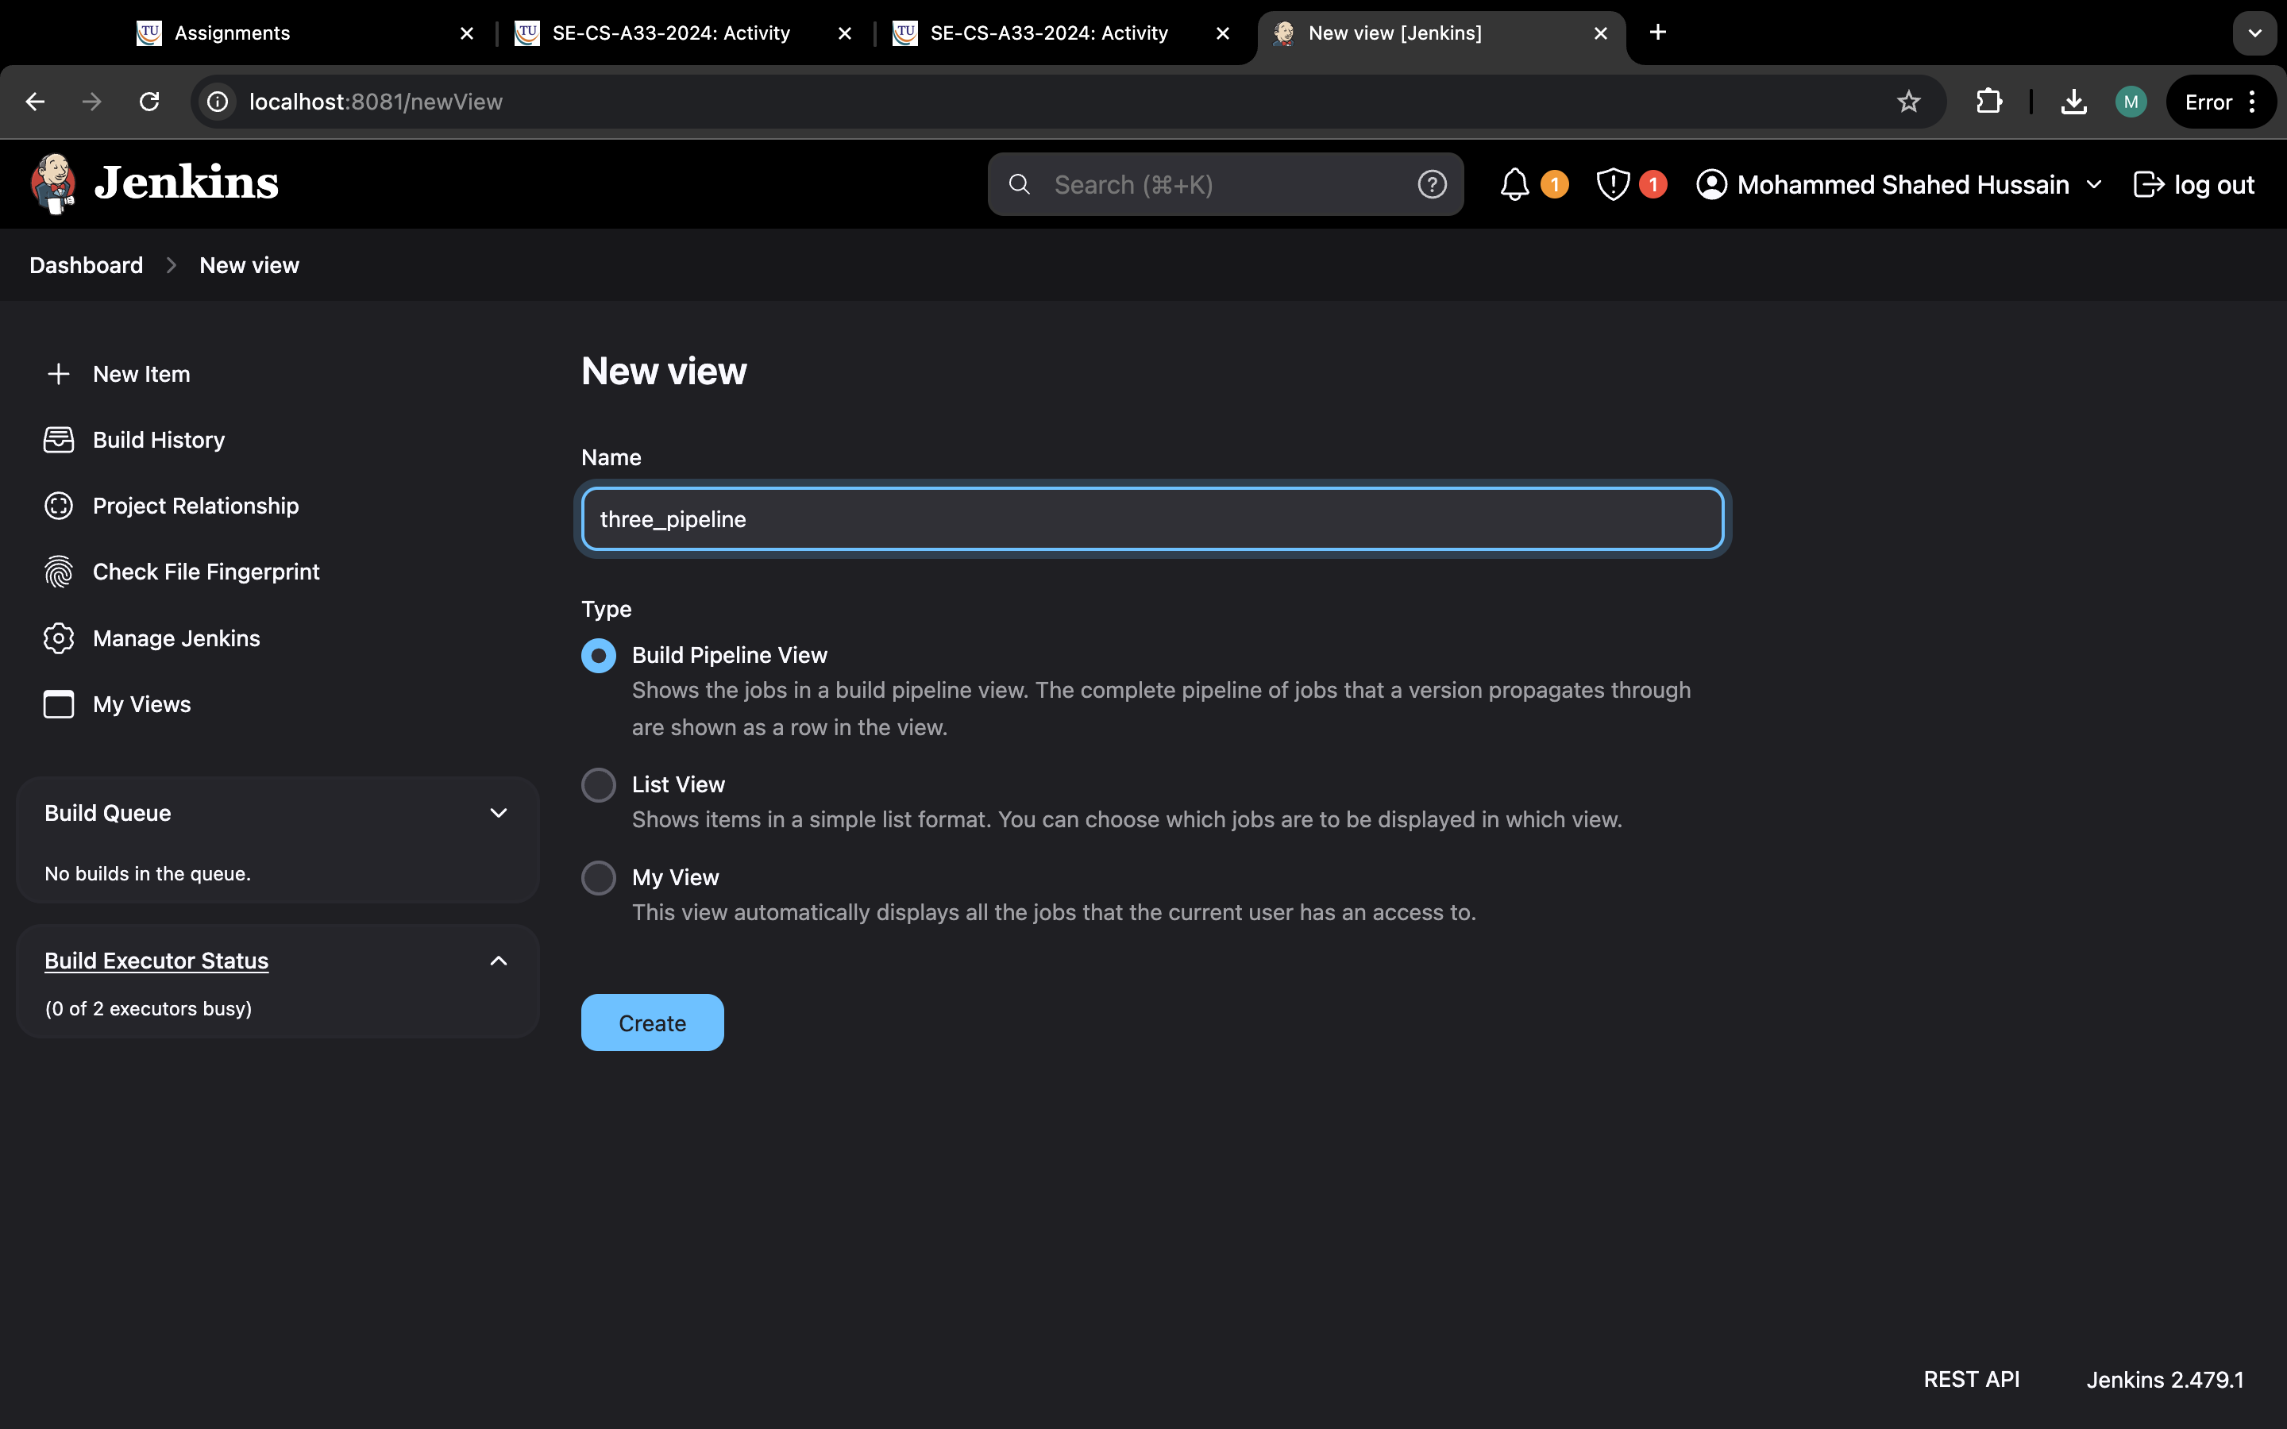

Step 32:now select “name-maven-build” in initial job and apply and ok.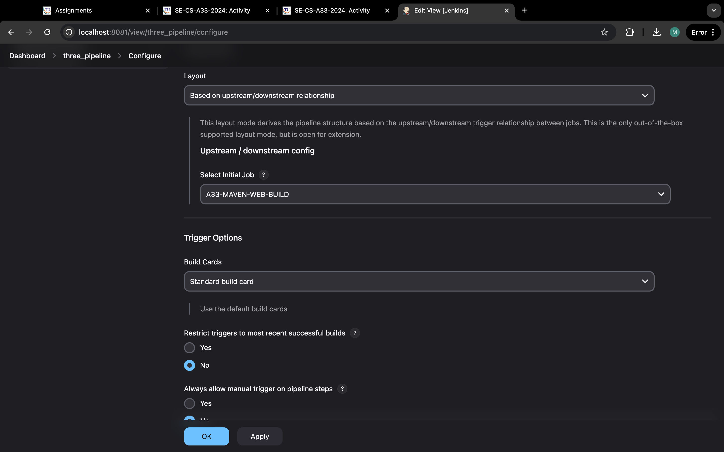

Step 33:this output.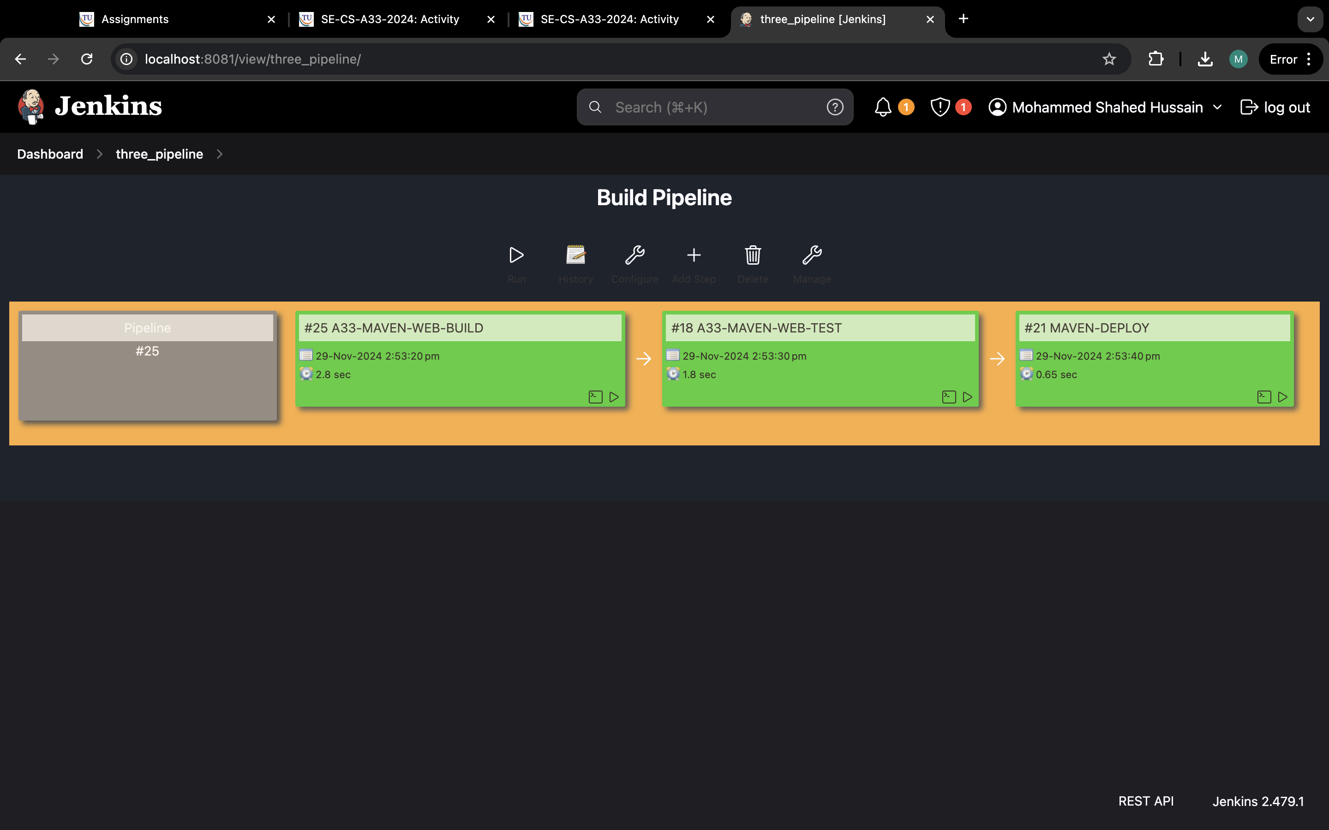

Step 34: go to you tomcat and click on manager app.

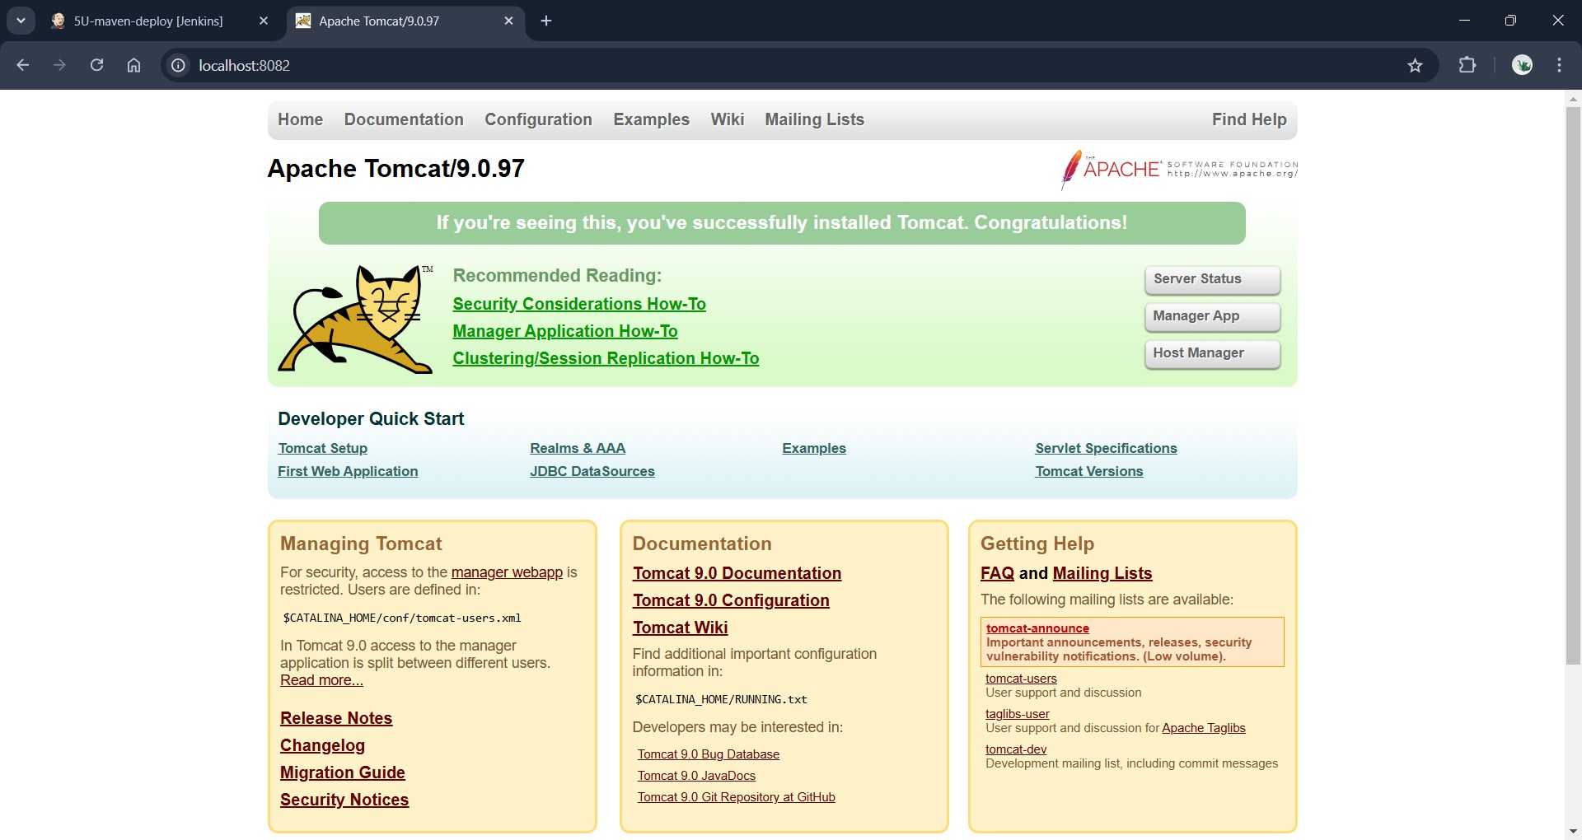

Step 35:now sign in

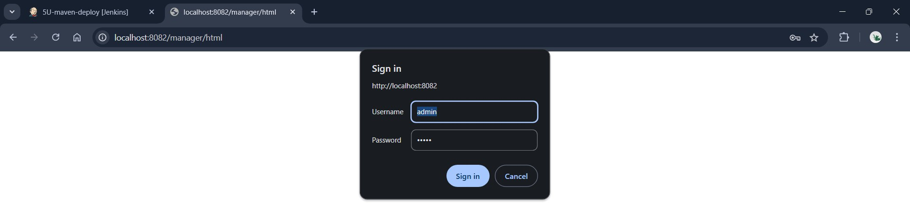

Step 36:now click on webpath.

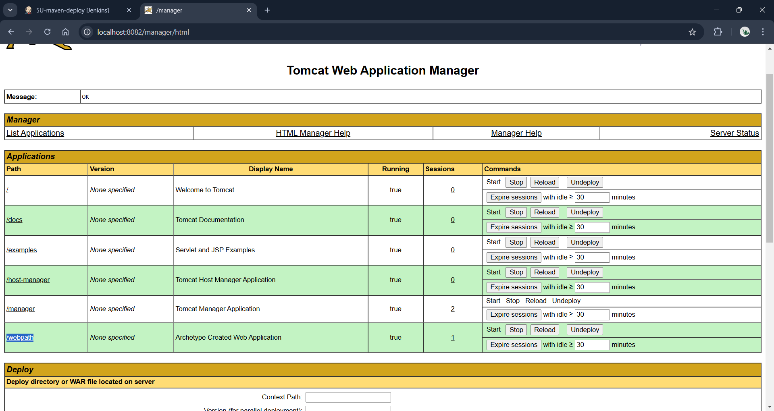

**JENKINS_SCRIPT**

Step 1:Click on new Item and create a jenkin_script and select pipeline in it and click on Ok

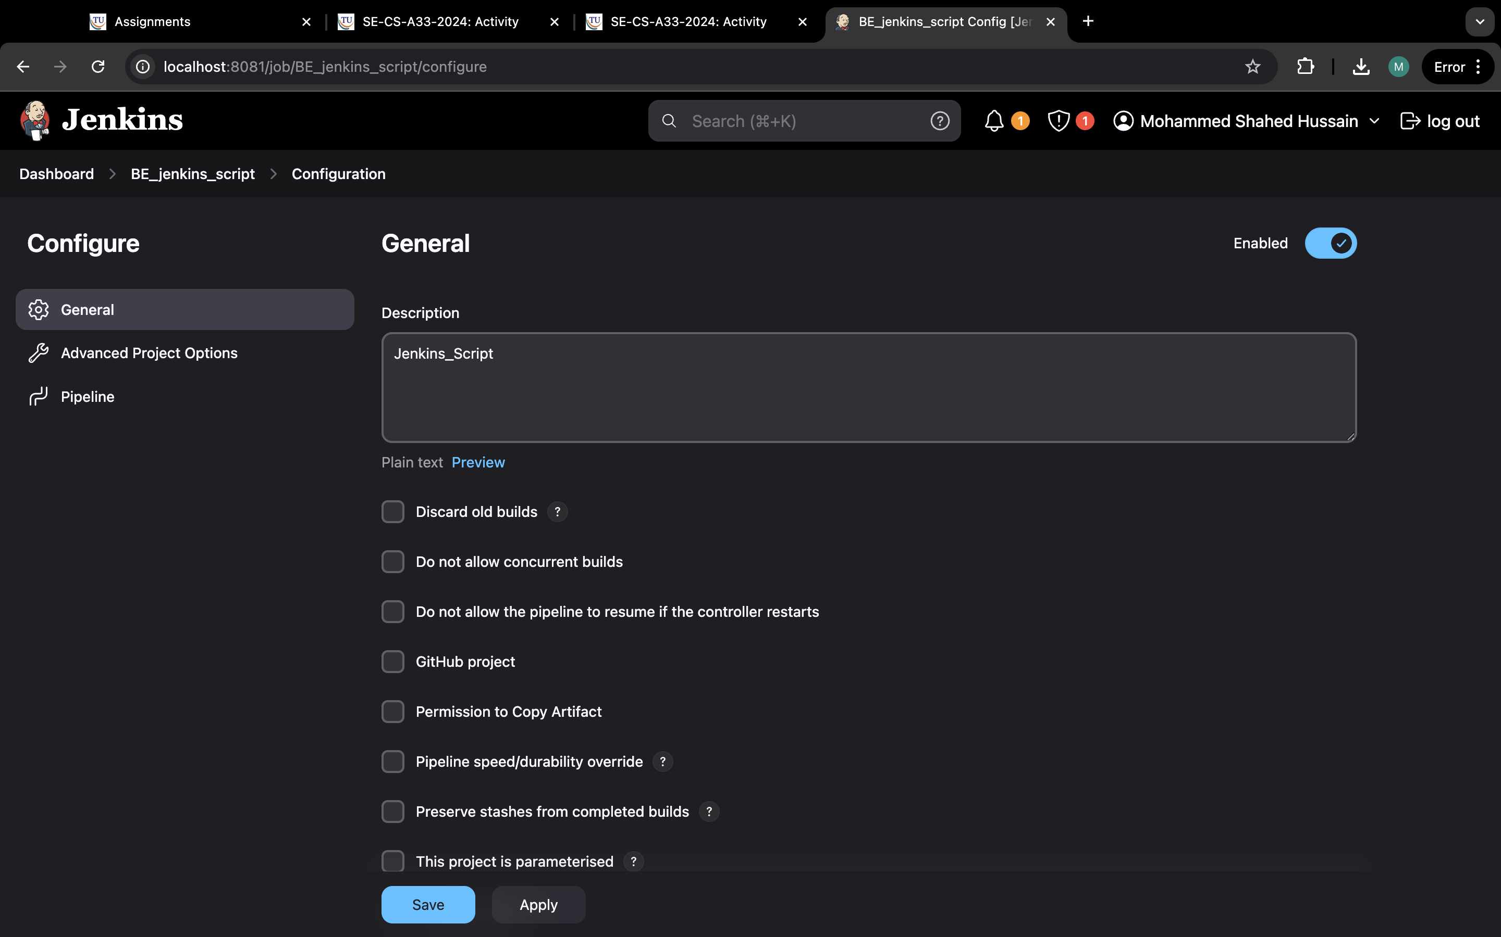

Step 2:Write the appropriate pipeline script to run the project with our git hub link and save it and build it

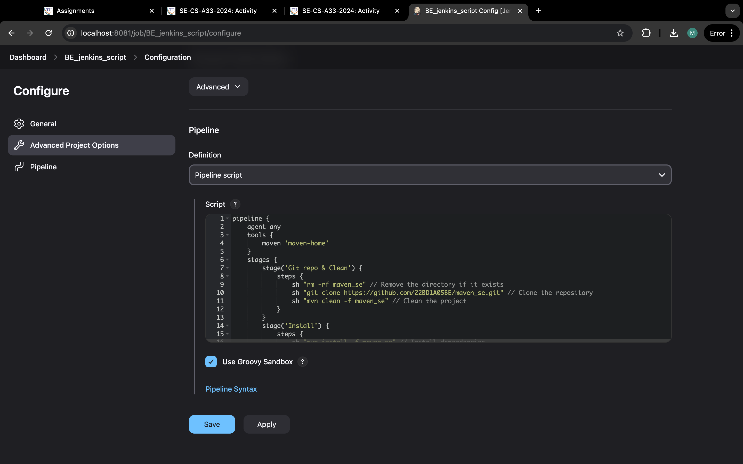

Step 3:This is the stage view of our project

